MLA Documentation

The MLA Handbook is generally used to document research in English and other humanities courses according to the guidelines established by the Modern Language Association. The MLA Handbook is periodically updated to reflect changes in the kinds of media writers are using and/or to improve on the standard format researchers use to cite their sources. The current, 9th edition—detailed in this handout—came out in 2021. The two parts to MLA documentation are in-text citation and a Works Cited page:

1.In-text citation, sometimes called parenthetical notation, shows all sources summarized, paraphrased, or quoted within your written text and includes the author’s last name and location (prose: page number, poetry: line, play: act and scene, and video or other recorded media: time stamp).

If the author’s name is used in the sentence introducing the quote, it is not necessary to include it in the parenthetical notation.

If you have more than one work by the same author, include part of the title.

2. The Works Cited page lists full bibliographic information for the sources cited (on a separate page), which is numbered consecutively as the last page of your paper.

All the sources quoted or paraphrased will have an entry on this page. When there is only one work referenced, the page is titled Work Cited.

Note the hanging indent. If you are unsure how to incorporate the hanging indent, consult a tutor or helpdesk associate.

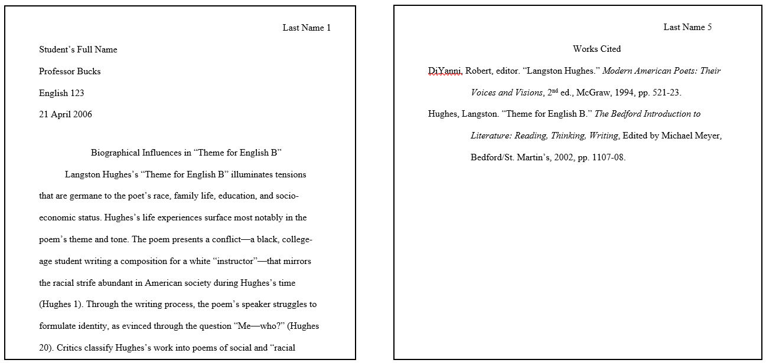
Table of Contents
Citation Considerations 3
Flexibility: 3
Long Quotes (Block Quotes 3
URLs, DOIs (digital object identifiers), and Permalinks: 3
Including Date Accessed: 3
Formatting a Works Cited Page 4
Main Template 5
Book with a Single Author 6
Book with Multiple Authors 6
Book with Author and Editor/Translator 6
Article in Reference Work 7
Entire Anthology 7
Work within an Anthology 7
Journal Article 8
Database (Library Subscription Service) 8
Online Source: Entire Website 9
Online Source: Page on a Website 9
Magazine 9
Brochure or Pamphlet 9
Newspaper 10
Advertisement 10
Image or Work of Art 11
Map, Chart, or Table 11
Film, DVD, Video Tape, or Slide Show 12
Sound Recording 12
Podcast 12
Television Show or Radio Show 13
Online Video (Uploaded to a sharing site- e.g. YouTube or Vimeo) 13
Interview 14
Email 14
Speech, Address, Lecture, or Reading 14
Legal Source (Print or Online): Law or Act 15
Court Case 15

Citation Considerations

Flexibility:
While there is a basic format for citing sources, this handout offers models for citing the most commonly cited resources. More than previous editions, the more recent versions of the MLA Handbook offer a degree of flexibility when citing. The 9th edition relies on a set of “universal guidelines” built around elements found in most sources (author, title, etc.). With that, the idea of the elements should be considered in a wide variety of situations. For example, the “author” element would extend to the equivalent “creator” when it comes to citing works of art.

Works Cited entries are organized around that set of common elements that can be combined to best fit the needs of the writer and the context in which the work is being cited. If you have any questions about citing a specific source, and the answer is not covered in this handout, you should consult The MLA Handbook (9th edition). The Academic Success Center has an MLA Handbook you may use in the Center. If you are not sure what kind of source the work you need to cite is, or if it is not listed here, please talk to your tutor.

Long Quotes (Block Quotes):
First, keep in mind that for much of the writing you’ll do at Bucks, your ideas should be the primary focus and any quoted and paraphrased material should support the development of those ideas. With that in mind, be sure to only use as much of a text as is necessary to fill that role. Long quotes can draw a reader’s focus away from your ideas, so they should be used sparingly.

Quotes longer than 4 lines long are formatted in a particular way. First, they are introduced with a colon and start on a new line. Additionally, the entire quote is indented a half inch —the same spacing as the start of a new paragraph. When block quoting, quotation marks are not needed. And in contrast to the in-text citation for shorter quotes, the parenthetical notation is placed after the ending punctuation of the quote.

DOIs (digital object identifiers), Permalinks, and URLs:
These are links to the location of works accessed online. Providing the access points to the works referenced in your writing can be important if your reader would like to explore one of the works cited on their own. Here is a brief explanation of each in order of preference:
- DOIs are the most reliable of the three options and should be included whenever available.
- A permalink is intended to be a more permanent access point and less likely to change over time.
- URLs are least reliable because they will very likely change over time as resources are relocated. They can also be very long and clutter the page. Follow your professor’s guidance when it comes to whether or not to include the URL.

Including Date Accessed:
Providing the date accessed is recommended if there is the potential for a source to change. For example, an article published in an academic journal would not necessarily need the date accessed because most journals have a publication date as well as other identifying information that would indicate whether the work was changed and released. Whereas works without a specific publication date, like a website, blog, or social media post, could change or be removed without notification, so these types of changeable sources should include a date accessed.

Formatting a Works Cited Page

Your Works Cited Page Should:

- Have Works Cited centered at the top of the page without quotes, italics, bold, or underlining.
- Be double spaced.
- Be organized alphabetically by author’s last name, or if there is no author, alphabetized by the title.
- Have a hanging indent for all lines beyond the top line of each citation.
**To format your Works Cited page correctly, follow the MLA’s specific guidelines for spacing, font size, margin size, and organization of entries. Refer to the MLA Handbook 9th ed. for additional information on proper formatting. Below is a sample Works Cited page. 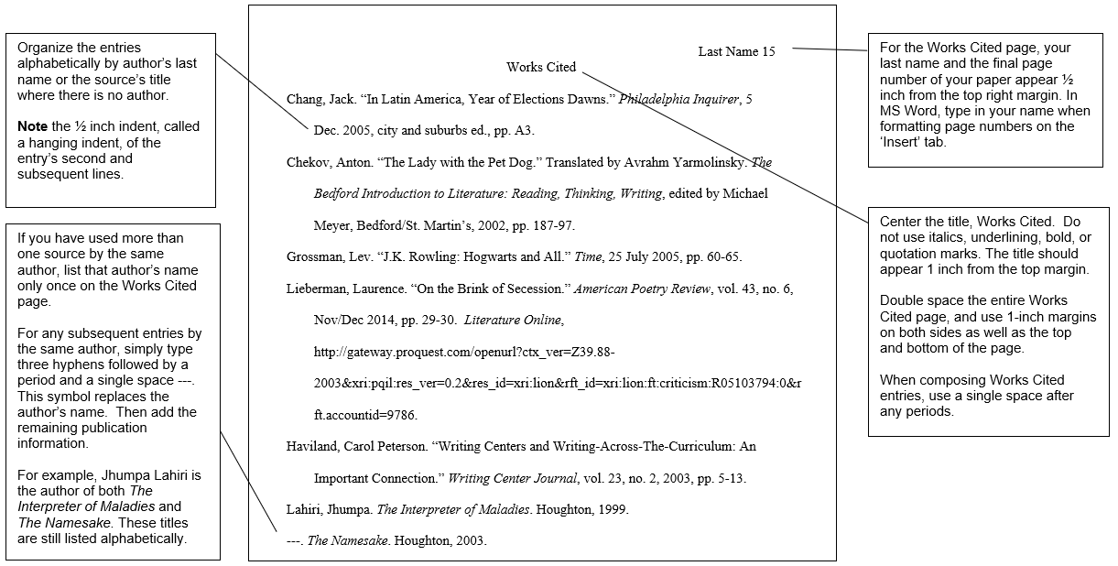

Main Template

According to MLA 9, sources should be thought of as being held within “containers.” Items like books can be thought of as self-contained, whereas items like book chapters are contained within a larger work. For example, a newspaper like the New York Times would be the container for a particular article; likewise, the television show Breaking Bad would be the container for a particular episode. The structure of citations in your Works Cited page will follow the general template below. Please note if the title belongs to a larger work, use quotation marks rather than italics. If the title is self-contained, use italics.

Author’s Last name, First name. Title of Source. Title of Container, Other Contributors, Version, Number, Publisher, Publication date, Location. Container 2 Title, Other contributors, Version, Number, Publisher, Publication Date, Location.
Sometimes sources can actually include multiple containers. For example, a particular TV episode may be contained within the body of the show (“Fly.” Breaking Bad.), but the show itself may be contained within a larger entity. In this instance, the writer may have accessed the episode through Netflix. Therefore, after providing information about the first container, the writer would also need to present info about the second container: Netflix, www.netflix.com/309493.

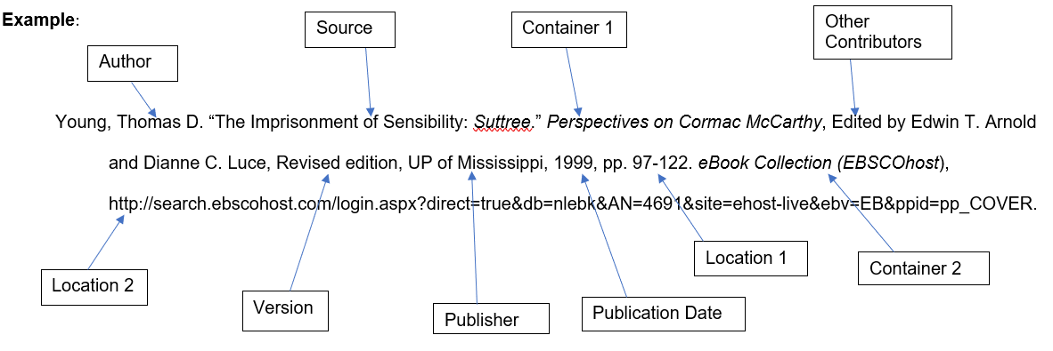
Note: In the example, based on the type of source you are citing, you may not use all of the elements listed in the template. When creating your Works Cited entries, use your best judgement about the elements that are most relevant and necessary.

Book with a Single Author

Format:
Author’s Last Name, First Name. Title of Book. Publisher, Date.

Example:
James, Henry. Washington Square. Penguin Books, 1998.

Note: List the most recent date listed in the book. Even if a book was originally published in 1925, you are citing the copy of the book that you used. Therefore, if your version of the book was published in 2016, the year of publication would be the year that your copy was published.

Book with Multiple Authors

Format:
Author’s Last Name, First Name, and Second Author’s Name. Title of Book. Publisher, Date.

Example with Two Authors:
Sayers, Dorothy L., and Robert Eustace. The Documents in the Case. Harper Torch, 1995.

Example with Three Authors:
Green, Ian, et al. St. Andrews Studies in Reformation History: Humanism and Protestantism in Early Modern English Education. Ashgate, 2009.
Note: The rules for citing a book with multiple authors apply to other types of works with multiple authors, such as a journal article and more. If there are more than three authors, acknowledge the first author’s name and follow it with a comma and et al.

Book with Author and Editor/Translator

Format:
Author’s Last Name, First Name. Title of Book. Other contributors, Publisher, Date.

Examples:
Johnson, Jean. The Power of Money. Edited by Caitlyn Jones, Random House, 2013.

Fryer, Robin. Misty Musings on Robert Frost. Translated by David Swanker, Taylor & Francis, 2004.

Article in Reference Work

Format:
Author’s Last name, First name. “Title of Article.” Title of Reference Work, Other Contributors, Version, Number, Publisher, Publication date, Location.
Example:
Connor, Mary J. “Blogging to Success.” Encyclopedia of Life, 2012, pp. 125-32.

Example:
Davis, Maria. “Using Articles in English.” Dictionary of American English Grammar, Continuum, 2013, pp. 22.

Entire Anthology
(An anthology is a collection of works from one or more authors.)

Format:
Editor’s Last name, First name. Title of Anthology, Version, Publisher, Publication date.

Example:
Baym, Nina, et al., editors. The Norton Anthology of American Literature, vol. A, Norton, 2011.

Note: Cite an entire anthology using the editors instead of the author(s) because the editors compile the work.

Work within an Anthology
Format:
Author’s Last name, First name. “Title of article, chapter, or short story.” Title of Anthology, Other Contributors, Version, Publisher, Publication date, Location.
Example:
Thomas, Dylan. “Memories of Christmas.” The Norton Reader: An Anthology of Expository Prose. Edited by Arthur M.
Eastman, 5th ed., Norton, 1980, pp. 1-5.

Journal Article
Format:
Author’s Last Name, First Name. “Title of Article.” Title of Journal, Volume, Number, Date, Location.

Example:
Campano, Gerald. “Honoring Student Stories.” Early Intervention at Every Age, vol. 65, no. 2, 2007, pp. 48-54.

Database (Library Subscription Service)

Note: Sources found online are commonly published in print form and then made available online in a PDF format. Such sources should be cited as if they were in their original form (i.e., newspaper, journal article, magazine, book, etc.), and the database should be included as a second container at the end of the citation.

Format:
Author’s Last name, First name. “Title of Source.” Title of Journal, Book, Magazine, etc., Volume, Number, Date, Location. Database, URL or DOI.
Example with link:
Ludlum, Marty, et al. "The Study Habits of Finnish College Students: A Two Sample Investigation." College Student Journal, vol. 50, no. 2, 2016, pp. 212-218. Academic Search Premier, http://search.ebscohost.com/login.aspx?direct=true&db=aph&AN=116190970&site=ehost-live.
Example with doi:
Felfe, Christina, et al. "Sports and Child Development." PLoS One, vol. 11, no. 5, 2016, pp. 1-23. Academic Search Premier, https://doi.org/10.1371/journal.pone.0151729.

Note: Some databases will generate citations for you. Always check these citations for the proper MLA format, as some may be outdated or incorrect to begin with. Articles in journals are often assigned digital object identifiers (DOI). A DOI will take the reader to the object even if the URL is changed. Again, when possible, cite a DOI (preceded by doi:) instead of a URL.

Online Source: Entire Website
Format:
Title of Website. Publisher, Publication date, URL. Date of Access.

Example:
BioMed Central. BioMed Central Ltd, 2016, http://www.biomedcentral.com. Accessed 2 September 2016.

Note: Cite blogs as an entire website.

Online Source: Page on a Website
Format:
Author’s Last Name, First name. “Title of Web Page.” Title of Website, Publisher, Publication date, URL. Date of Access.

Example:
Alan, Henry. “Eight Useful Microsoft Excel Shortcuts Worth Memorizing.” Lifehacker, Gawker Media, 31 Mar. 2016, http://lifehacker.com/eight-useful-microsoft-excel-shortcuts-worth-memorizing-1767484423. Accessed 2 September 2016.

Magazine
Format:
Author’s Last name, First name. “Title of Article.” Title of Magazine, Publication date, Location.

Example:
Freeman, Richard. “Poses of the Month.” Yoga Journal, 1 October 2016, p. 21.

Brochure or Pamphlet
Format:
Title of Brochure or Pamphlet, Publisher, Date.

Example:
Transferring to a Four-Year College. Newtown: Bucks County Community College, 2013.

Note: If the pamphlet has an individual or corporate author, put that information before the title of the brochure.

Example:
Tasting for Tyler. Bucks County Courier Times, Advertisement, 4 June 2014. D12.

Newspaper
Format:
Author’s Last name, First name. “Title of Article.” Title of Newspaper, Publication date, Location.

Example:
Lipton, Eric, and Rachel Abrams. “EpiPen Maker’s Tactics Could Quell Protests Over Prices.” The New York Times, 16 Sep. 2016, http://www.nytimes.com/2016/09/16/business/epipen-maker-mylan-preventative-drug-campaign.html?hp&action=click&pgtype=Homepage&clickSource=story-heading&module=second-column-region&region=top-news&WT.nav=top-news.

Advertisement
Format:
“Title of Advertisement (if available).” Name of Item or Organization being advertised (if not identified in the title), Publication venue, Advertisement, Publication date, Location.
Example (print with no title):
Advertisement for Friskies cat food. Rolling Stone, Mar. 2021, pp. 11.
Example (print with title):
“Introducing the Sky.” Natural American Spirit cigarettes, Rolling Stone, Mar. 2021, pp. 12.
Example (digital):
Advertisement for Frederick P. Lenz Foundation Residential Fellowship Program. Naropa University. The Arrow, 13 Dec. 2022, https://arrow-journal.org. Pop-up advertisement.
Example (filmed)
“Find the perfect Freelancer.” Fiverr, YouTube, uploaded by Fiverr, 27 Nov. 2021, https://www.youtube.com/watch?v=G-_l_KpKnhc.

Image or Work of Art
Format:
Photographer’s (or Artist’s) Last Name, First Name. Title of Work, Date of creation, Location (the institution that houses the work, city where it is located). Website, URL. Date of Access.
Example:
Baumgartner, Christiane. Strand, 2015, Museum of Modern Art, New York. MoMA, https://www.moma.org/collection/works/194751?locale=en. Accessed 2 Sept. 2016.
Example:
Leibovitz, Annie. Russell Brand as Captain Hook, 2007, Vanity Fair, http://www.doctordisney.com/annie-leibovitzs-image-gallery-of-disney-dream-portraits-celebrities-as-disney-characters. Accessed 8 Dec. 2022.

Note: Cite an image as a work of art. If the image is found only online, provide the artist’s name, title of the work, and then follow the format for citing a website.

Map, Chart, or Table

Format:
“Illustration label or number. Caption” Container, Author or contributor, Publisher, Publication Date, Location.

Example:
“Model 11-1: Executive Summary.” Technical Writing: Principles, Strategies, and Readings, by Diana C. Reep, 8th ed., Pearson, 2011, pp. 272.
Example:
“Provinces of Papua New Guinea Map.” WorldAtlas, https://www.worldatlas.com/maps/papua-new-guinea. Accessed 13 Dec. 2022.

Example:
“Fig. 5.2. The MLA template of core elements with two containers.” MLA Handbook, Modern Language Association of America, 9th ed., 2021, pp. 106.

Note: Variations of examples based on how or where the map, chart, or table was accessed. Review the models for print, web, and Internet resources as necessary.

Film, DVD, Video Tape, or Slide Show
Format:
Title of source. Director’s name, Other contributors (actors, producers, editors, etc.), Publisher or Distributor, Publication date.

Example:
South Pacific. Directed by Joshua Logan, produced by Buddy Adler, screenplay by Paul Osborn, edited by Robert L. Simpson, 20th Century Fox, 1958.
Note: If information regarding actors, producers, or writers is relevant to your particular citation, add this information before the distributor.

Sound Recording
Format:
Author’s Last Name, First Name. “Title of Song.” Title of Album, Publisher, Date.

Example:
Swift, Taylor. “We Are Never Ever Getting Back Together.” Red, Big Machine, 2012.

Note: If you access a song or album from a service like Spotify or Amazon music, cite the service as a container and provide a URL when possible.

Example:
Ocean, Frank. “Be Yourself.” Blonde, Boys Don’t Cry, 2016. Spotify, https://play.spotify.com/album/1PDX0hMmsSdq122EupvNZF.

Podcast
Format:
“Title of Episode.” Title of Podcast, Other contributors (narrator, host, etc.), Date, Location.

Example:
“What We Learn Before We’re Born.” TED Talks, narrated by Annie Murphy Paul, 16 Nov. 2009, https://www.ted.com/talks/annie_murphy_paul_what_we_learn_before_we_re_born?language=en.

Note: This is how you would cite a podcast if it was downloaded from the Internet ONLY. If you are listening to a podcast online, cite it as you would a page on a website.

Television Show or Radio Show
Format:
“Title of episode.” Title of Television or Radio Series, season, episode, Publisher or Network, Broadcast date.

Example (television broadcast):
“The One Where Dr. Ramoray Dies.” Friends, season 2, episode 18, NBC, 21 Mar. 1996.

Example (viewed on a website):
“The Balloonman.” Gotham, season 1, episode3, Warner Brothers Television, 2014. Netflix, www.netflix.com

Example (viewed through an app):
“Baby Blue.” Person of Interest, season1 episode 17, CBS, 2011. Amazon Prime Video app.

Note: If the TV show is one of a series, such as Nature on PBS, list the title of the series after the show or program title.

Online Video (Uploaded to a sharing site- e.g. YouTube or Vimeo)
Format:
Author’s Last Name if available, First Name if available. “Title of Video.” Title of Containing Website, Name of Uploader if different from author, Date, URL.
Examples:
“Lecture 1: What is electrical engineering?” YouTube, uploaded by John Breslin, 9 Nov. 2009, https://www.youtube.com/watch?v=p5cXV0dNANg.
Wise, Tim. “Tim Wise: On White Privilege.” YouTube, uploaded by ChallengingMedia, 19 Feb. 2008, https://youtu.be/J3Xe1kX7Wsc.

Note: If the author’s name is the same as the uploader’s name, only mention the name once. If the names are different, list the author’s name prior to the title.

Interview

Format:
Interviewee’s Last name, First name. “Title of Interview.” Title of Container, Publisher, Publication date, Location.

Note: If the interview is untitled, include the phrase “Interview by” before the interviewer’s name.

Example:
Street, John. “Interview by Terry Gross.” Fresh Air, NPR, WRTI, 13 Oct. 2008.

Note: To cite a personal interview, use the following format.
Format:
Interviewee’s Last Name, First Name. Personal interview. Date when interview was conducted.

Example:
Street, John. Personal Interview. 22 Aug. 2006.

Email
Format:
Author’s Last Name, First Name. “Title of Message.” Received by Recipient’s First Name Last Name, Date.

Example:
Eubank, Annette. “Re: CRLA Conference.” Received by Molly Bye, 25 July 2006.

Note: “Title of the Message” is usually the subject line.

Speech, Address, Lecture, or Reading
Format:
Speaker’s Last Name, First Name. “Title of Speech.” Title of Conference, Meeting, etc., Title of Sponsoring Organization, Date, Name of Location, City, State. Type of presentation (Speech, Conference Presentation, etc.).
Example:
Tomlinson, Carol Ann. “Differentiating for Success: Strategies for Supporting Students who Struggle in College.” 30th Annual Conference, NADE, 16 Feb. 2006, Marriott Downtown Hotel, Philadelphia, PA. Conference Presentation.

Legal Source (Print or Online): Law or Act
Format:
Title of Source. Version, Number, Publisher, Publication date, Location.

Example:
Patient Protection and Affordable Care Act of 2010. Pub. L. 110 Stat. 2033. 23 Mar. 2010, pp. 111-148.

Court Case

Format:
Title of Case. Title of Container, Version, Number, Publisher, Publication date, Container 2 Title, Publication Date, Location.

Example:
Brown v. Board of Education. Collection of Supreme Court Rulings, 347 US 483, Supreme Court of the US, 1954, Legal Department, Harvard U Law School.

