A Student’s Guide to Real-time Online Tutoring
using GoBoard
Academic Success Center
Bucks County Community College
Spring 2020

Logging In to GoBoard
Clicking on the Tutoring Room Link sent in the appointment reminder email will take you to the appropriate GoBoard space. After clicking on the room link, a screen will pop up asking you to click either “I’m a Tutor” or “I’m a Student.”

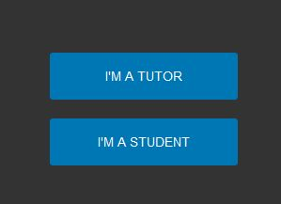

Please click on “I’m a Student.” This is the simplest way for you to log in and get into the room.

On the next screen, please enter your name and then finish by providing your Bucks email and then click “Enter GoBoard.”
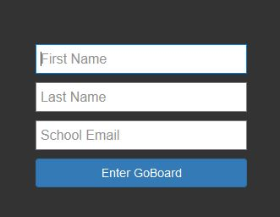

GoBoard Tools and Features
If the following message pops up, you can just click on “Enter Now.” You’ll have a chance to enable your 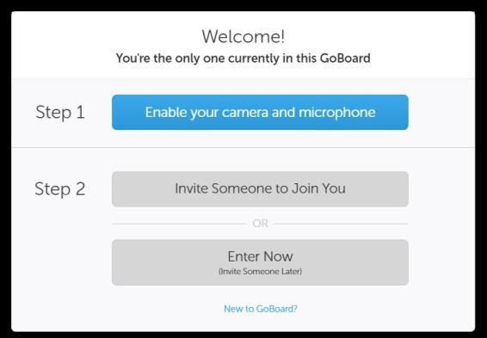microphone and webcam at a later point.

OPENING SCREEN
Below is the opening screen for each GoBoard room. The upper right corner contains video/audio/chat settings as well as basic and advanced menus.

1

3
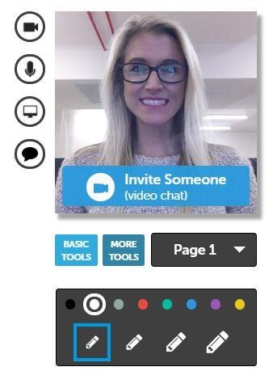
- Video/Webcam: allows for a video session using your webcam
2
1
8

9

3
- Video Chat Window: the tutor’s image will appear in this window
- Microphone: allows for an audio conversation using your computer’s 2
4
microphone and speakers
- Screen Sharing: allows you to share what you’re seeing on your Computer
5
—see Section II for more details.
- Chat Window: allows you and the tutor to chat in a text box
- Page Navigation: allows you to create new pages and move between pages
- Writing Tools: allows you to draw on the whiteboard
- Basic Tools: a collection of tools like erase and draw shapes—
6
See Section III 6 for more details
- More (Advanced) Tools: a collection of more advanced and subject specific tools like Import/Export, calculator, and more—See Section III for more details.
7
7

Screen Sharing
GoBoard offers a screen sharing option that tutors can utilize during a session. This option can be used in a few different ways in case you want the tutor to look at something on your computer screen rather than upload something to the whiteboard. There are three different screen sharing options:

Share the entire screen
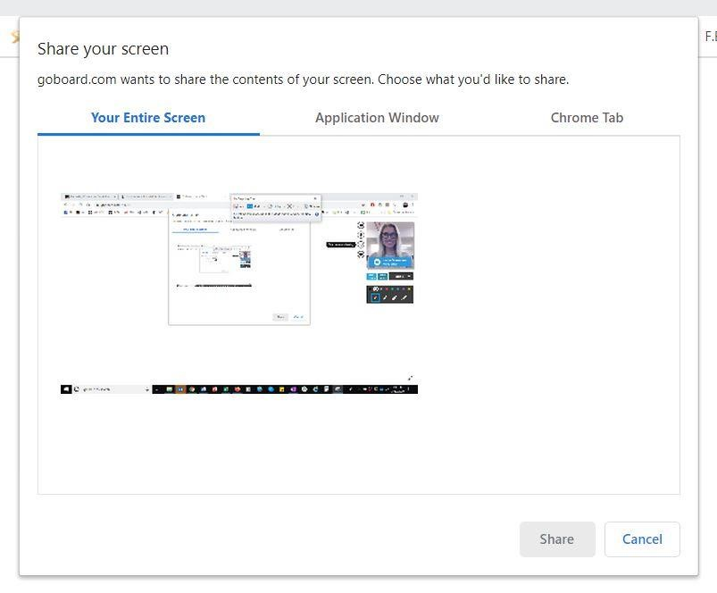
With this option, anything visible on the sharer’s screen will be visible to others.

Share an application
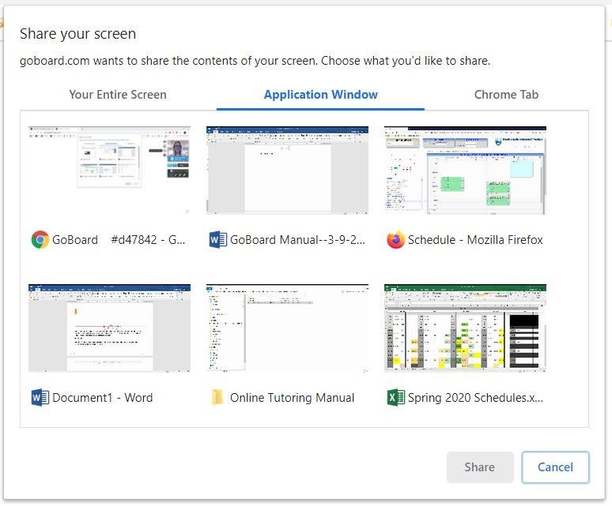
With this option, a single application is shared (i.e., Chrome, Word, Excel, etc.). Even if the sharer switches to a different application, the viewer won’t see anything else.

Share a tab
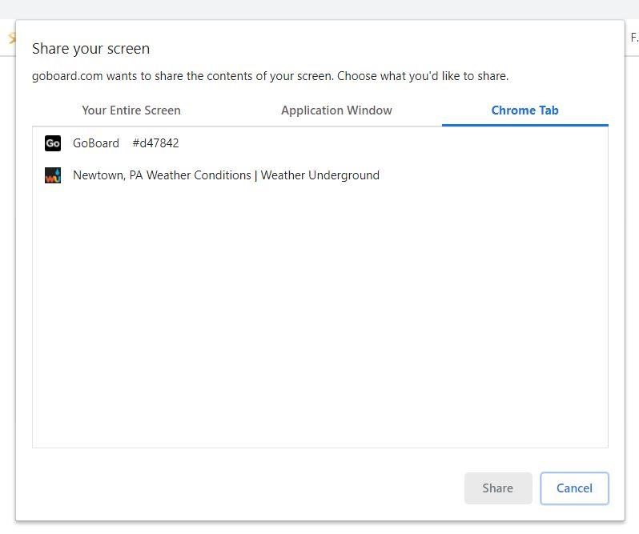
With this option, a single tab of the web browser is shared (i.e. Chrome or Firefox, not Internet Explorer.). Even if the sharer switches to a different tab or application, the viewer won’t see anything else.

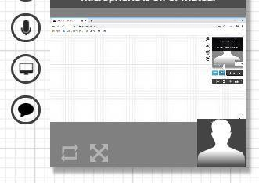
NOTE: Once you have shared your screen, it will appear in the upper right corner where your image apperas during video chat. To make the image bigger, click on the gray arrow icon and the shared screen will expand.

End Screen Share
When the need to screen share is over, just click the “Stop sharing” button:

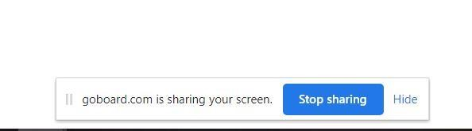
Tools

Text Chat
- After clicking the chat tool, a chat window will appear on the screen. Remember that the chat tool is found in the upper right corner of the screen.

- Everyone in the room will appear in the chat window and can use this space to type messages to each other. If you are the only person in the room, you may not be able to type anything into the chat box.

NOTE: GoBoard does not automatically show the text chat window. When you log in, make sure that you say hello through chat. Once you and the tutor have started chatting, you can decide if you want to switch to a different form of communication like video or audio.

Basic Tools
GoBoard offers several common features that may be familiar if you’ve used Word, Google Docs, or Pages, including drawing and erasing options, highlighting, and a text box. To access those features, click on the “Basic Tools” menu:
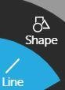
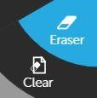
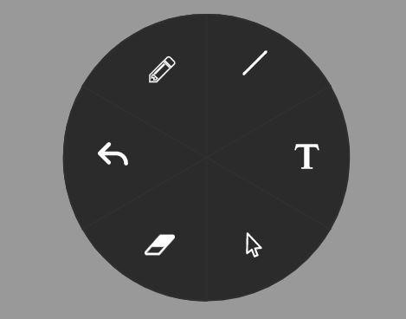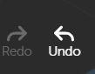
If you hover over the icons, the options will expand.

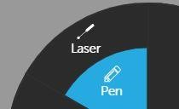
NOTE: Laser--lets you point at items on the screen without making a mark.
Pen--lets you draw on the white board.
The “T” button allows you to create a text box in the whiteboard. The text box can also be used as a chat option.

More (Advanced) Tools
GoBoard has a number of advanced tools, including items like basic and graphing calculators and an option to change the color/format of the white board using the “Background/Grid” option. Some options will appear in multiple tabs, while others are found under specific subject tabs.

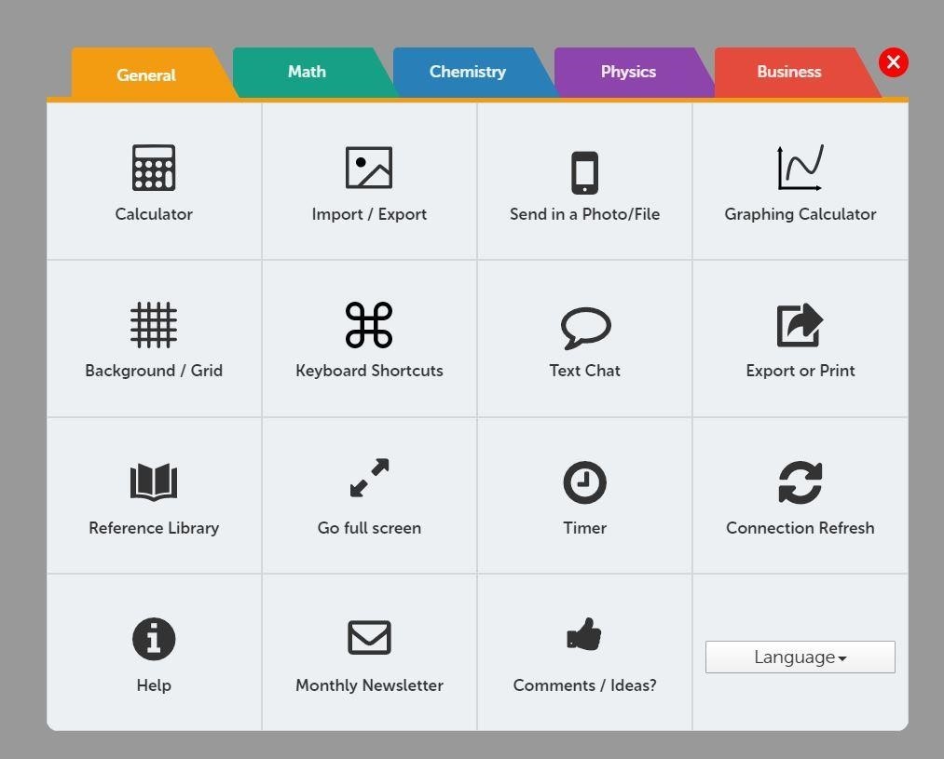
- Import/Export—clicking here gives options to upload an image, document, or PDF file to the board. It also gives the option to save or print pages of the board as a pdf file.

- Send in a Photo/File—offers similar choices to the
Import/Export option

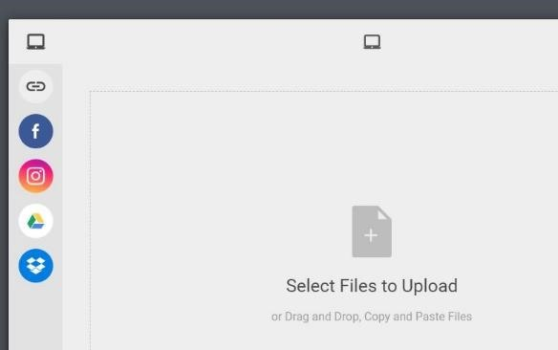
- When importing a file, there are several options, including pulling files from cloud services like Google Drive and Dropbox and also attaching files from the computer.
NOTE: GoBoard suggests using image or .pdf files. However, you can also upload .doc and .docx files to the whiteboard.

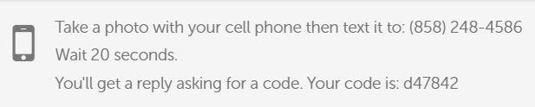
- Students can also take a photo with their phone and text it to the board. The code shown here will change depending on the room being used.

Subject Specific Tools

- Under the Math tab, there are several useful tools: a graphing calculator, graphing tool, equation editor, and more.
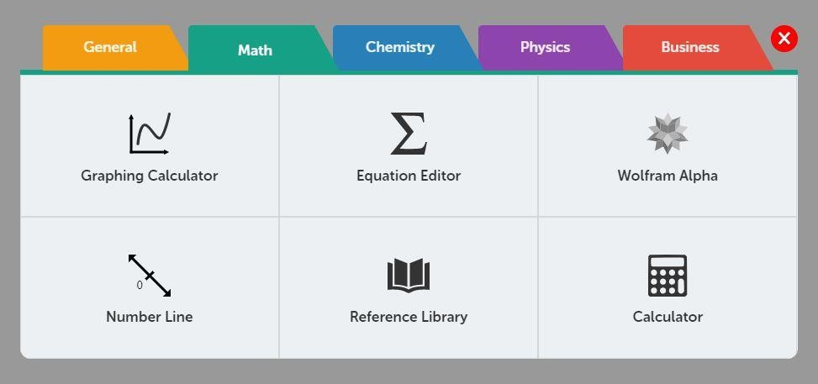

- The Chemistry tab has a Bond Drawing tool that may be useful during sessions.
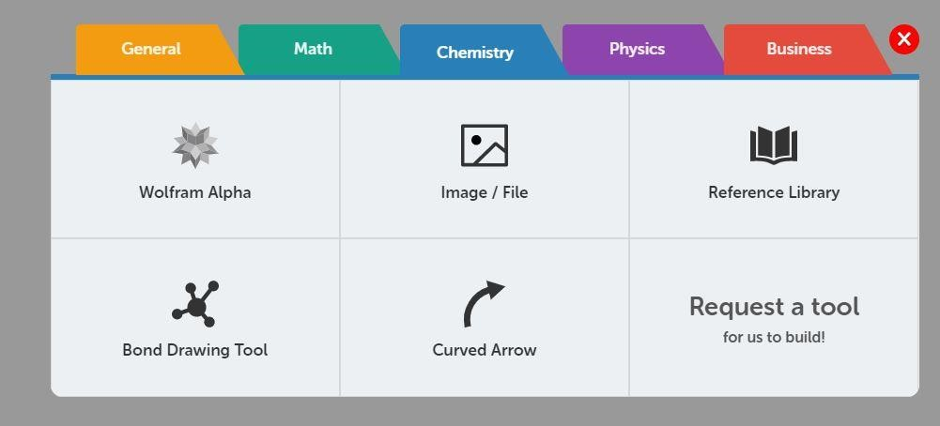

Saving Your Work

- At the end of the session, the tutor will erase the whiteboard and any comments in the chat window. Before that happens you will have the opportunity to save any work done on the whiteboard.

- Click on the More Tools button, and then click the Export or Print option:

- If you’d like to save your work as a PDF, click on the Export with colors option. If you’d like to print your work, click on the Export for printing option.

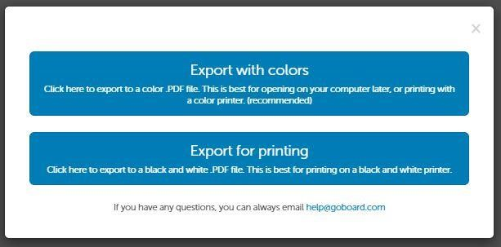

Note: Both options will capture all whiteboard pages used during the session.

Once the session is over and you’ve saved your work, just close your browser to end the session.

Please email tutor@bucks.edu if you have any questions.

