Using Substitution
Homogeneous and Bernoulli Equations

Sometimes differential equations may not appear to be in a solvable form. However, if we make an appropriate substitution, often the equations can be forced into forms which we can solve, much like the use of u substitution for integration. We must be careful to make the appropriate substitution. Two particular forms of equations lend themselves naturally to substitution.
Homogeneous Equations A function F(x,y) is said to be homogeneous if for some t 6= 0
F(tx,ty) = F(x,y).
That is to say that a function is homogeneous if replacing the variables by a scalar multiple does not change the equation. Please note that the term homogeneous is used for two different concepts in differential equations.
Examples

- 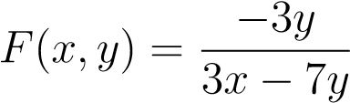 is homogeneous since
- 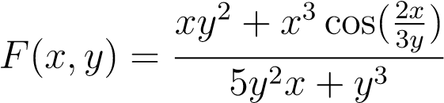 is homogeneous since
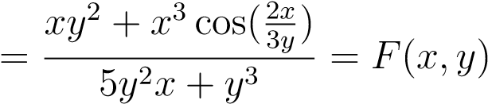
We say that a differential equation is homogeneous if it is of the form 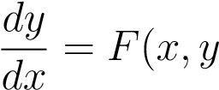) for a homogeneous function F(x,y). If this is the case, then we can make the substitution y = ux. After using this substitution, the equation can be solved as a seperable differential equation. After solving, we again use the substitution y = ux to express the answer as a function of x and y.
Example

1. 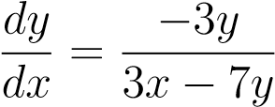
We have already seen that the function above is homogeneous from the previous examples. As a result, this is a homogeneous differential equation. We will substitute y = ux. By the product rule, 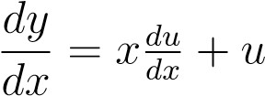. Making these substitutions we obtain
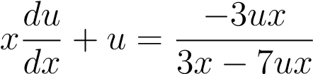
Now this equation must be separated.
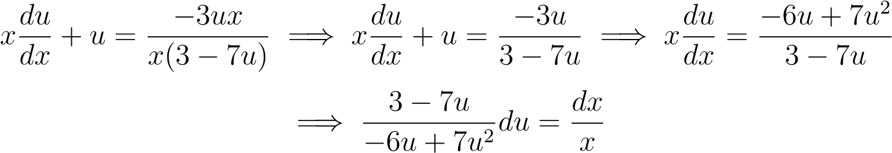
Integrating this we get,
.
Finally we use that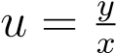to get our implicit solution 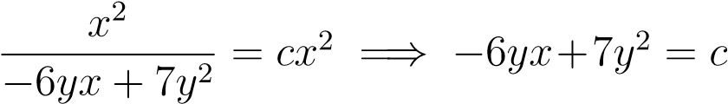.
Bernoulli Equations We say that a differential equation is a Bernoulli Equation if it takes one of the forms
.
These differential equations almost match the form required to be linear. By making a substitution, both of these types of equations can be made to be linear. Those of the first type require the substitution v = y^{m+1}. Those of the second type require the substitution u = y^{1−n}. Once these substitutions are made, the equation will be linear and may be solved accordingly.
Example

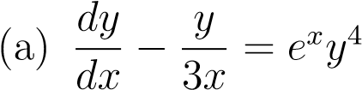
You can see that this is a Bernoulli equation of the second form. We make the substitution u = y¹⁻⁴ = y⁻³. This gives 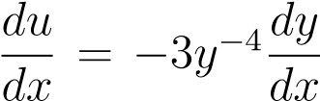. The equation will be easier to manipulate if we multiply both sides by y⁻⁴. Our new equation will be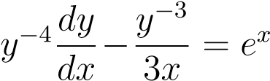.
Making the appropriate substitutions this becomes 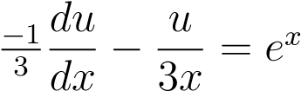.
If we multiply by −3 we see that the equation is now linear in u and can be solved:
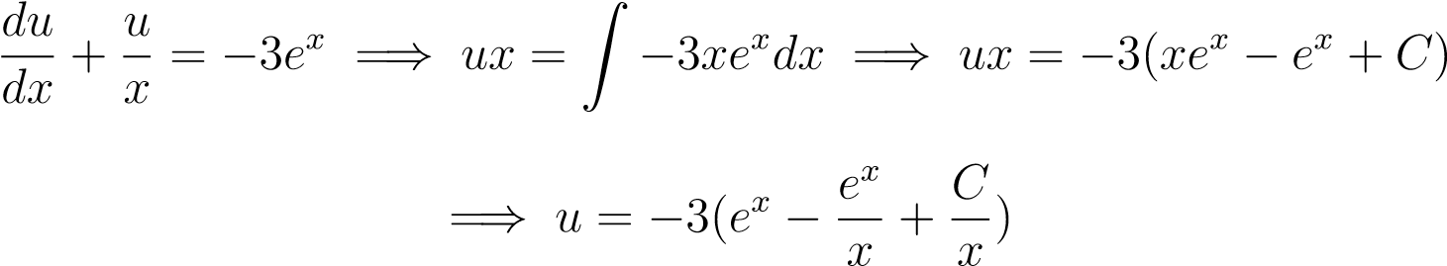
After undoing the u substitution, we have the solution
