Fractions
A fraction is a number of the form where a and b are integers and b is not 0. They are used when we want to refer to parts of a whole, like half of a pizza, or three quarters of an hour. We also see used for a ÷ b. This is no coincidence – fractions are quotients of two integers.

Representing Fractions
If we cut a pie into four equal pieces, each piece is
1
4
, or one fourth (also called a quarter)
of the pie:
If we cut something into five equal pieces and take three pieces then the fraction is
3
5
, or
three fifths:
We can also visualize a fraction on the number line. Imagine a ruler where the units are
subdivided into smaller parts.
0
1
1
5
2
5
3
5
4
5
1
5
1
5

The top of a fraction (number above the bar) is called the numerator and the bottom is called the denominator.
+ Numerator
+ Denominator
a
b
A proper fraction is one whose numerator is less than its denominator.
Examples: 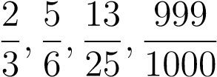
Helpful Hint: Proper fractions are less than one whole. Since the whole is 1, proper fractions are less than 1.
Sometimes we use fractions that where the numerator is greater than or equal to the de-
nominator. These are called
improper fractions
.
Example:
5
3
can be pictured as:
or:
0
1
2
1
3
2
3
1
1
3
1
2
3
5
3
This can also be written as a
mixed fraction
as
1
2
3
. This is because
3
goes into
5
once, with
remainder
2
.
Example:
We can go even further.
13
4
can be pictured as:
or
0
1
2
3
1
2
1
1
2
2
1
2
3
1
2
1
4
3
4
1
1
4
1
3
4
2
1
4
2
3
4
3
1
4
13
4
As a mixed fraction, we would write
3
1
4
.
Question:
What is
15
3
?
Answer:
15
3
is the same as
15
÷
3
, which is the whole number
5
.
Dividing integers:
If
a
and
b
are integers,
a
divided by
b
is the fraction
a
b
.
Fraction properties of 1:
+ If n is any integer, other than 0, 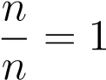
+ If n is any integer, 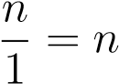
Question: What is?
Answer: If we divide a whole into 5 parts, then 5 of those parts equals the whole! The whole is 1, so = 1.

Question: What is ?
Answer: 3 divided by 1 is 3, so = 3.

Equivalent Fractions
Question: How are and related?
Answer: They are the same:
When we multiply both the numerator and the denominator of a fraction by the same number, as long as it isn’t 0, we get an equivalent fraction. “Equivalent” means “equal.” For example,
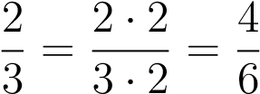
- · 2 = 4
- · 2 = 6
Since multiplication and division are inverse operations, we also can divide the numerator and denominator by the same number if it goes into them both:
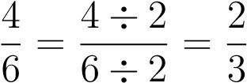
- ÷ 2 = 2
6 ÷ 2 = 3
Fundamental Property of Equivalent Fractions:
If
a
,
b
, and
c
are numbers, as long as
b
and
c
are not
0
a
b
=
a
·
c
b
·
c
and
a
b
=
a
÷
c
b
÷
c
Examples:
+
1
2
=
2
4
=
3
6
=
4
8
etc.
+
4
3
=
8
6
=
12
9
=
16
12
etc.

Simplest Form
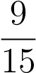
We saw that a fraction has many different forms. For example,is the same as. To see this, 3 goes into both 9 and 15, so
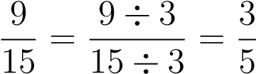
We can also cancel common factors to get an equivalent fraction. First, write 9 and 12 in factored form 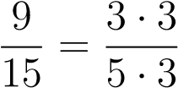
Now, cross out the common factor 3
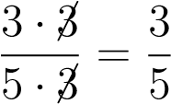
Question: Do 3 and 5 have any common factors?
Answer: They have no common factors other than 1. Dividing a number by 1 leaves it the same, so we can’t get anything new by dividing the numerator and denominator by it.
When the numerator and denominator of a fraction have no common factors other than 1, the fraction is in simplest form or lowest terms.
Even though a fraction can be written in many different ways, there is only one way to write a fraction in simplest form. Most problems require us to write our answers in simplest form.

To write a fraction in simplest form:
+ Step 1: Write the prime factorization of the numerator and denominator.
+ Step 2: Cross out any factor that appears in both the numerator and the denominator.
+ Step 3: Repeat step 2 until there are no common factors that have not been crossed out.
+ Step 4: Multiply the remaining factors in the numerator to get the numerator of the answer. If all factors are crossed out, then the numerator is 1. Do the same thing for the denominator.
Example: Simplify 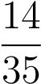
Solution: 14 factors as 2 · 7 and 35 factors as 5 · 7. So:
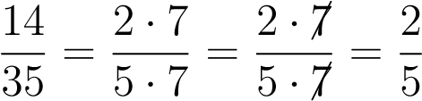
Example: Simplify 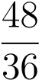
Solution: The prime factorization of 48 is 2 · 2 · 2 · 2 · 3 and 36 factors as 2 · 2 · 3 · 3. So:
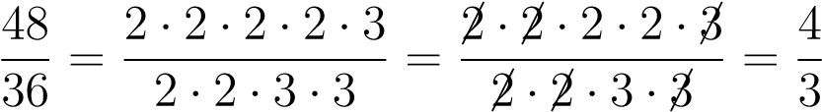
Example: Simplify 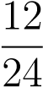
Solution: The prime factorization of 12 is 2 · 2 · 3, and 24 = 2 · 2 · 2 · 3.
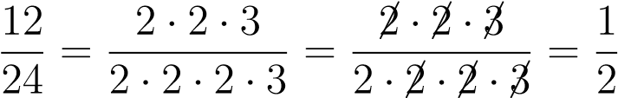
Since all factors were crossed out in the numerator, we put 1 in the numerator of the answer. This is because when we cross a factor out, we are really dividing by it. When we divide a number by itself, the answer is 1.

Multiplying Fractions
If we want to multiply
2
7
by
3
, we can use repeated addition:
+
+
=
2
7
·
3=
2
7
+
2
7
+
2
7
=
6
7
But this is also the same as
2
7
of
3
.
When we multiply fractions, multiplication is the same as the word “of.”
For example, to multiply
1
2
by
3
5
, we take
1
2
of
3
5
.
1
2
·
3
5
=
1
·
3
2
·
5
=
3
10
To multiply two fractions:
+ Step 1: Multiply the numerators and make this the numerator of the answer.
+ Step 2: Multiply the denominators and make this the denominator of the answer.
+ Step 3: Simplify the answer.
Helpful Hint: To make the simplification easier, you can divide common factors in the numerator of one and the denominator of the other fraction before multiplying.
When the numerator or denominator is negative, we can pull the negative sign in front to make the fraction negative. When both the numerator and denominator are negative, the negative signs cancel.
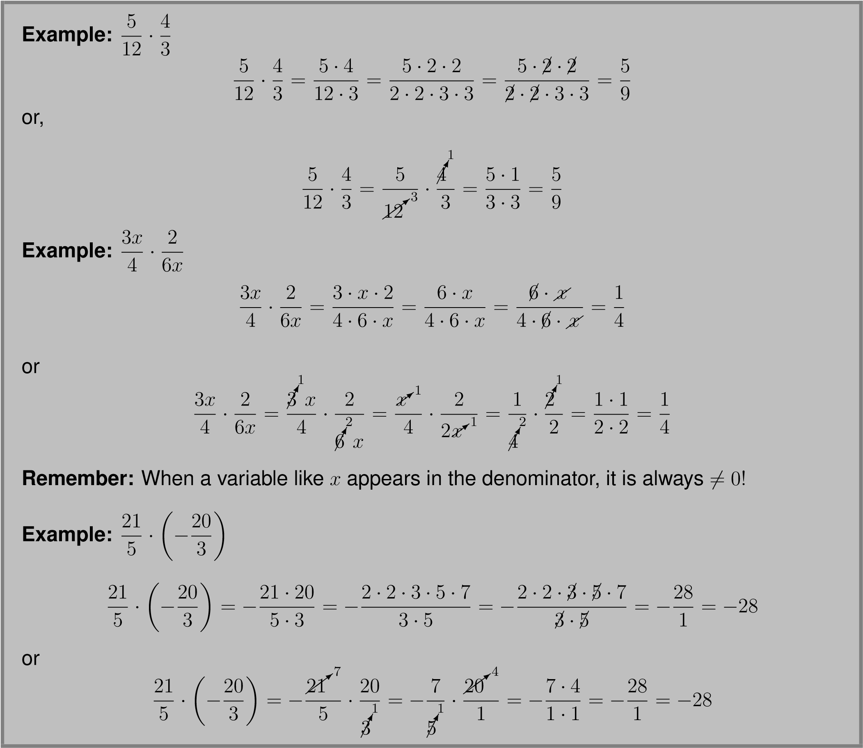

Dividing Fractions
Question: What is 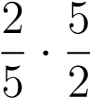?
Answer: 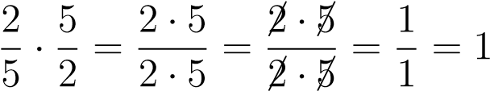
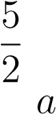
is called the “reciprocal” of .
If is a fraction, and a 6= 0 and b 6= 0, then the reciprocal is . Reciprocals are important b because when we multiply a fraction by its reciprocal, the answer is always 1.
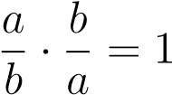

Careful: The reciprocal of 0 is undefined!
Helpful Hint: Whole numbers also have reciprocals. For example 3 = has reciprocal .
If we want to divide
3
by
1
2
we can use reciprocals. First, we picture
3
, divided into halves:
Question:
How many halves are there?
Answer:
There are
6
halves!
3
÷
1
2
=6
. We can check this by multiplying.
6
·
1
2
=
6
2
=3
We see that dividing fractions is the same as multiplying by the reciprocal of the second
fraction.
3
1
÷
1
2
=
3
1
·
2
1
=6
.
To divide two fractions: 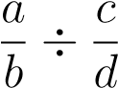
+ Step 1: Take the reciprocal of the second fraction, and change the division sign to ·
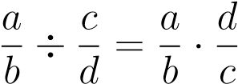
+ Step 2: Multiply the fractions as usual:
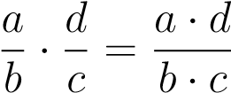
+ Step 3: Simplify the answer.
Careful: The order of division matters! Only take the reciprocal of the second fraction.
Example:
We can also write
a
÷
b
=
a
b
. This is true with fractions. For example:
3
5
2
7
=
3
5
÷
2
7
The
bottom
fraction goes second. Now we take the reciprocal of the second fraction and
change the division to multiplication.
3
5
÷
2
7
=
3
5
·
7
2
=
21
10
Remember:
Don’t get multiplication and division of fractions confused. To divide fractions,
take the reciprocal of the second (or bottom) fraction. But to multiply fractions, just multiply
straight across.
Example:
−
6
7
−
4
21
−
6
7
−
4
21
=
6
7
÷
4
21
=
6
7
·
21
4
=
6
·
21
7
·
4
=
2
·
3
·
3
·
7
2
·
2
·
7
=

2
·
3
·
3
·

7

2
·
2
·

7
=
9
2

Adding and Subtracting Fractions
The way we add or subtract fractions depends on whether the numerators are the same or
different. Let’s start with numerators that are the
same
.
If we want to add
2
7
and
3
7
we can use pictures.
+
=
2
7
+
3
7
=
2+3
7
=
5
7
We can similarly subtract
2
7
from
6
7
.
−
=
6
7
−
2
7
=
6
−
2
7
=
4
7

To add or subtract fractions with the same denominator:
+ Step 1: Add or subtract the numerators. This gives the numerator of the answer.
+ Step 2: The denominator of the answer is the same as the common denominator.
+ Step 3: Simplify the answer.
Remember: The denominator doesn’t change when adding or subtracting fractions with the same denominator.
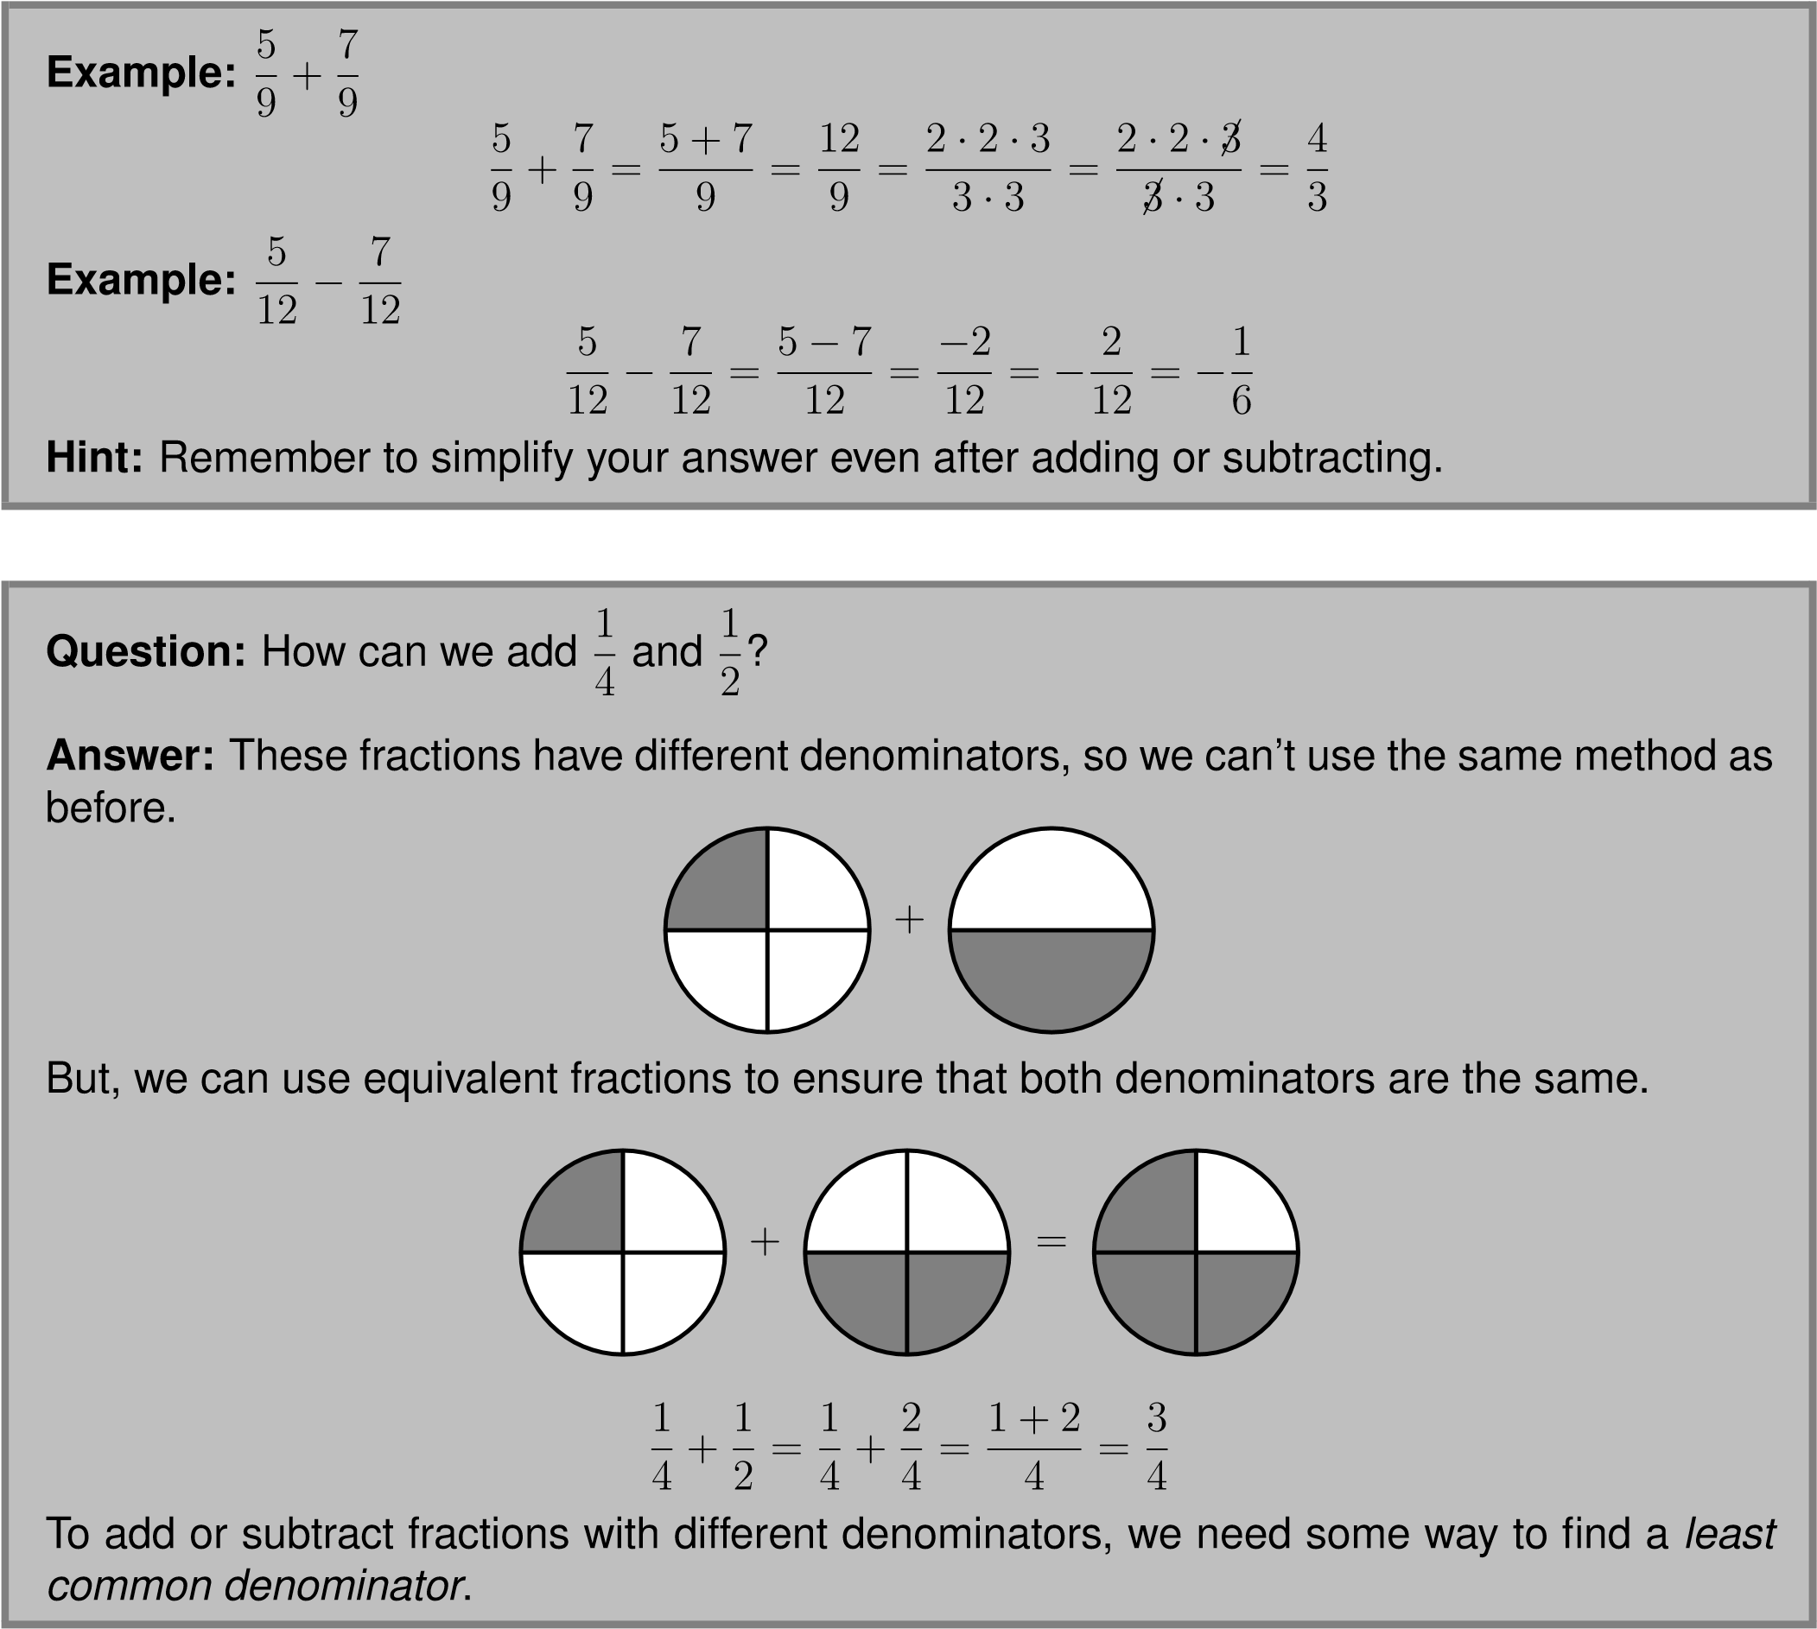

Question: What is the least common multiple of 12 and 8?
Answer: We can list the multiples of 12
12,24,36,...
and the multiples of 8
8,16,24,32,...
The smallest number that appears in both lists is 24, which equals 3 · 8 and 2 · 12.
We can also use the prime factorizations of 8 = 2 · 2 · 2 and 12 = 2 · 2 · 3. Start by writing the factors of 8 over the factors of 12 with equal factors over each other:
2 2 2
2 2 3
Now, carry down the factor in each column, only once if it is repeated:
2 |  | 2
2 |  | 2
2
3
↓ ↓ ↓ ↓

2 2 2 3
Finally, we multiply the numbers below the line:
2 · 2 · 2 · 3 = 24
So the least common multiple of 8 and 12 is 24.
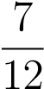
Now that we know how to find least common multiples, we can use this to add and subtract fractions with different denominators. For example, let’s say we want to addand. The least common multiple of 8 and 12 is 24, which is 3·8, or 2·12. We find an equivalent fraction towhich has a denominator 24 by multiplying both the numerator and the denominator by
3
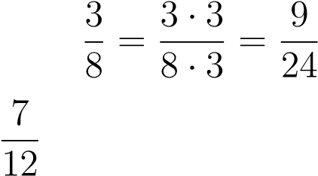
We find an equivalent fraction to by multiplying both the numerator and denominator by
2: 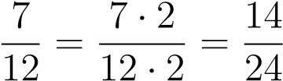
Once we have found equivalent fractions with the same denominator we can add the numerators as before. 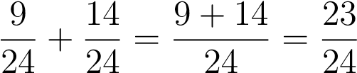
To add or subtract fractions with different denominators:
+ Step 1: Find the least common multiple of the denominators.
+ Step 2: Find the fractions that are equivalent to the starting fractions, with the denominator you found in Step 1.
+ Step 3: Add or subtract the fractions you found in Step 2.
+ Step 4: Simplify the answer.
Careful: When you find the equivalent fractions in Step 2, remember to multiply both the numerator and the denominator by the same number.
Example:
2
6
+
4
9
The least common multiple of
6
and
9
is
18
, which is
3
·
6
and
2
·
9
. We find the equivalent
fractions with the common denominator of
18
.
2
6
+
4
9
=
2
·
3
6
·
3
+
4
·
2
9
·
2
=
6
18
+
8
18
Now, we add the equivalent fractions with the same denominator.
6
18
+
8
18
=
6+8
18
=
14
18
Don’t forget to simplify your answer.
14
18
=
7
9
Example:
4
5
−
7
10
The least common multiple of
5
and
10
is
10
. Notice that
7
10
already has a denominator of
10
.
4
5
−
7
10
=
4
·
2
5
·
2
−
7
10
=
8
10
−
7
10
=
1
10
Now Give It a Try!
Simplifying Fractions
1. 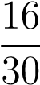
2. 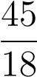
3. 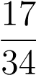
Multiplying Fractions
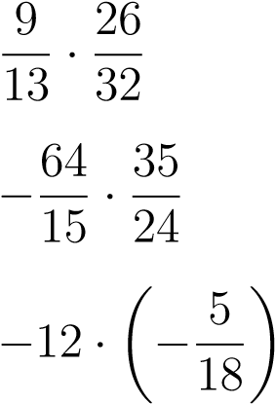
4.
5.
6.
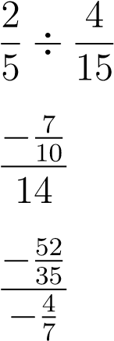
Dividing Fractions
7.
8.
9.
Adding and Subtraction Fractions
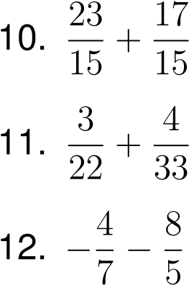
AnswerKey:
1.
8
15
2.
5
2
3.
1
2
4.
9
16
5.
−
56
9
6.
10
3
7.
3
2
8.
−
1
20
9.
13
5
10.
8
3
11.
17
66
12.
−
76
35

