First Order Differential Equations

Seperable Equations A differential equation is called seperable if it is of the form
g(y)y⁰ = f(x)
An equation is seperable if we can isolate all y terms on one side of the equation and all x terms on the other side. Equations of this type can be solved by integrating each side of the equation with respect to the appropriate variable.
Examples

- y⁰ = yx
This equation is seperable, as can be seen after dividing by y. This gives 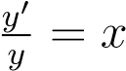. Integrating both sides gives lny = x + C =⇒ y = e^{x+C} = Ce^{x}. When we divided by y, we tacitly assumed that y 6= 0. We must therefore check if y = 0 solves the differential equation. The soltuions are then y = 0 and y = Ce^{x}.
- 2xy² − x⁴y⁰ = 0
We can rearrange this equation to give 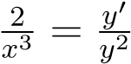. This is seperable, and the solution is revealed by integrating. 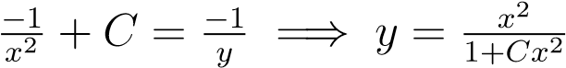.
First Order Linear Equations These differential equations take the general form
y⁰ + p(x)y = q(x)
where p(x) and q(x) are functions of x only. The following are examples of linear equations.
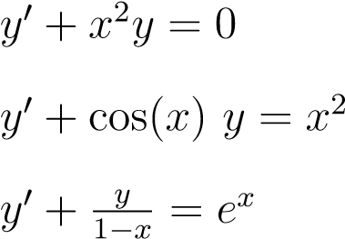
1.
2.
3.
The following equations would not qualify as linear.
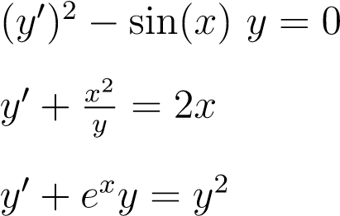
1.
2.
3.
To solve these equations, we use the integrating factor µ = e^{R p(x) dx}. With this integrating factor, the solution can then be written as 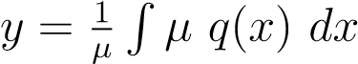.
Examples

1. 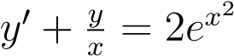
In this case,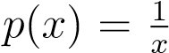 and 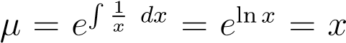. Using our above equation for y gives the solution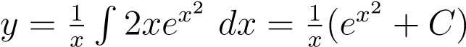
2. y⁰ + y cosx = cosx
In this case, p(x) = cosx and µ = e^{R cosx dx} = e^{sinx}. Again, applying the solution equation gives
Exact Equations An equation of the form
M dx + N dy = 0
with M and N functions of x and y, is said to be exact if ^{∂M}_{∂y} = ^{∂N}_{∂x} .
To solve an exact equation, we follow these steps:
- Our solution will be F(x,y) = Ψ(y) + ^{R} M dx = C, where Ψ(y) is a function entirely of y to be found later.
- Calculate the integral ^{R} M dx.
- Take the derivative of F(x,y) with respect to y. Set this equal to N and solve for Ψ⁰(y).
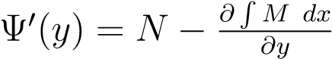.
- Find Ψ(y) by integrating Ψ⁰(y) with respect to y. Ψ(y) = ^{R} Ψ⁰(y) dy.
- Plug Ψ(y) into F(x,y) to obtain the solution.
Examples

- 2xy dx + (x² + 2y) dy = 0
Here M = 2xy and N = x² + 2y. We see the equation is exact since ^{∂M}_{∂y} = 2x = ^{∂N}_{∂x} .
F(x,y) = ^{R} 2xy dx + Ψ(y) = x²y + Ψ(y). Now we solve for Ψ(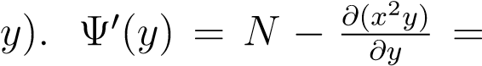
(x² + 2y) − x² =⇒ Ψ⁰(y) = 2y. Integrating we see that Ψ(y) = y². Our solution is then x²y + y² = c.
- (2xy − 9x²) dx + (2y + x² + 1) dy = 0
Here M = 2xy − 9x² and N = 2y + x² + 1. We see the equation is exact since ^{∂M}_{∂y} =
). Next, solve for Ψ(y).
+1. Integrate this to see that Ψ(y) = y² +y.
The solution is then F(x,y) = x²y − 3x³ + y² + y = C.
Making Equations Exact Ocassionally, one will encounter an equation of the form
M dx + N dy = 0
that does not meet the criterion for exactness. In certain situations, we can find an appropriate
integrating factor which will transform this into an exact equation.
Case 1 Integrating factors of x only: If the quantity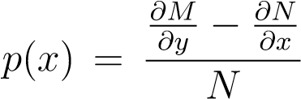 is a function with no occurances of y, then µ = e^{R p(x) dx} is an integrating factor for the differential equation.
Case 2 Integrating factors of y only: If the quantity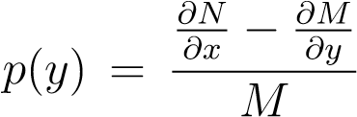 is a function with no occurances of x, then µ = e^{R p(y) dy} is an integrating factor for the differential equation.
When the integrating factor µ exists, one may multiply the differential equation by µ to created an exact equation.
Examples

1. (y²(x² + 1) + xy) dx + (2xy + 1) dy = 0
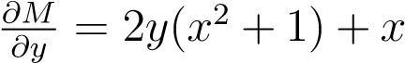, and 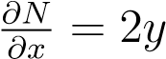. As we can see, this equation is not exact. We will search
for an integrating factor. 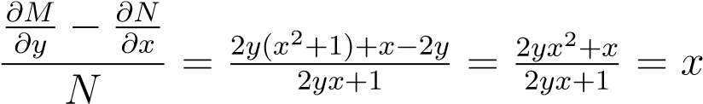. This a function entirely of x so that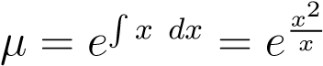 will be an integrating factor.
2 2 2 2
Multiply the initial equation by µ to give (
Now 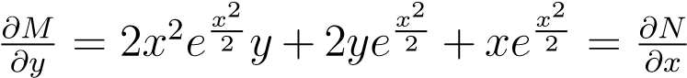 so that the equation is now exact and can be solved via the methods previously discussed.
2.
The equation is not exact since 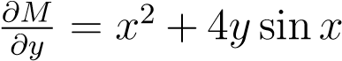, and 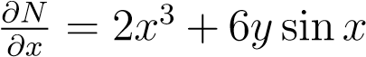. Now attempt to
find an integrating factor. .
This is a function entirely of y so the equation has an integrating factor of the form e^{R y1 dy} = elny = y.
Multiply the initial equation by y to give (
Now ^{∂M}_{∂y} = 2x²y+6y² sinx = ^{∂N}_{∂x} . As we can see, this equation is now exact and can be solved accordingly.

