Tutoring Appointment Text Message Alerts
How to Activate Text Message Alerts From TutorTrac
You now have the option to receive SMS Text Message Alerts from TutorTrac for your tutoring appointments. Please follow directions below to learn how to activate Text Alerts. Please note that standard text messaging rates apply.
Sign into TutorTrac by going to www.bucks.edu/tutor. From the “Schedule Appointment” link, click on “Enter TutorTrac”.
Once you have signed into TutorTrac, you will see the screen below:
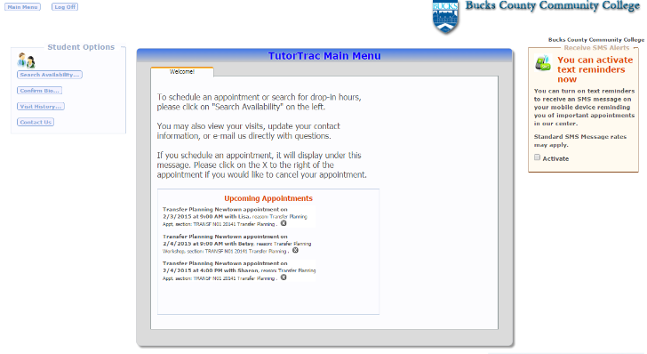
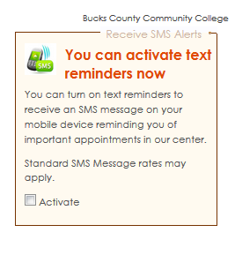
In the box located on the right-hand side of the screen, click on the “Activate” checkbox to begin the set-up process.

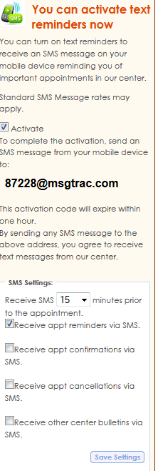
To complete the setup process, you must send a text message from your mobile device to the email address provided with the unique code. The content of the text message has no effect on the setup and activation process.
You have the choice of how far in advance you’d like to receive the Text Alerts, (15 minutes, 30 minutes, etc.) as well as the option to receive appointment request confirmation and/or cancellation notifications. Once you have made your selections, be sure to “Save Settings” in the bottom
right-hand corner of the window.

This box will expand, displaying a unique activation code. By sending a text message to this code, you will activate text message alerts, but before that, you may wish to create your individual settings.

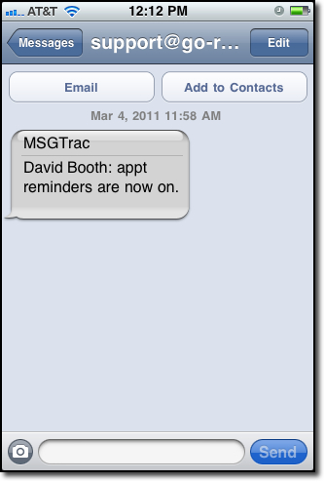
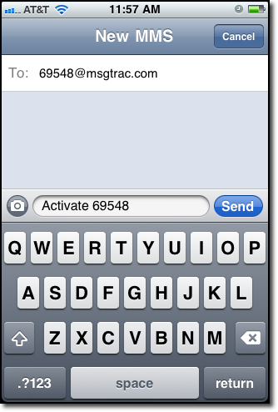
The TutorTrac application will send a confirmation message to your mobile device letting you know that your account is now set up to receive Text Alerts!

Be aware that your unique activation code will expire in one hour if unused.

If you have any questions, please call the BCCC Tutoring Center’s main number at 215-968-8044.

