How to start your Learning Module in ALEKS
1. Go to “aleks.com” and login with your assigned name and password (you were assigned a login name when you took your initial placement assessment in the Testing Center). You should have written it down on your ALEKS paper work. If you do not know your login name, you will have to contact ALEKS tech support at (714) 619-7090 or http://support.aleks.com/.
After completing the placement assessment, you will arrive on the Placement tab which displays your placement results. The Placement Pie and its slices represent core topic areas that you need to know for success in your courses. The dark part of each pie slice shows what you know; the topics you know make up your placement result. The light part of each pie slice shows what you do not know.
If you have not chosen a Learning Module/Course, you will click on “Start”.
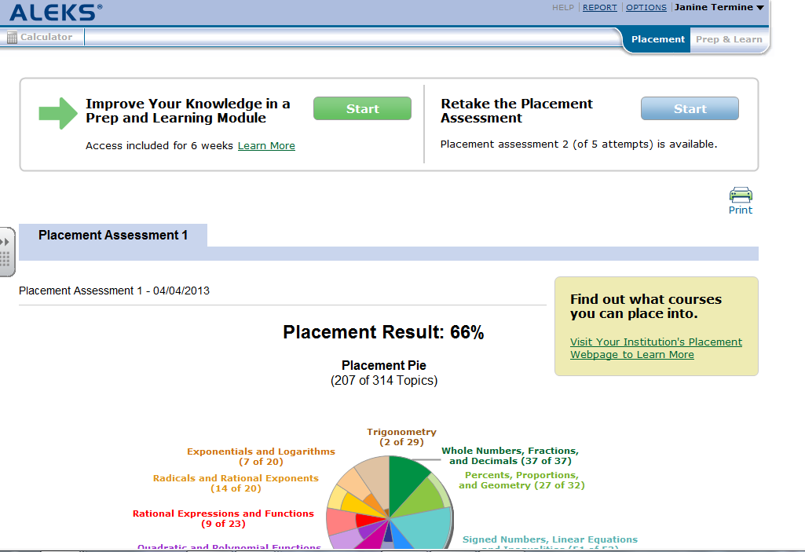

2. Now you will have to choose a Learning Module/Course. You cannot choose a course more than one course lower than your placement. For example, Prep for Calculus is the recommendation, then you will not be able to choose a Learning Module lower than PreCalculus.
You should choose the Learning Module that ALEKS recommends, however, you can choose a higher level Learning Module if you would like to. Be careful, once you have chosen a Learning Module, you will not be able to switch to a different Learning Module. Then click “Continue”.
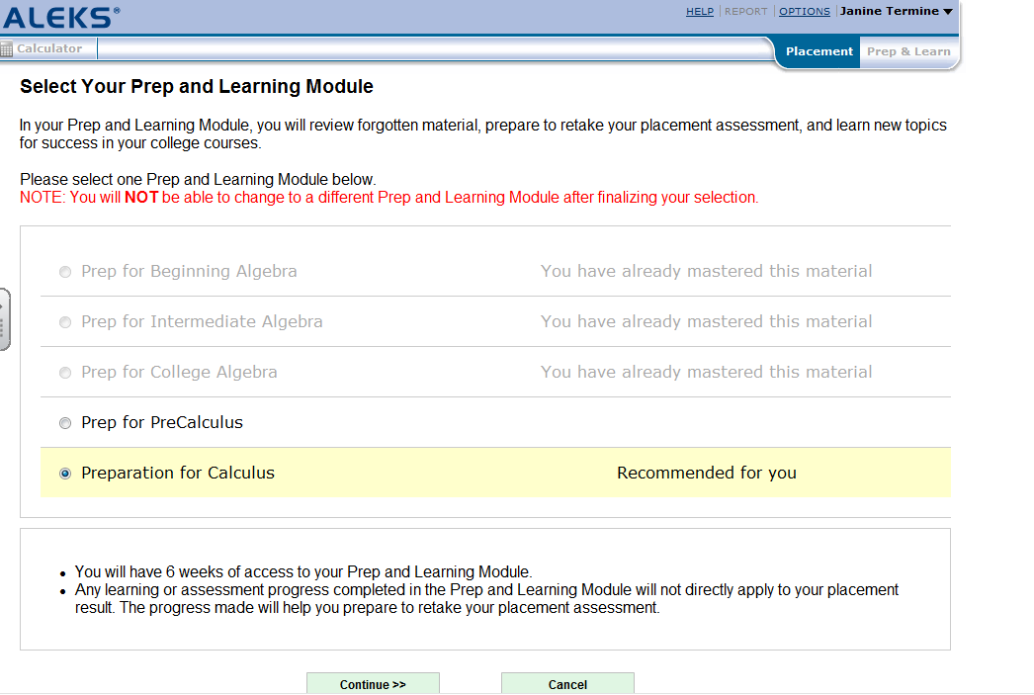
3. Last chance to change your mind for the Learning Module…Click “Yes, Start Now”.
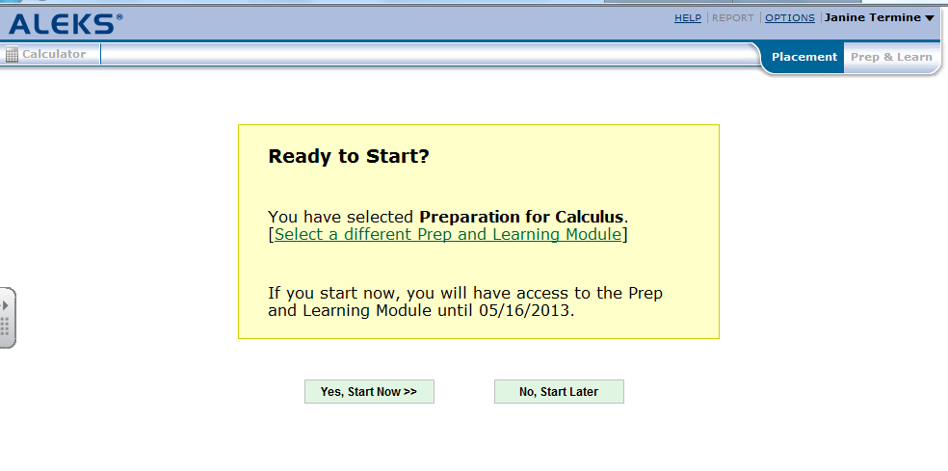

4. Please read the information ALEKS gives you on this screen and then click “Continue”.
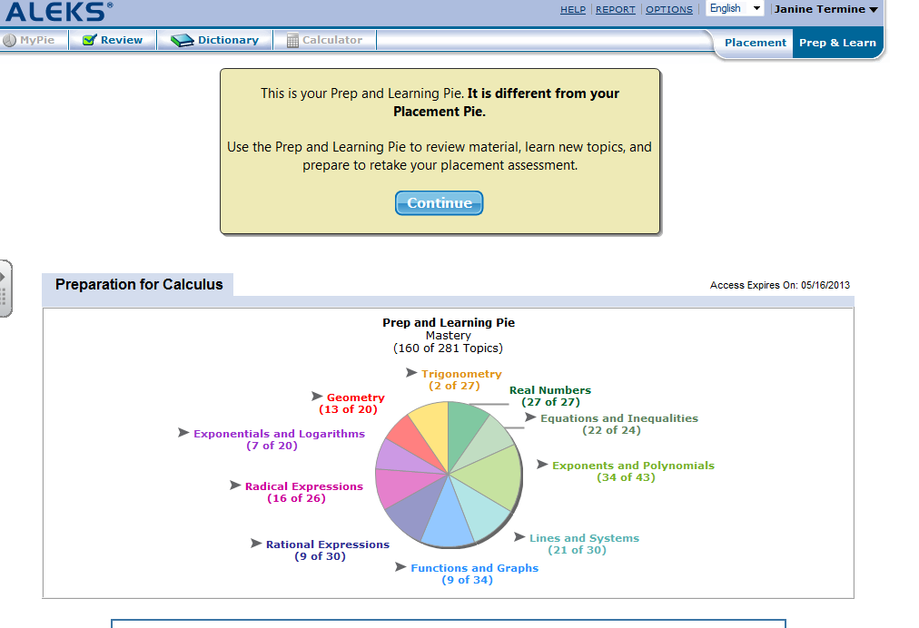
5. Your goal is to learn the topics you need to be successful in this course. If you place your mouse on one of the pie slices, topics you need to learn will appear. You can choose any of the links that appear.
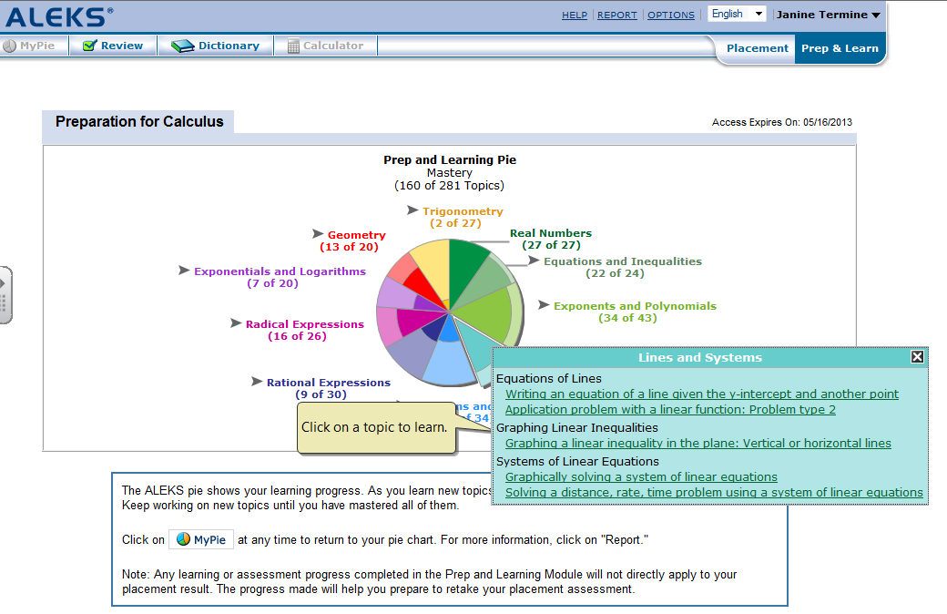

6. Once you choose a topic, your Learning Module begins.
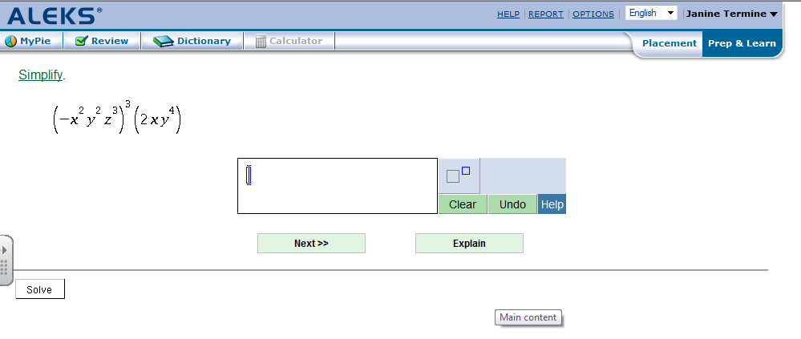
If you do not know how to do the given question, click “Explain” for help from ALEKS. You must get three question correct in a row before ALEKS will give you credit for “mastering” the topic.
If you would like to go back to your pie to choose another topic to learn, click on “My Pie” at the top of the page to return to your pie.
7. Once you are ready to retake the placement assessment, click on “Placement” at the top right of your
screen.
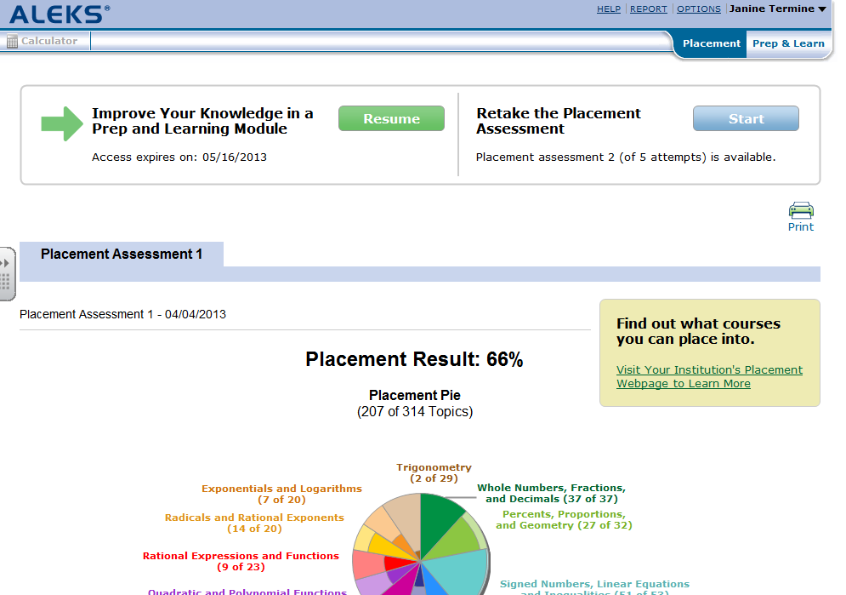
Then click on “Start” when you are ready. You will not be able to retake a placement assessment for 48 hours from your initial placement assessment. You also must work “at least” 5 hours in your Learning Module before retaking a placement assessment.
Best of luck!!!

If you need technical assistance, please contact ALEKS at…
Hours (Eastern Time):
Sunday, 4:00 PM to 1:00 AM
Monday-Thursday, 7:00 AM to 1:00 AM
Friday, 7:00 AM to 9:00 PM
Phone: (714) 619-7090
Fax: (714) 245-7190
Email: contact at http://support.aleks.com

If you have questions on which math class you should take, please refer to the chart in the document “Do you want to skip a math class” and/or make an appointment with an advisor.
Just remember, you have the opportunity to change your placement score by working in ALEKS and retaking the placement test. You do not have to return to Bucks to retake the test, however, you do want to be honest. If someone else takes the test for you, you will be placed in the wrong class, possibly setting you up for failure.

