BUCKS COUNTY COMMUNITY COLLEGE
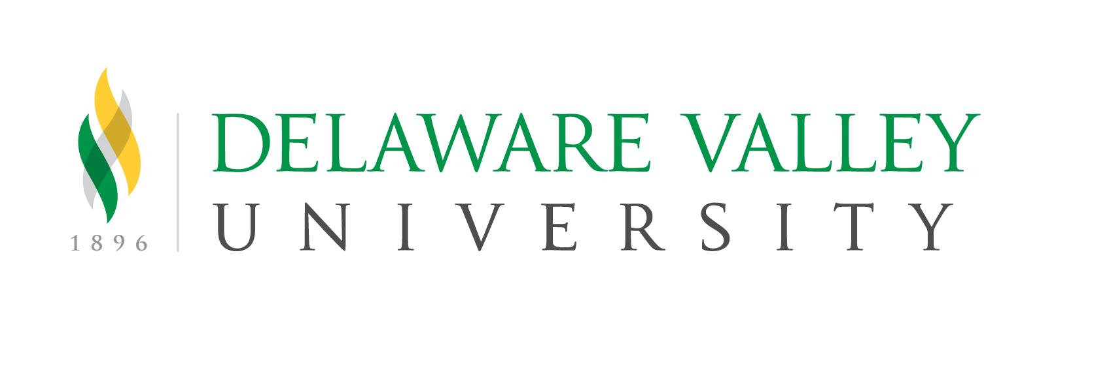
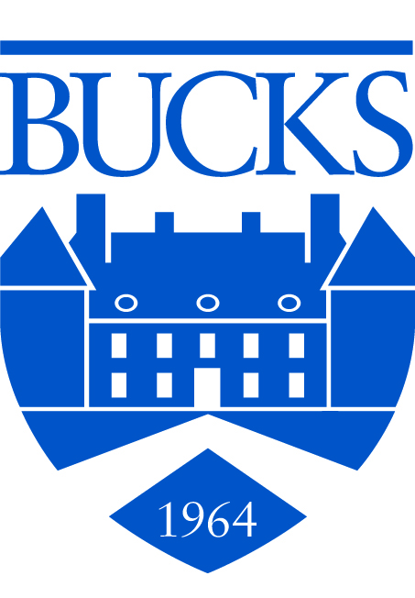
And
DELAWARE VALLEY UNIVERSITY

Guaranteed Transfer Admissions Intent Form
To be submitted to Bucks before completing 30 transferable credits

The Guaranteed Transfer Admissions Agreement between Bucks County Community College and Delaware Valley University is designed to allow students who complete their Associate of Arts (A.A.) or Associate of Science (A.S.) degrees at Bucks in the following programs to transfer into a Bachelor’s degree program at Delaware Valley University as listed in the Guaranteed Transfer Admissions Agreement.

Biology (1003) | Hospitality & Tourism Management (2022)
Business Administration (1009) | Liberal Arts General Emphasis (1002)
Chemistry (1004)  Cinema Video Production (1181)  Communication Studies (1120) | Liberal Arts: Psychology Pre-Professional (1060)  Multimedia (1175)  Secondary Education – Biology (1169)
Criminal Justice (1189) | Secondary Education – Chemistry (1170)
Environmental Science (1188) | Sport Management (1154))
Food Service Management (2101)

By satisfying the conditions of this agreement (as outlined in the Guaranteed Transfer Admissions Agreement), the student will have the following advantages:
- Delaware Valley University’s Application Fee will be waived.
- Bucks students will have the opportunity to meet with a Delaware Valley University representative for assistance with transferring to Delaware Valley University (prior to graduating from Bucks).
- Bucks students who have a 2.50 GPA or higher will receive an academic scholarship provided they enroll for 12 or more credits per semester at DVU. The higher the GPA, the higher the amount of the scholarship offered to the student. See the scholarship information on DVU’s website (https://delval.edu/admission-aid/undergraduate/transfer ) for a listing of the various awards.

Please provide the following information and return this form to: Transfer Services, Bucks County Community College, 275 Swamp Road, Newtown, PA 18940

Name _________________________________________________ Bucks Student ID______________________

Address ______________________________________ City___________________ State_____Zip__________

Home Phone __________________________________ Cell Phone_____________________________________

E-Mail ________________________________@_____________________________

Major at Bucks ______________________ Intended Major at Delaware Valley University _____________________

Intended Semester and Year of Enrollment at Delaware Valley University (Fall or Spring) ________________________

I will be attending full time (12+ credits per semester) :________ I will be attending Part time: __________

I have read and I understand the conditions of the Guaranteed Transfer Admissions agreement and understand that my signature gives Bucks and Delaware Valley University the right to exchange information regarding my academic progress at Bucks and Delaware Valley University.

Signature __________________________________________________ Date ___________________

DVU Full Time Transfer Counselors: Thomas O’Connor at 215-489-4829, thomas.oconnor@delval.edu
DVU Part Time Transfer Counselor: Stephanie Morace Stephanie.Morace@delval.edu
Visit DelVal at www.delval.edu
Revised TO 09132021

