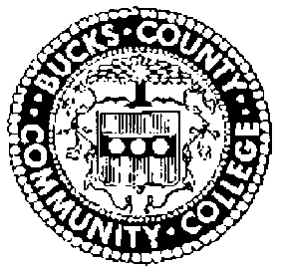
BUCKS COUNTY COMMUNITY COLLEGE
BOARD OF TRUSTEES
MEETING SCHEDULE 2022-2023

All meetings are scheduled for the second Thursday of the month at the Newtown Campus, unless noted otherwise. Executive Session Meetings are held at 9 AM and are not open to the public. The public meeting beginning at 10:15 AM is open to the public and available via live stream.
Live Meetings – available via live stream at https://www.youtube.com/user/BucksCCC
Meetings will be held on the following dates:

Thursday, September 8, 2022
Thursday, October 13, 2022
Thursday, November 10, 2022 – Upper Bucks Campus
Thursday, December 8, 2022
Thursday, January 12, 2023
Thursday, February 9, 2023
Thursday, March 9, 2023 – Epstein Campus @ Lower Bucks
Thursday, April 13, 2023
Thursday, May 11, 2023
Thursday, June 8, 2023

