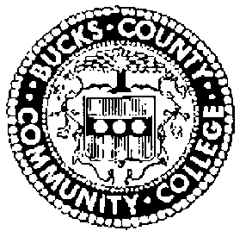
BUCKS COUNTY COMMUNITY COLLEGE
BOARD OF TRUSTEES
MEETING SCHEDULE 2021-2022

The Bucks County Community College Board of Trustees will hold regularly scheduled meetings for the remainder of the 2022 academic year and make them available to the public as follows. All meetings are held at the Newtown Campus unless otherwise noted.
All meetings are held on the second Thursday of the month. Executive Committee Meetings are held at 9 AM and are not open to the public. Committee meetings beginning at 10:15 AM and the public meeting beginning at 11:00 AM is open to the public and available via live stream.
Live Meetings – available via live stream at https://www.youtube.com/user/BucksCCC
Meetings will be held on the following dates:
Thursday, February 10
Thursday, March 10 – Epstein Campus @ Lower Bucks
Thursday, April 14
Thursday, May 12
Thursday, June 9

