Embedded Quotes
Academic writing often calls for quoted material and requires the writer to reference the ideas of others and provide support through the use of quotations from experts. An academic essay should include the student’s own ideas and discussion of the topic, supported by evidence of material written by others.
When quotes are used as support in an essay, it is best to create a smooth connection from your idea to the quoted material. The ideas should flow together and be logical. One way to do this is to embed the quote, which places the quote into the context of your own writing.
For example:
If the original text by John Doe reads:
“As Sarah walked up the stairs, she came upon John, waiting at her door with her favorite flowers and a sorrowful expression on his face.”
The quote can be embedded like this:
John exhibits his true feelings for Sarah when she finds him “waiting at her door with her favorite flowers and a sorrowful expression on his face” (Doe 75).
This quote would then be followed by more analysis of John’s feelings for Sarah.
Sandwiching Quotes
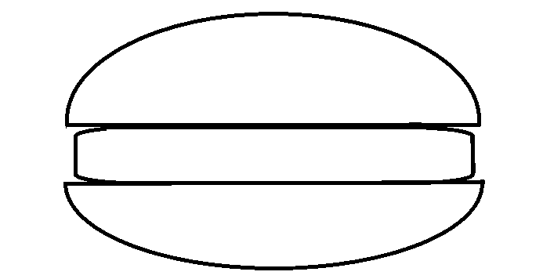
It is also a good idea to “sandwich” the quote, which means providing your own analysis and explanation of the quote before and after the quote, like two pieces of bread in a sandwich. In the following example, note how the quote is only a small part of the student’s writing. The majority of the words are the student’s own thoughts and analysis.

Although John is a character who has made many bad choices, he is revealed to
have redeeming qualities, such as his love for his wife.
John exhibits his true feelings for Sarah when she finds him “waiting at her
door with her favorite flowers and a sorrowful expression on his face” (Doe 75).
By asking for Sarah’s forgiveness this way, the author shows that John is not the
flat, dark character that he seemed to be in the beginning; rather, he is a multi- dimensional, flawed human who has made mistakes
but still has emotions.

Using Ellipsis and Brackets in Embedded Quotes
Ellipsis:
Ellipsis is the series of three dots that look like this: …
An ellipsis is used to indicate that something has been omitted from a quote. If a quote is long and includes information that is not essential to discuss, you can use an ellipsis to show that part of the quote has been removed.
For example: This original quote from the BCCC Tutoring Center website informs the reader about the different types of tutors available and tells the reader to try a few different tutors:
“Our range of tutors, including students, professionals from the community, and faculty, are here to help you, so please feel free to work with different tutors to find the right one or ones for you” (About the Tutoring Center).
If an author wants to use this quote but would only like to emphasize the part about working with different tutors, they can use an ellipsis:
The Bucks Tutoring Center offers a “range of tutors…so please feel free to work with different tutors to find the right one or ones for you” (About the Tutoring Center).
Brackets:
Brackets are the symbols that look like this: [ ]
They are occasionally used in embedded quotes when you need to change a verb tense or a few words in the quote to make the quote grammatically correct within a sentence.
For example: Here is the original quote from the BCCC Tutoring Center website:
“Our range of tutors, including students, professionals from the community, and faculty, are here to help you, so please feel free to work with different tutors to find the right one or ones for you” (About the Tutoring Center).
The author, however, would just like to quote the part about the different type of tutors, so it calls for some changes in the sentence in order to be grammatically correct within the context of the author’s paper:
The Bucks Tutoring Center has a “range of tutors, including students, professionals from the community, and faculty, [who] are here to help you” (About the Tutoring Center).
Occasionally, you may come across a source that may have a grammatical error or misspelling in the original source material. This often occurs in historical documents, such as letters or journals. When this takes place, transcribe the quote exactly as it occurs, including the error. To inform the reader that you intentionally left something incorrectly written, you will use [sic] after the error.
For example, the following quote from a handwritten Civil War era letter contains a misspelling, so [sic] is used:
Private Smith wrote home, “paper has been scarce, but I will try to rite [sic] more often.”
*When using ellipsis and/or brackets, make sure that the original author’s meaning is not lost. The quote should never be manipulated or changed in such a way that the author’s meaning is changed.*

