Some Important Notes about
SUBJECTS and VERBS

The SUBJECT of a sentence is either a NOUN or a PRONOUN.
A noun is a word used to represent a person, place, or thing by naming it: John, physics, girl, kite, and New York.

A pronoun is a word used to represent a thing (or person) without naming it: I, we, you, he, she, it, and they.

It is important to note that not all nouns are subjects. The best way to identify the subject is by asking yourself, “who is doing what?”

- Steve painted the house.
- She planted trees.
In the first example, the noun “Steve” is the subject; whereas in the second example, the pronoun “She” is the subject. Note that “house” and “trees” are both nouns but not subjects.

The VERB is used to express an action or state of being.
Many verbs consist of more than one word, depending on the time of the action, which relates to the tense of the verb.

PLEASE NOTE: Words like NOT, JUST, NEVER, ONLY, and ALWAYS are not part of the verb although they may appear within the verb.

It is important to note that some verbs require a DIRECT OBJECT to complete their meaning. For example to simply write: “Steve likes” leaves a reader to ask, “Steve likes what?” A direct object answers the question of “what” and completes the sentence.

- Steve likes trees.
- Steve painted the house.
- She has been painting the house.
- Steve is always painting the house
In the first example the verb “likes” illustrates the point relating to direct objects. Notice that in the third and fourth examples, the verb consists of more than one word. Other forms of the verb “paint” might look like this:

paint
paints
have painted
had painted
has been painting
does paint
must paint
can paint
should have painted
will be painting
could paint
are painting

The subject OR the verb of a sentence may be COMPOUND, or BOTH the subject AND the verb may be COMPOUND. This means that there may be more than one.

- Steve and Mary painted the house and planted trees.
- Steve planted trees and painted the house.
- Steve and Mary painted the house.
In the first example, both the subject and the verb are compound. Steve AND Mary are the subjects of this sentence. The verbs or actions performed by the subjects are “painted” and “planted.” “House” and “trees” are direct objects.

A PREPOSITION is a word that shows a noun’s (or pronoun’s) relationship to another word. Words such as, behind, before, of, on, in, during, beneath, among, toward, over, under and between are all prepositions.

A PREPOSITIONAL PHRASE is a group of words that begins with a preposition.
The subject of a sentence NEVER appears within a prepositional phrase.

It is often helpful to locate prepositional phrases first, in order to correctly identify the subject of a sentence.

In the following sentences, the prepositional phrases have been crossed out in order to make it easier to identify the subjects of those sentences.
- She has planted trees in the park.
(“She” is the subject and “has planted” is the verb)

- Steve painted the house and across the street, she planted trees.
(“Steve” and “she” are the subjects. “Painted” and “planted” are the verbs.)

- Steve painted the house before it got too dark.
(“Steve” is the subject and “painted” is the verb.)

Here is a list of some frequently used prepositions:
about | before | by | in | on | through
above | behind | during | inside | onto | to
across | below | except | into | out | toward
among | beneath | for | of | over | under
around | beside | from | off | past | with
at | between

Practice Exercises
- Underline the subjects in the following sentences. Remember to ask yourself WHO or WHAT the sentence is about.

- Next, circle the verbs. Refer to the previous page if you are unsure what is and is not a part of the verb. Keep in mind that the verb may be more than one word.

- Lastly, strike a line through the prepositional phrases. Remember that it is often helpful to identify the prepositional phrase first if you are having difficulty locating the subject.

- Most students took one hour to finish the exam.

- The video game was played by the entire family.

- The dishes in the sink must be washed before tomorrow.

- Without the help of a calculator, I could not balance my checkbook.

- Your first thought is often your best.

- Tuna and dolphin were trapped in the fisherman’s net.

- She wrapped the packages and tied them with ribbon.

- I rose, steadied myself, and launched into my speech.

- He pruned the hedges, mowed the lawn, weeded the vegetable garden, and watered the flower beds all in one evening.
- I did not hear about the cancellation of class until yesterday.

- The man shuffled along the sidewalk and stopped at intervals for a chat with the neighbors.
- The window fan made a clanking noise that kept them awake at night.

- They start every morning with a series of yoga exercises.

Practice Exercise Answer Key:
- Most students took one hour to finish the exam.

- The video game was played by the entire family.

- The dishes must be washed before tomorrow.

- Without the help of a calculator, I could not balance my checkbook.

- Your first thought is often your best.

- Tuna and dolphin were trapped in the fisherman’s net.

- She wrapped the packages and tied them with ribbon.

- I rose, steadied myself, and launched into my speech.

- He pruned the hedges, mowed the lawn, weeded the vegetable garden, and watered the flower beds all in one evening.

- I did not hear about the cancellation of class until yesterday.

- The man shuffled along the sidewalk and stopped at intervals for a chat with the neighbors.

- The window fan made a clanking noise that kept them awake at night.

- They start every morning with a series of yoga exercises.

Subject/Verb Agreement

While it is important to master identifying the subject and verb of a sentence, it is equally important that the subject and verb “agree.”
What this means is that if the subject of a sentence is singular the verb must be singular, and likewise, if the subject is plural, the verb must also be plural.
The boy jumps. The boys jump.
Note that these examples, while similar, indicate something very different. In the first sentence, there is only one boy. In the second sentence, there is more than one boy. Notice how the verb “jump” changes. When the subject is singular the verb ends with an “s.” When the subject is plural and ends with an “s” the verb does not.
The apple is ripe. The apples are ripe.
These sentences are similar, to the first set of examples in that the subject in the first sentence is singular (apple), while the subject in the second sentence is plural (apples). The sentences about apples are using forms of the irregular verb “be,” and similar to the first example about the boy, the verb ends with an “s” and when the subject is plural, the verb does not end with an “s.”

There are some instances when determining if a subject is singular or plural can be a little more difficult to determine; for example, when the subject seems plural because it represents a large collection. These words are called collective.
The word “group” is a good example of a collective noun. Though the word itself indicates more than one of something, it is singular in that there is only one group versus many groups.

The group of students is studying.The groups of students are studying.
This bunch of grapes is ripe. 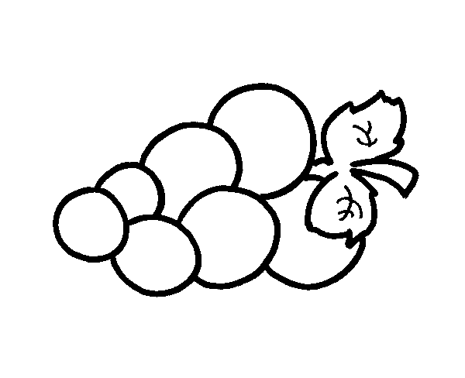These bunches of grapes are ripe.

Note that in these examples, the subjects are the collective nouns, while “students” and “grapes” are included in the prepositional phrases that modify or describe the “groups” and “bunches.”

Practice Exercises
Try to find the appropriate verb for the identified subject (in bold) in each of the following sentences.
- This car (run/ runs) smoothly.
- These flowers (has/ have) a lovely scent.
- This bouquet of flowers (is/ are) beautiful.
- The dog and cat (is/are) both named Sam.
- Steve (paint/paints) houses many different colors.
- My brothers (paint/paints) houses red.
- The administrative assistant (need/needs) a vacation.
- She (have been/ has been) sick for three days.

In the following sentences, the subject has not been identified. Underline the subject. Then, choose the appropriate verb form. Remember that the subject is never a part of a prepositional phrase.
- The group of students (is being/are being) a little too loud.
- My papers for sociology class (is/are) overdue.
- Those red grapes (have/has) seeds.
- This pile of laundry (is/are) dirty.
- The folded clothes (need/needs) to be put away.
- My copy of the book A Tree grows in Brooklyn, (is missing/are missing) pages.
- The basket of socks (has been mated/have been mated).
- I (am trying/ is trying/are trying).
Answer Key:
- The group of students (is being/are being) a little too loud.
- My papers for sociology class (is/are) overdue.
- Those red grapes (have/has) seeds.
- This pile of laundry (is/are) dirty.
- The folded clothes (need/needs) to be put away.
- My copy of the book A Tree grows in Brooklyn, (is missing/are missing) pages.
- The basket of socks (has been mated/have been mated).
- I (am trying/ is trying/are trying).

- This car (run/ runs) smoothly.
- These flowers (has/ have) a lovely scent.
- This bouquet of flowers (is/ are) beautiful.
- The dog and cat (is/are) both named Sam.
- Steve (paint/paints) houses many different colors.
- My brothers (paint/paints) houses red.
- The administrative assistant (need/needs) a vacation.
- She (have been/ has been) sick for three days.

- The group of students (is being/are being) a little too loud.
- My papers for sociology class (is/are) overdue.
- Those red grapes (have/has) seeds.
- This pile of laundry (is/are) dirty.
- The folded clothes (need/needs) to be put away.
- My copy of the book A Tree grows in Brooklyn, (is missing/are missing) pages.
- The basket of socks (has been mated/have been mated).
- I (am trying/ is trying/are trying).

