Free Body Diagrams
Free body diagrams are used to help create a visual representation of all forces and restraints being applied to an object, known as a body. With a free body diagram, factors such as direction and magnitude can be accounted for. How is a free body diagram made?
Procedure
- First, set up a coordinate system and label positive x and y values on the plane.
- Next, identify what object(s) are having forces enacted upon them. Note that the object should occupy the origin (0,0) position on the xy-plane.
- Lastly, identify all external restraints and forces acting upon the object, then label them with direction (angle) and magnitude (total force), using vectors (arrows) to signify the forces.

This can be a rough sketch! The idea is to represent the information in the word problem visually, and to label all appropriate forces.
Below are common types of forces represented in a free body diagram.
- Weight (gravitational) – will change depending upon the force of gravity, but most commonly will utilize 9.8m/s^2
- Normal force – acts perpendicular to surfaces, most often against weight
- Frictional force – typically static
- Tensile force – tension from rope/string
- Spring force

Keep the focus of the diagram so that it only reflects the forces exerted on the body. If object A is exerting a force on object B, that force should only be applied to object A’s free body diagram if it impacts object A. In other words, if the object applies an external force to another object, that external force cannot be included on the original objects’ free body diagram but would be on the second object.
Net forces should not be applied to the free body diagram – keep net forces for calculation purposes, but force components for the diagram.
Lastly, be aware that forces may have to be split into component forces, and those component forces should be present on the diagram. This is common when an object is on an inclined plane. This will involve using sin and cos as appropriate
On the back of the page, we see an example of a free body diagram, with objects A and B being pulled up an inclined plane.
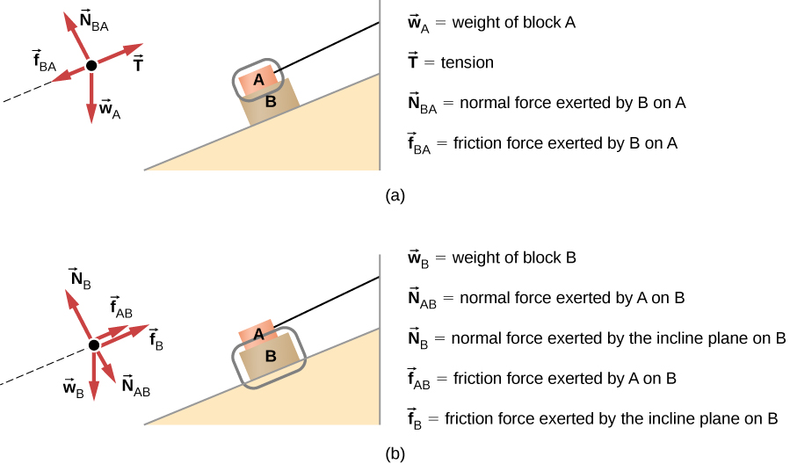
Image taken from https://pressbooks.bccampus.ca/universityphysicssandbox/chapter/drawing-free-body-diagrams/ under a CC 4.0 Attribution (https://creativecommons.org/licenses/by/4.0/)
There are two objects in this diagram, and each object needs to have its own free body diagram. Note that both A and B have a separate free body diagram created for them, and that the diagrams are labeled applying forces to Object A and Object B separately.
Understanding how forces act upon a body will help to draw the free body diagram, such as knowing that normal forces always act perpendicular to the surface, and that weight will be applied “down”.

