Graphing: Functions and Transformations
For the purposes of this handout, it is important to clearly define “Function”.
Function: A relation between two corresponding sets, Domain and Range. One being a set of all potential inputs (x-values), each one having their own unique output (y-value), respectively. If there is more than one output for a unique input, it is not a function.
*Note: A vertical line test can determine if a curve is a function. If the vertical line crosses through the graphed curve twice, it is not a function.

Parent Function Graphs
Constant | Linear | Parabola
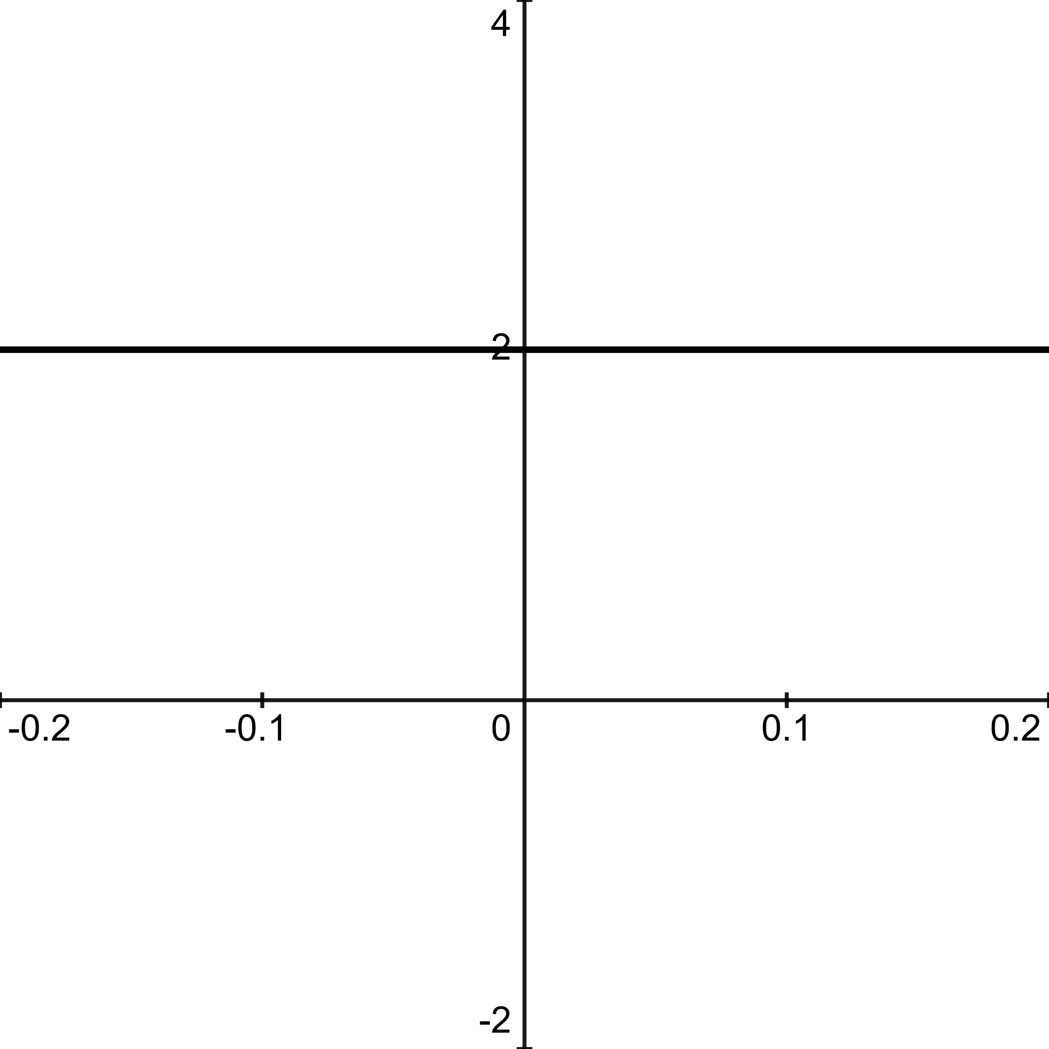 | 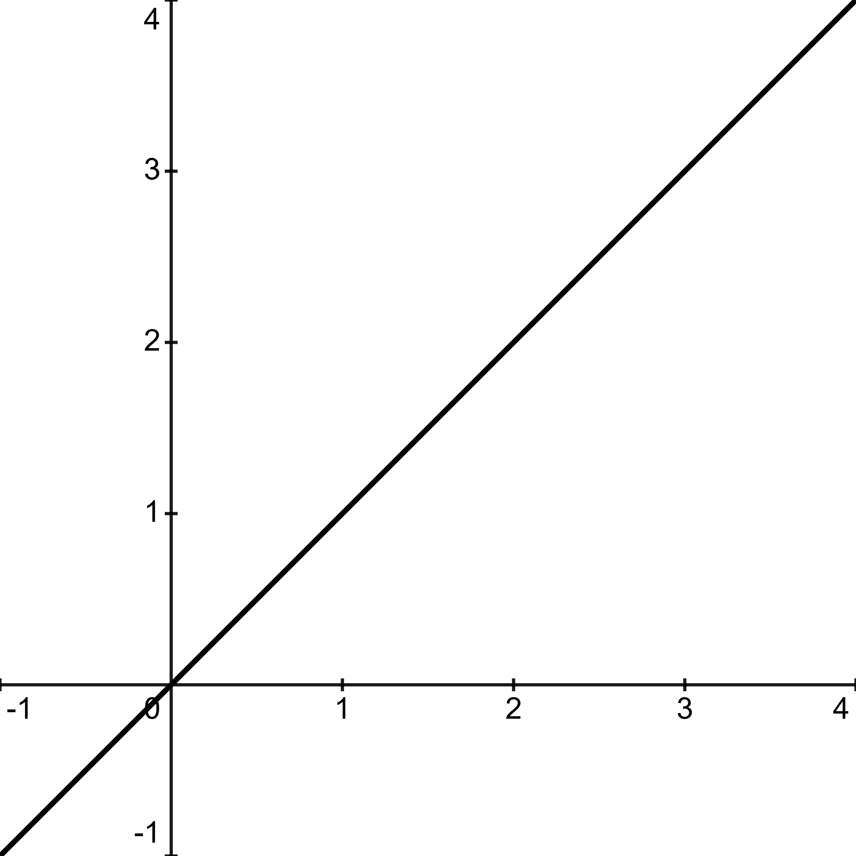 | 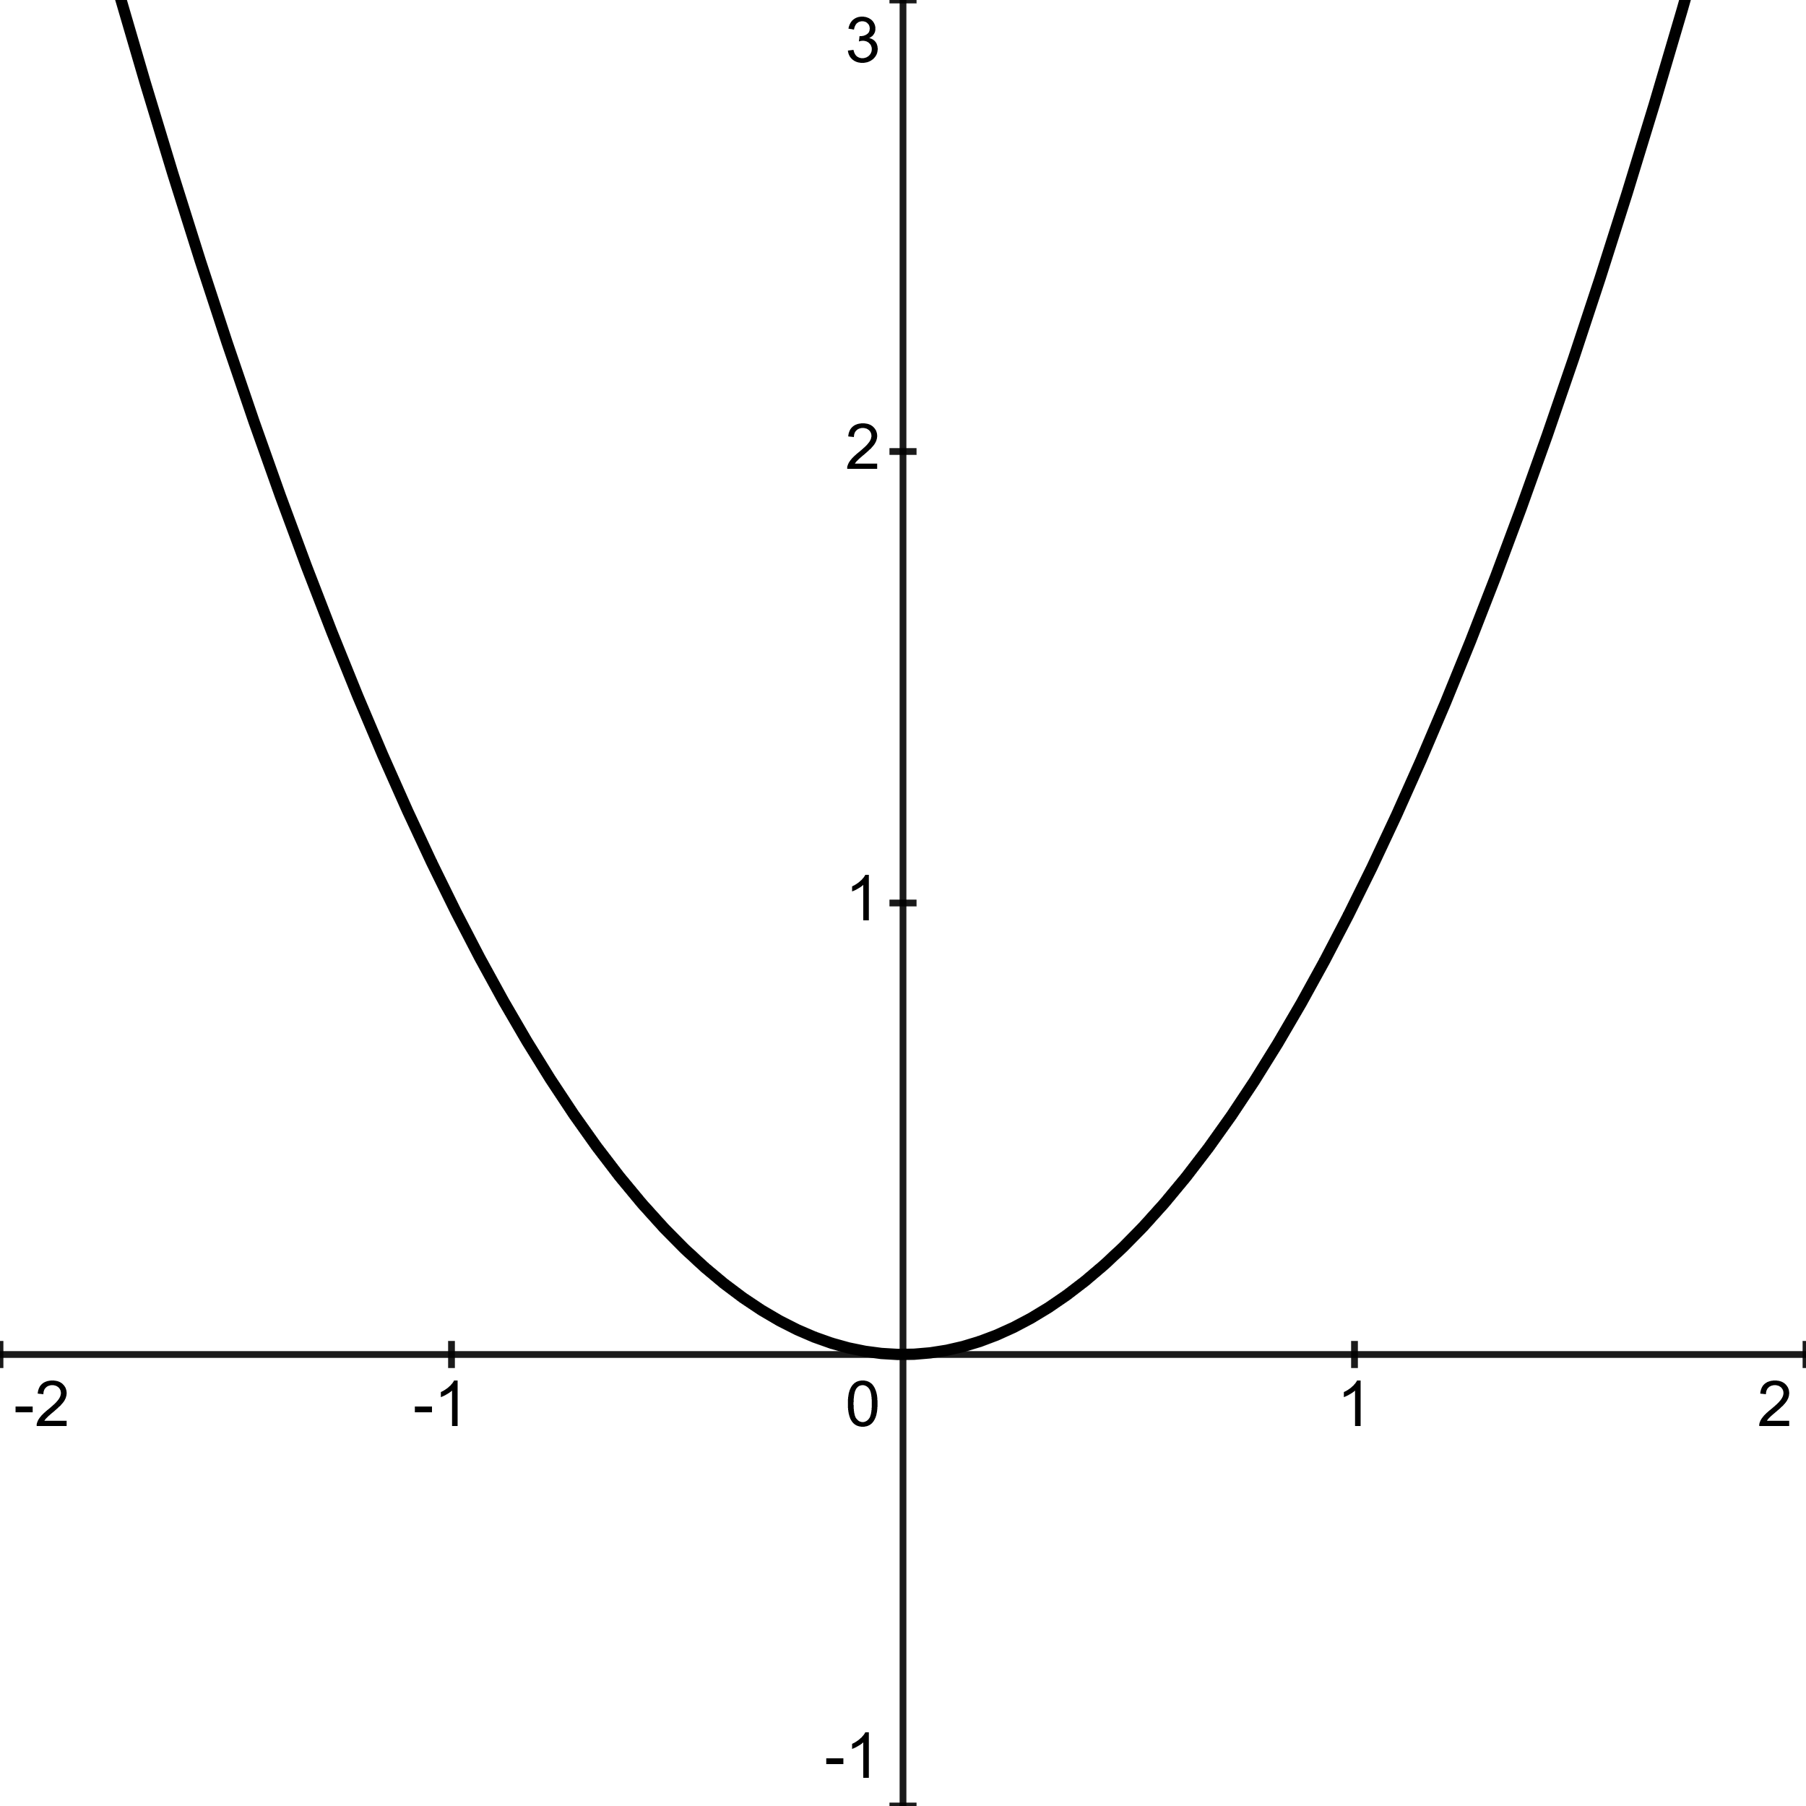
$$f\left(x\right)=c$$  Ex: $c=2$ | $$f\left(x\right)=x$$ | $$f\left(x\right)=x^{2}$$
Domain: $(-∞,∞)$  Range: y $=c$  The function progresses along the x-axis, $f\left(x\right)=2$ , for every x-value. This follows for any constant c  Constant, neither increasing or decreasing toward infinity. | Domain: $(-∞,∞)$  Range: $(-∞,∞)$  For every value of $x$ there is an identical $f(x)$ value.  Example: When $x=1$ ,  $f\left(x\right)=1$ , and so on. | Domain: $\left(-∞,∞\right)$  Range: $(0,∞)$  Decreasing when  $$-∞≤f(x)≤0$$  Increasing when  $$0≤f(x)≤∞$$
Absolute | Cubic | Square Root
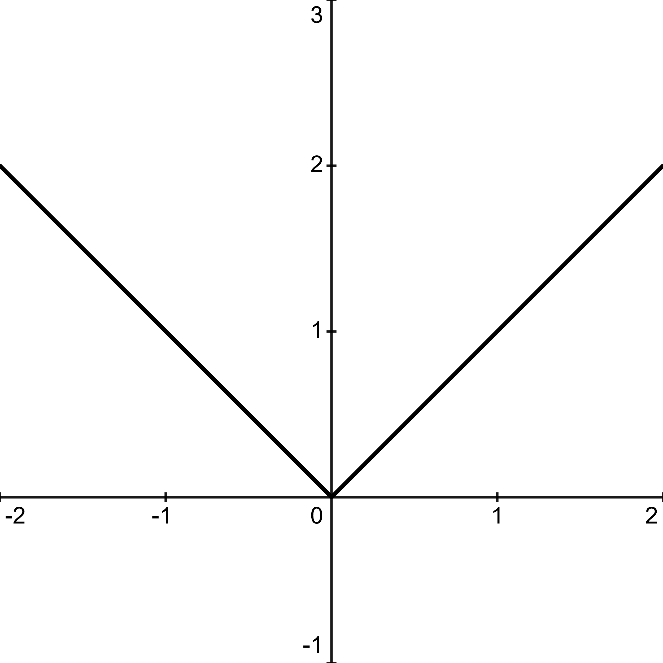 | 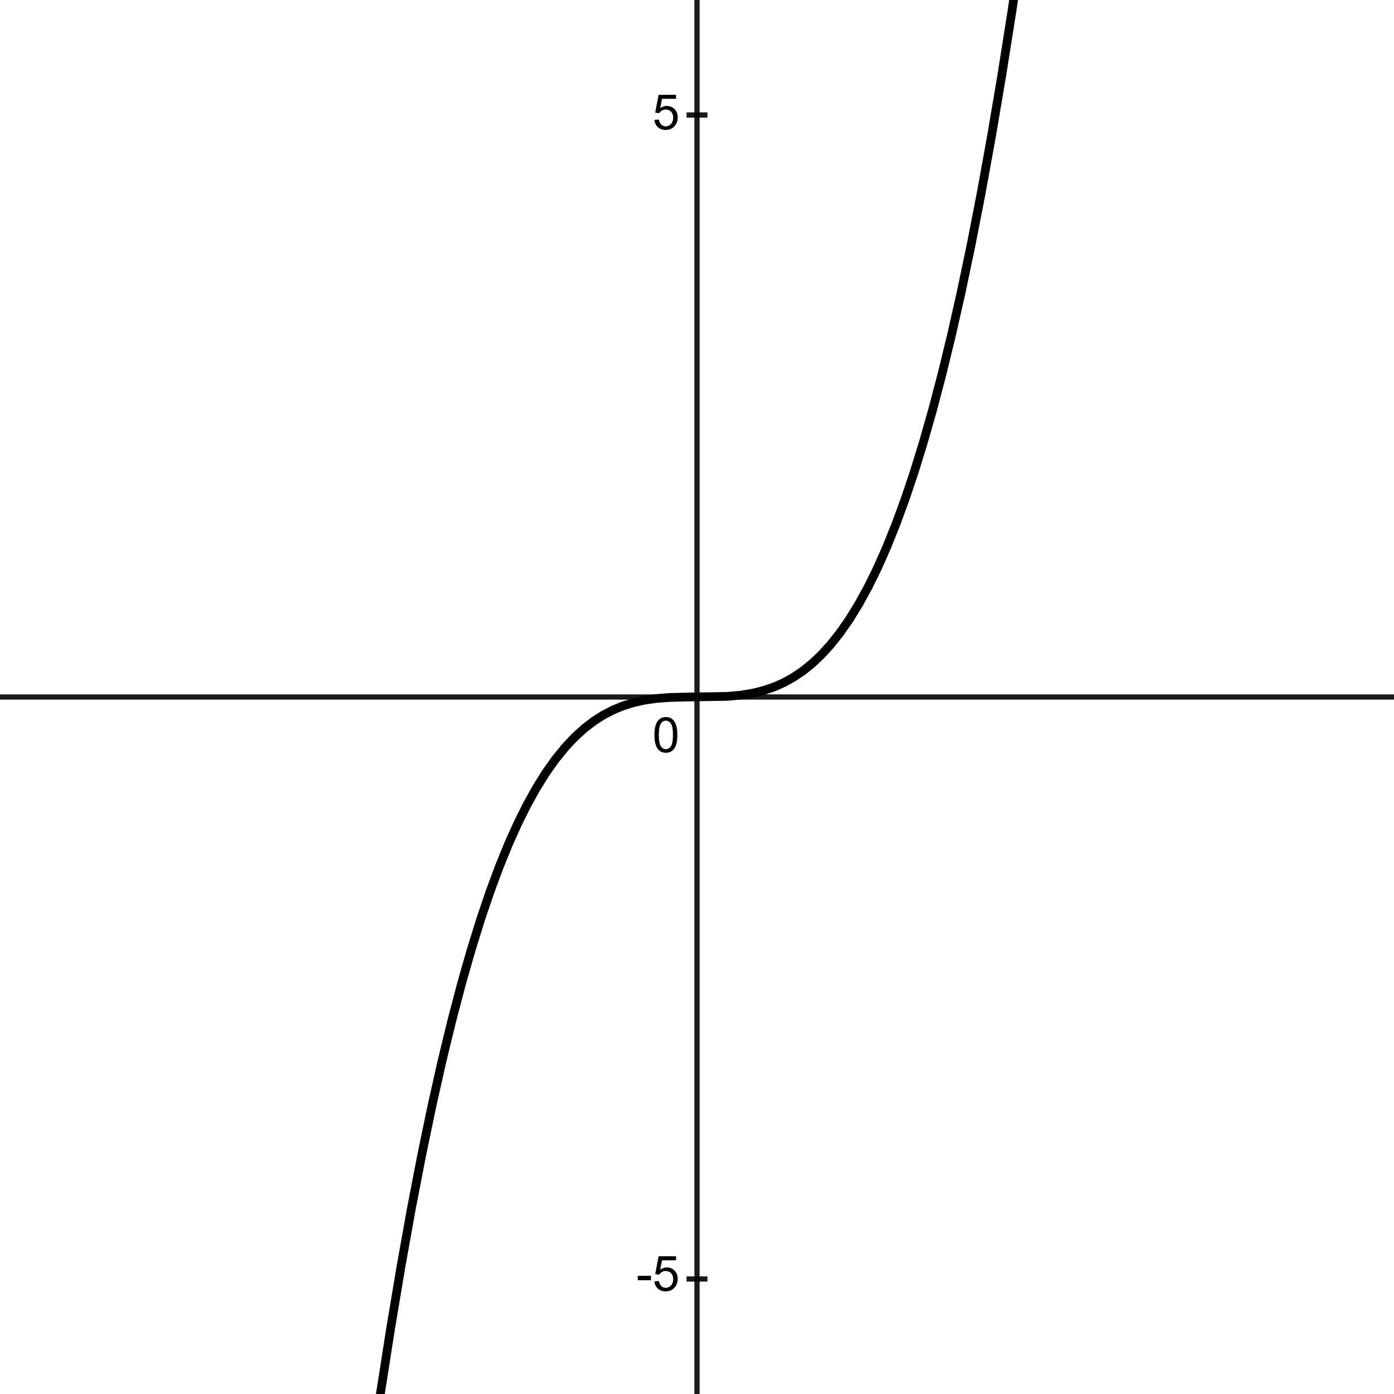 | 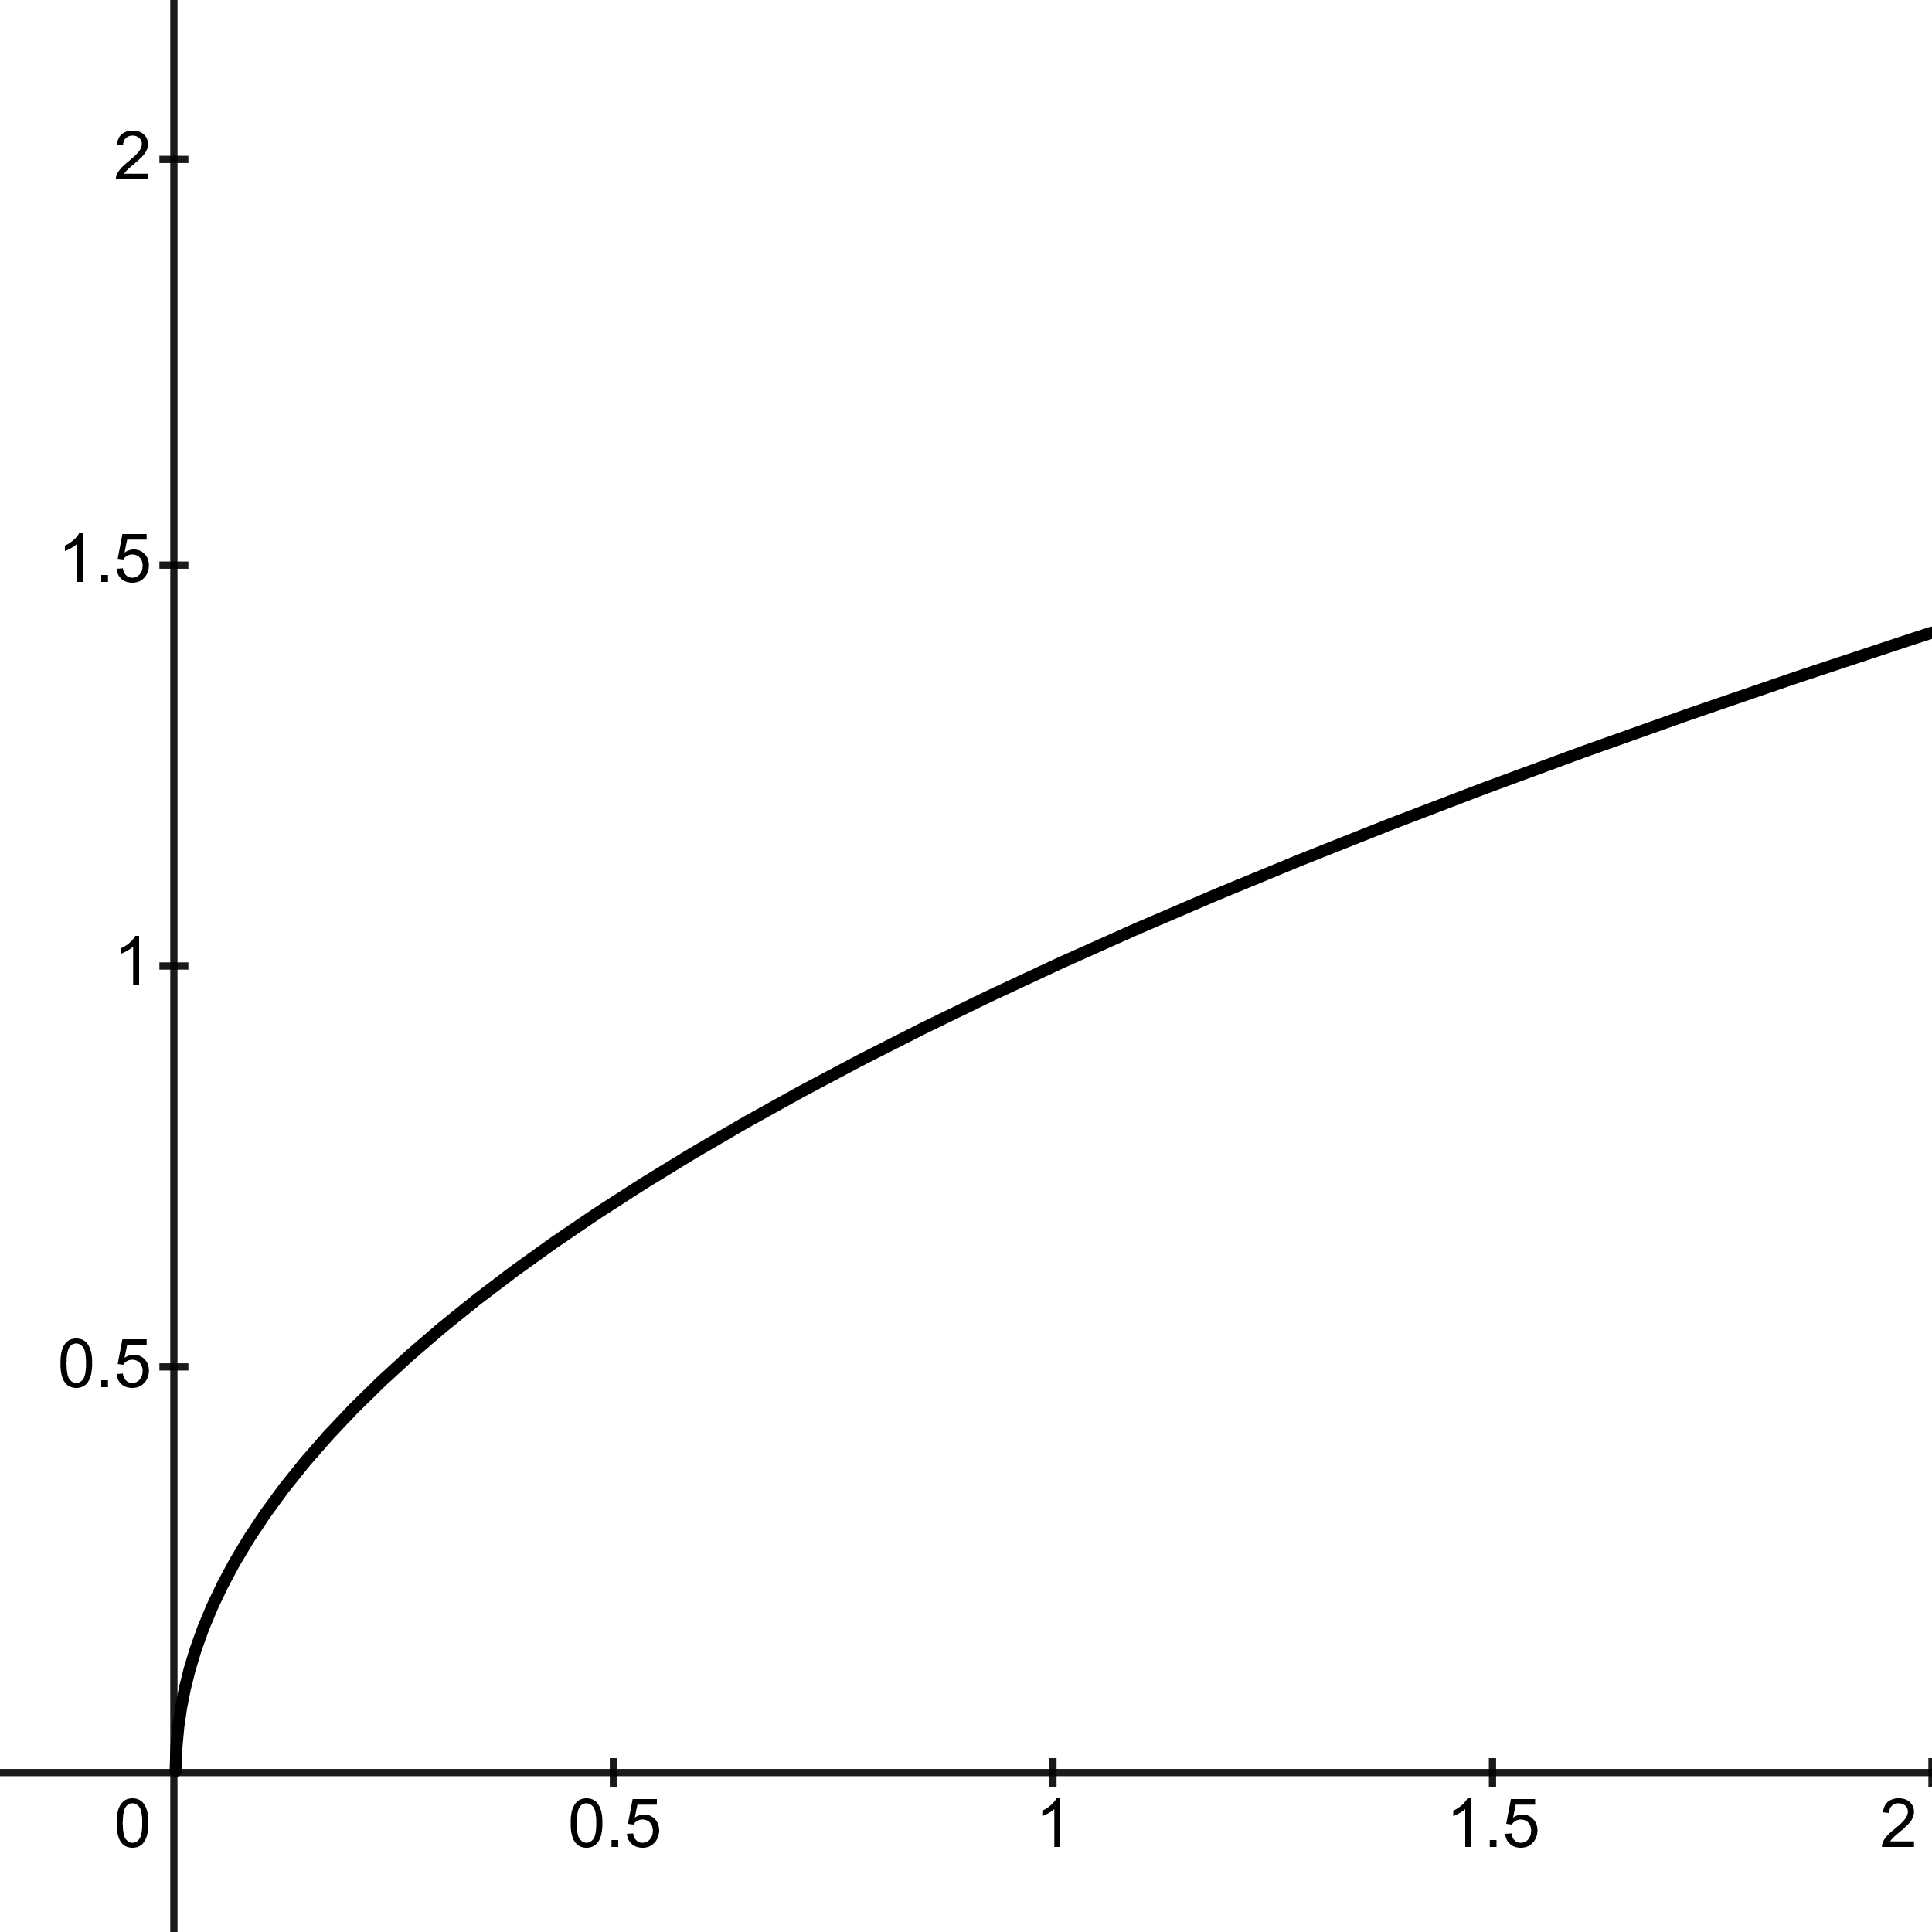
$$f\left(x\right)=\left|x\right|$$ | $$f\left(x\right)=x^{3}$$ | $$f\left(x\right)=\sqrt{x}$$
Domain: $(-∞,∞)$  Range: $(0,∞)$  Decreasing when  $$-∞≤f(x)≤0$$  Increasing when  $$0≤f(x)≤∞$$ | Domain: $(-∞,∞)$  Range: $(-∞,∞)$  Always Increasing to the right, and always decreasing to the left, from origin. | Domain: $\left[0,∞\right)$  Range: $\left[0,∞\right)$  Always Increasing from 0 to infinity.
Inverse | Exponential | Logarithmic
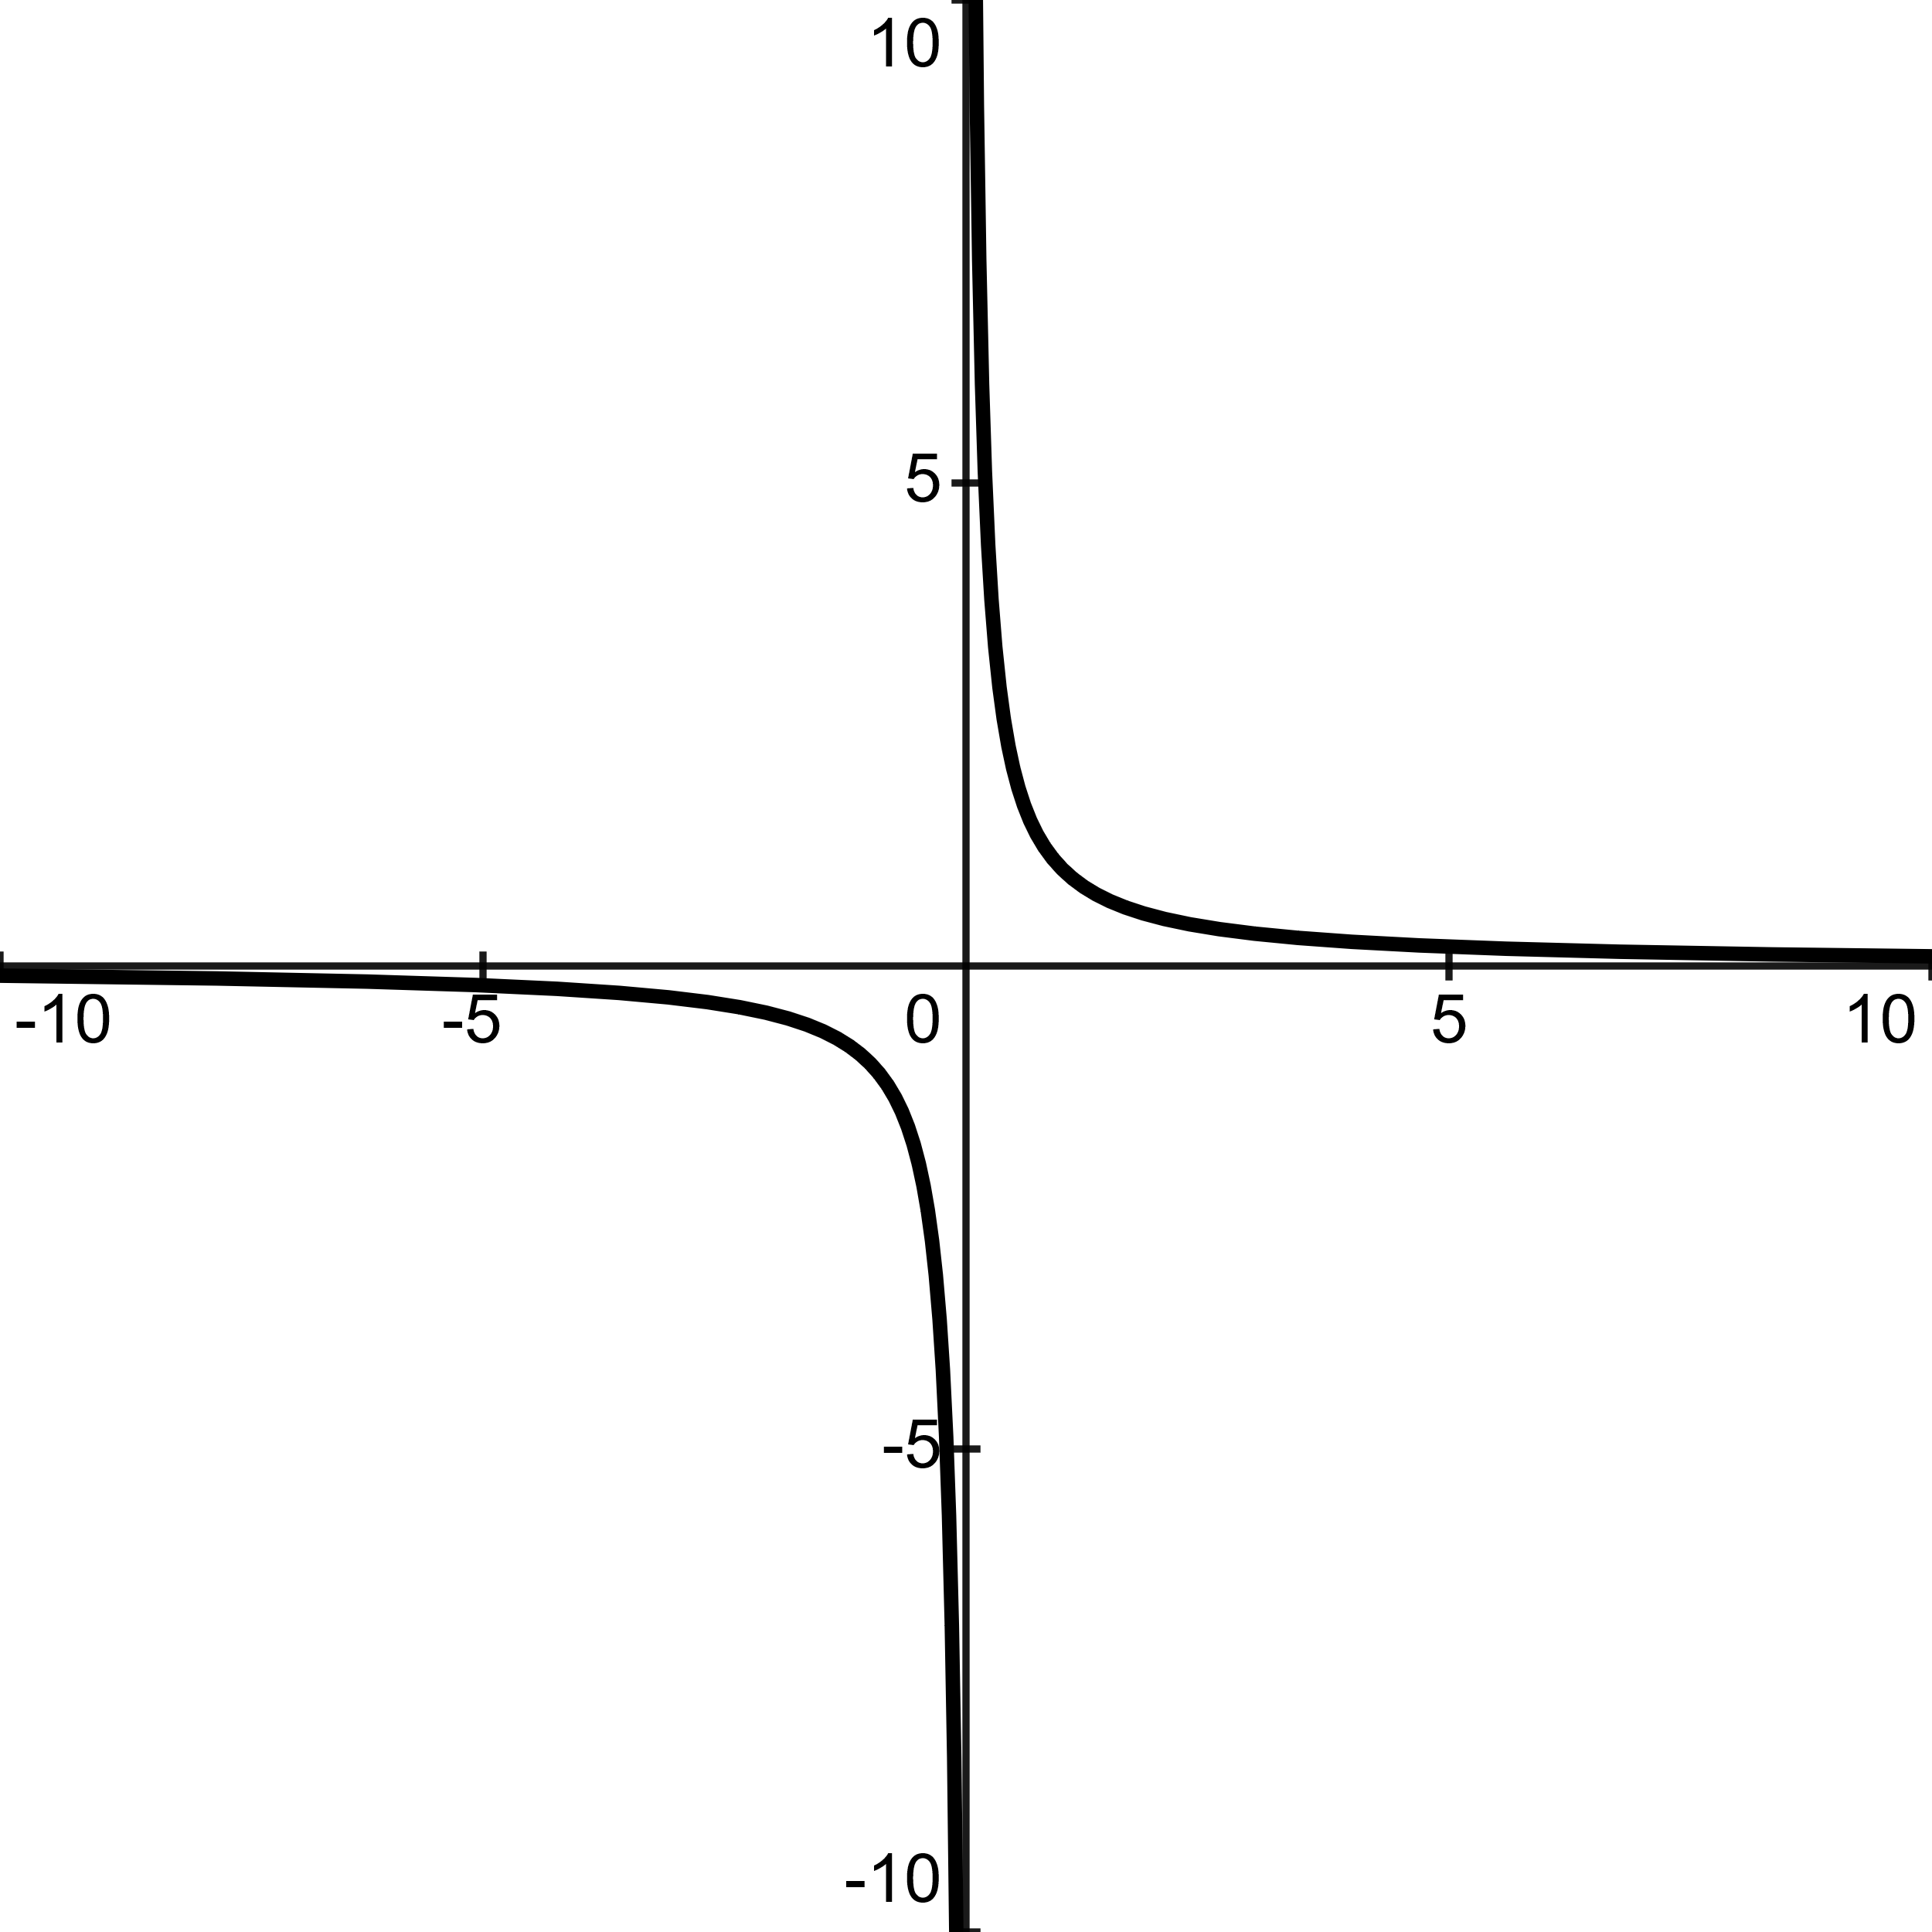 | 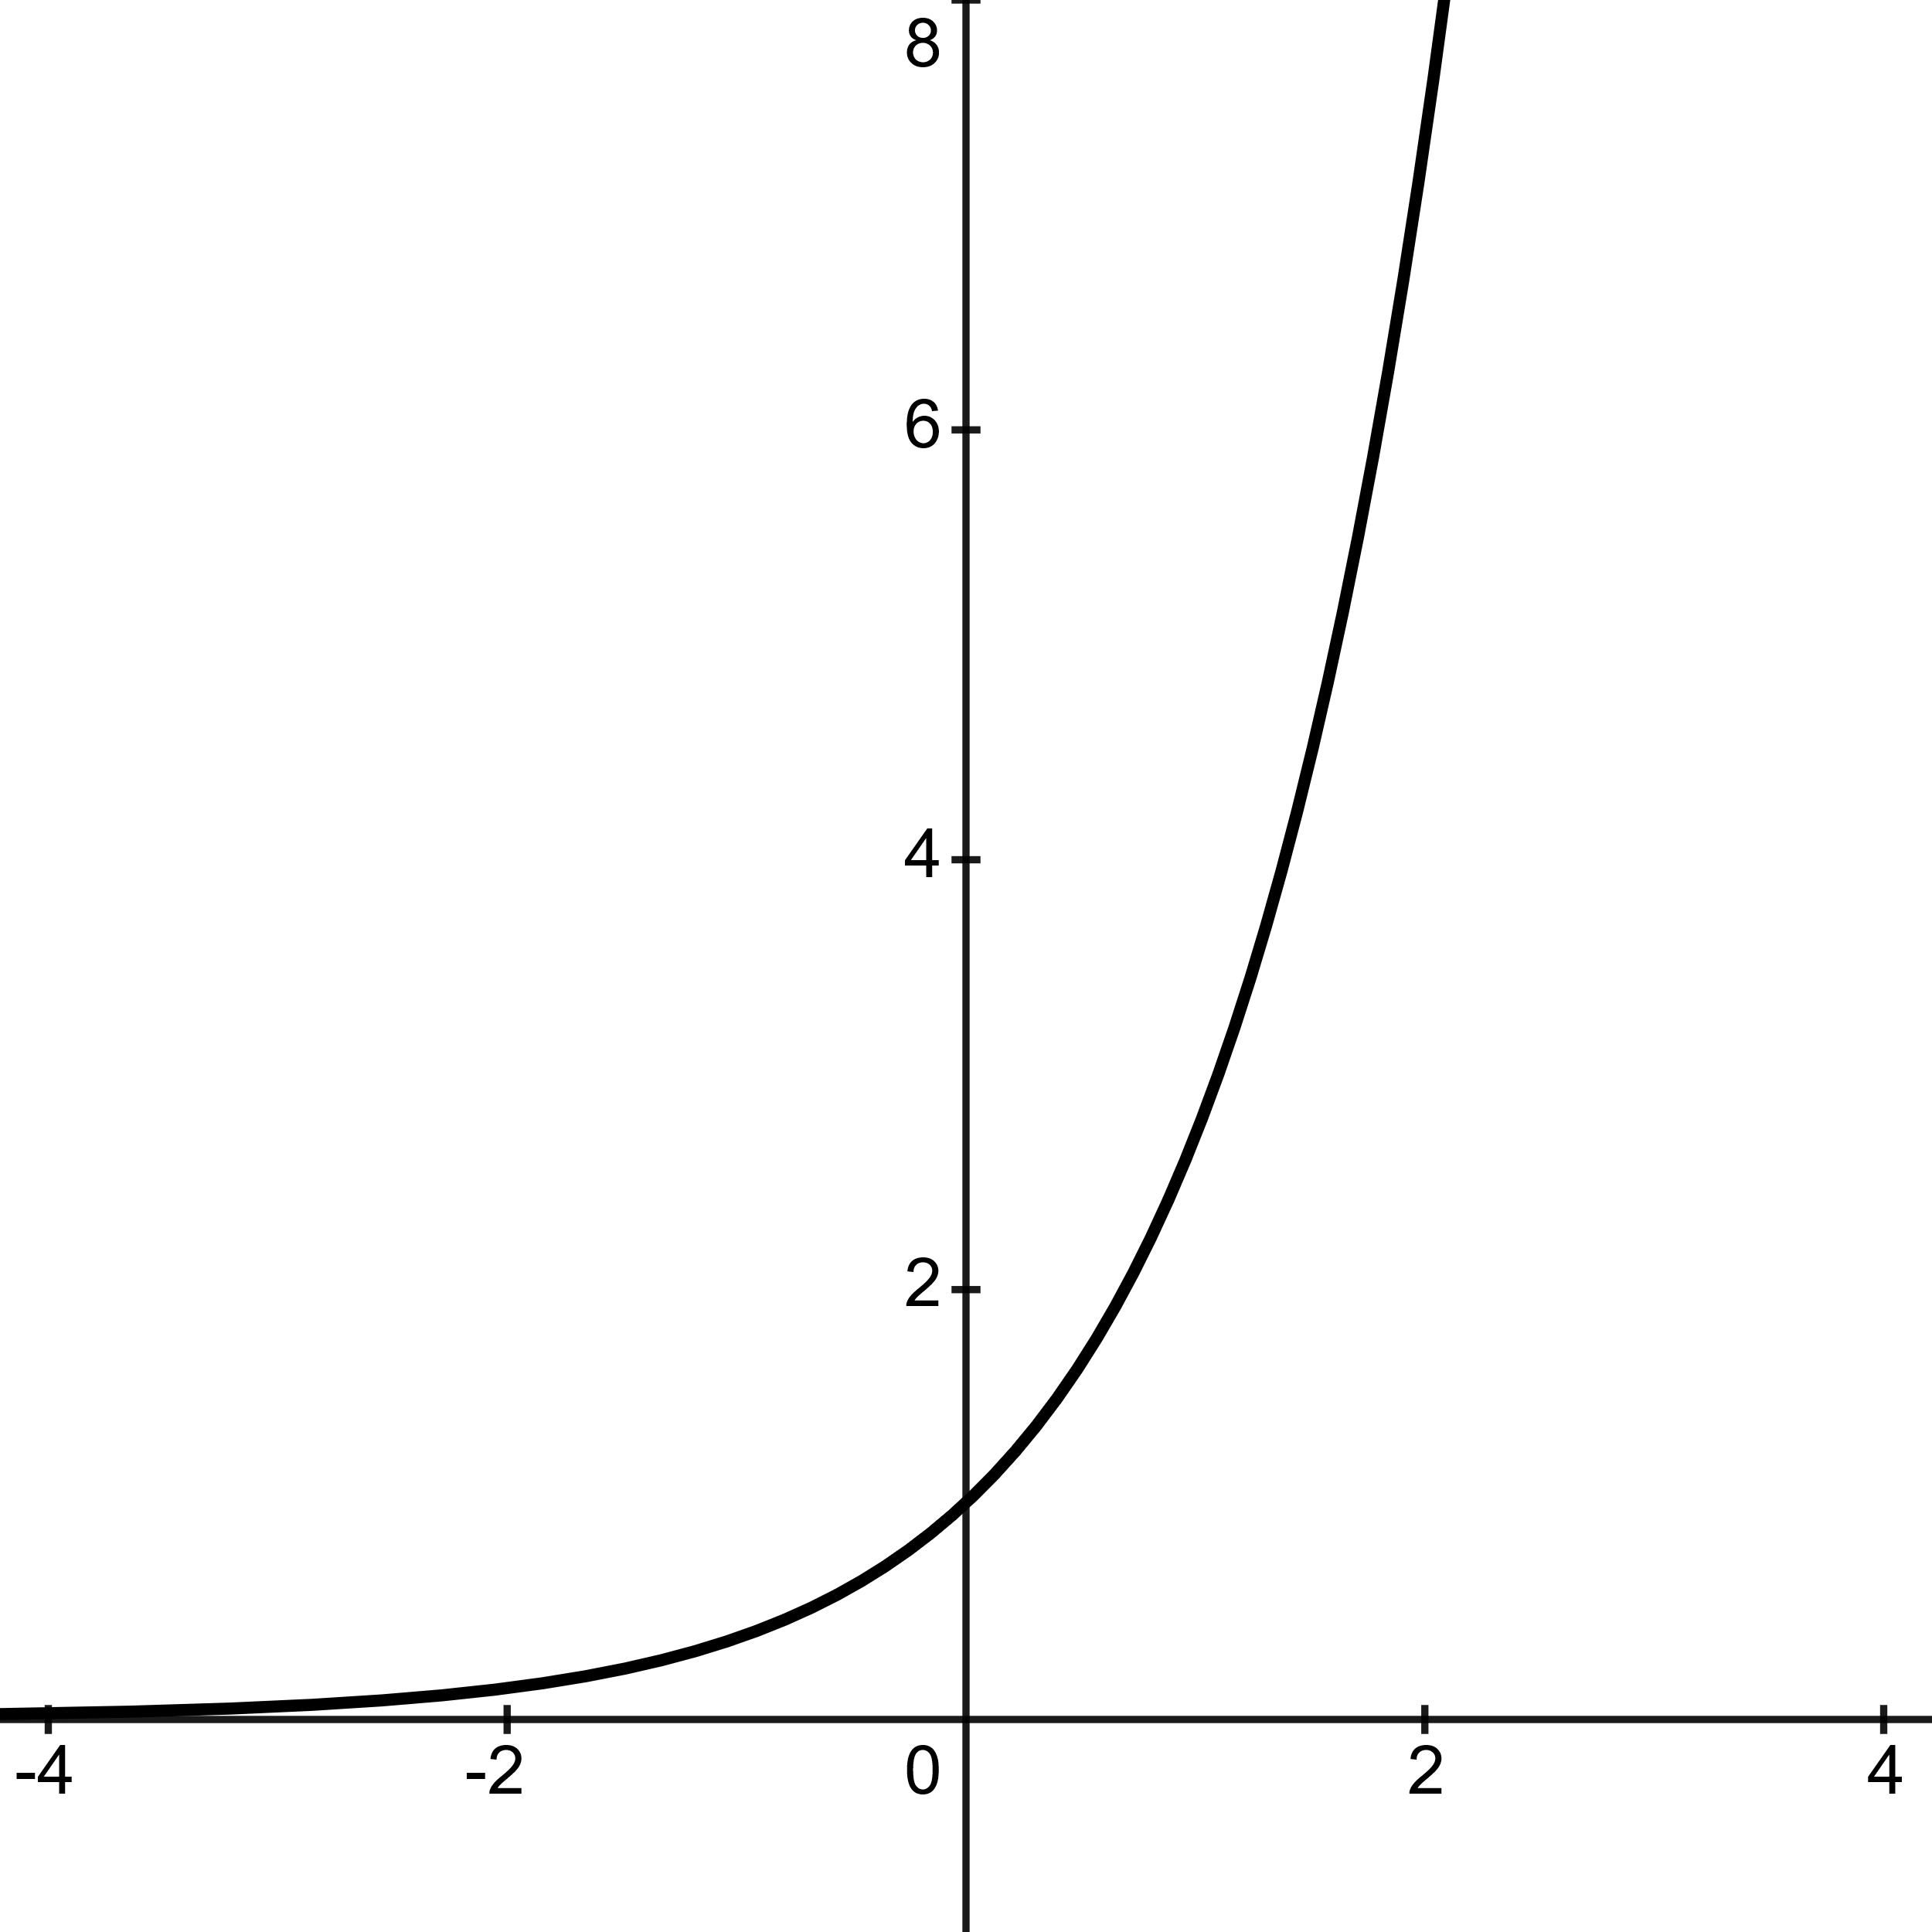 | 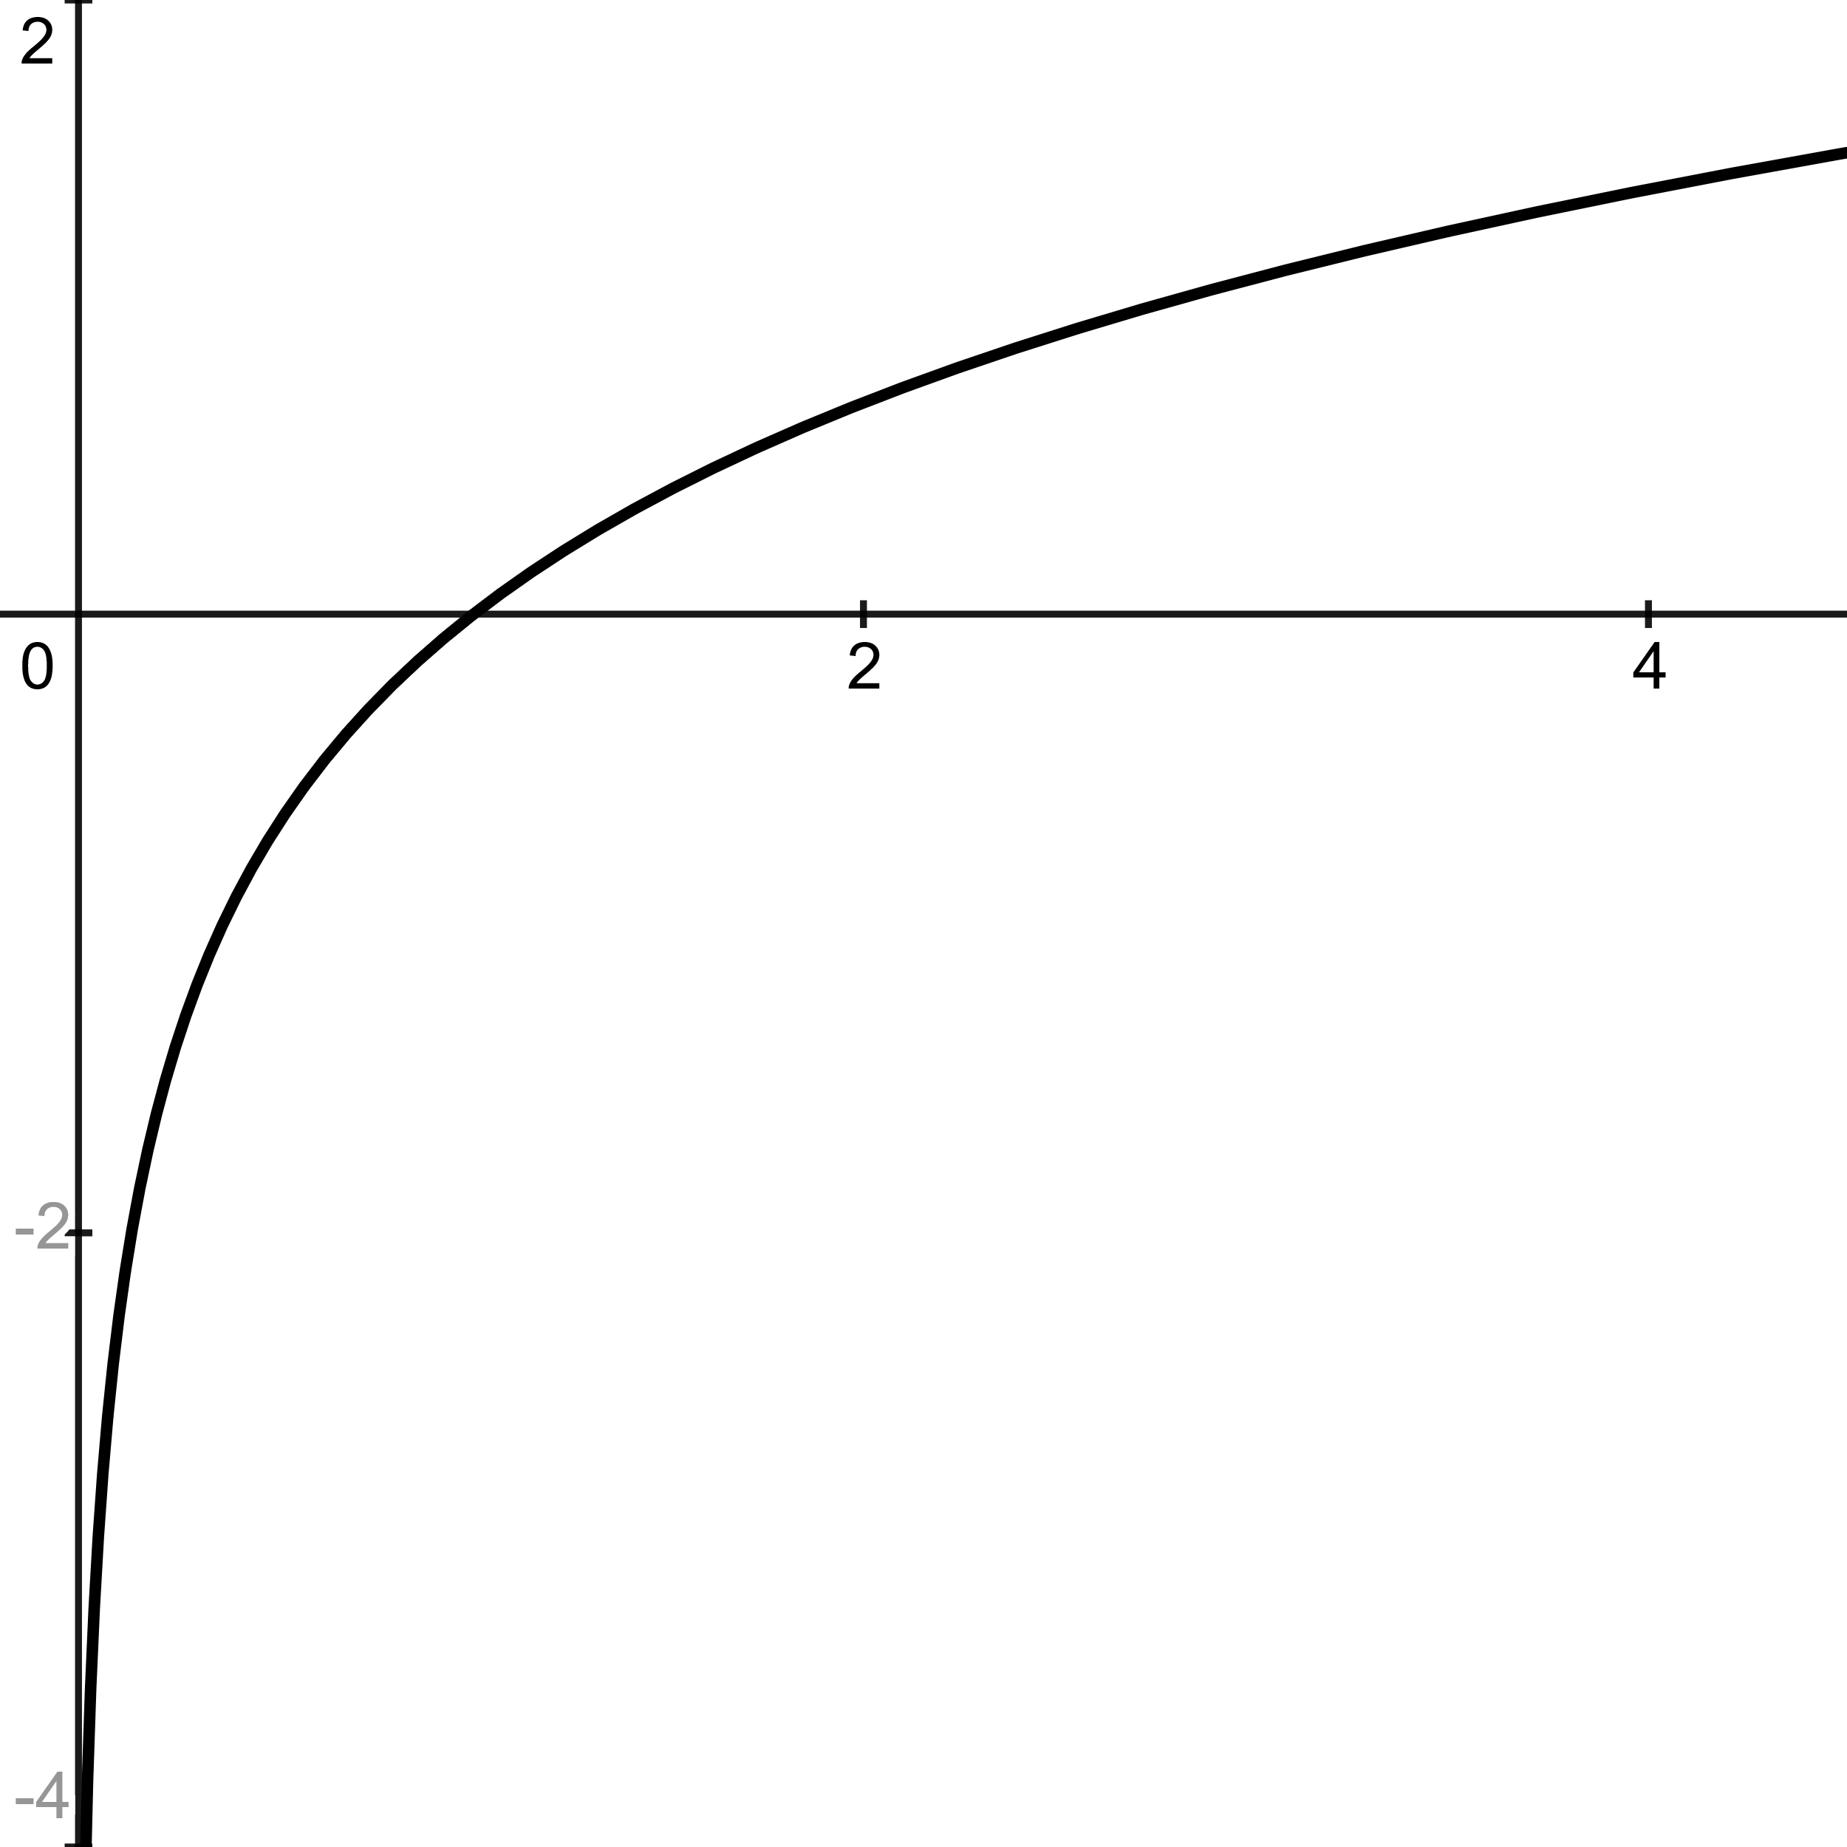
$$f\left(x\right)=\frac{1}{x}$$ | $$f\left(x\right)=e^{x}$$ | $$f\left(x\right)=\ln{x}$$
Domain: $(-∞,0)∪\left(0,∞\right)$  Range: $(-∞,0)∪\left(0,∞\right)$  Decreases as $x$ approaches $0$ from the left-side of the y-axis.  Decreases as $x$ moves away from $0$ on the right-side of the y-axis. | Domain: $\left(-∞,∞\right)$  Range: $\left(0,∞\right)$  Increases as $x$ moves from $-∞$ to $∞$  This function expresses  “Exponential Growth”. | Domain: $\left(0,∞\right)$  Range: $\left(-∞,∞\right)$  Increases as $x$ moves from $0$ to $∞$  Notice, this is the inverse of $f\left(x\right)=e^{x}$

Transformations
These transformations are applicable to all the Parent Functions shown above. Notice the coordinates in the following Parent Function, $f\left(x\right)=x^{2}$.
Parent Function
x | y
0 | 0
1 | 1
2 | 4
3 | 9
-1 | 1
-2 | 4
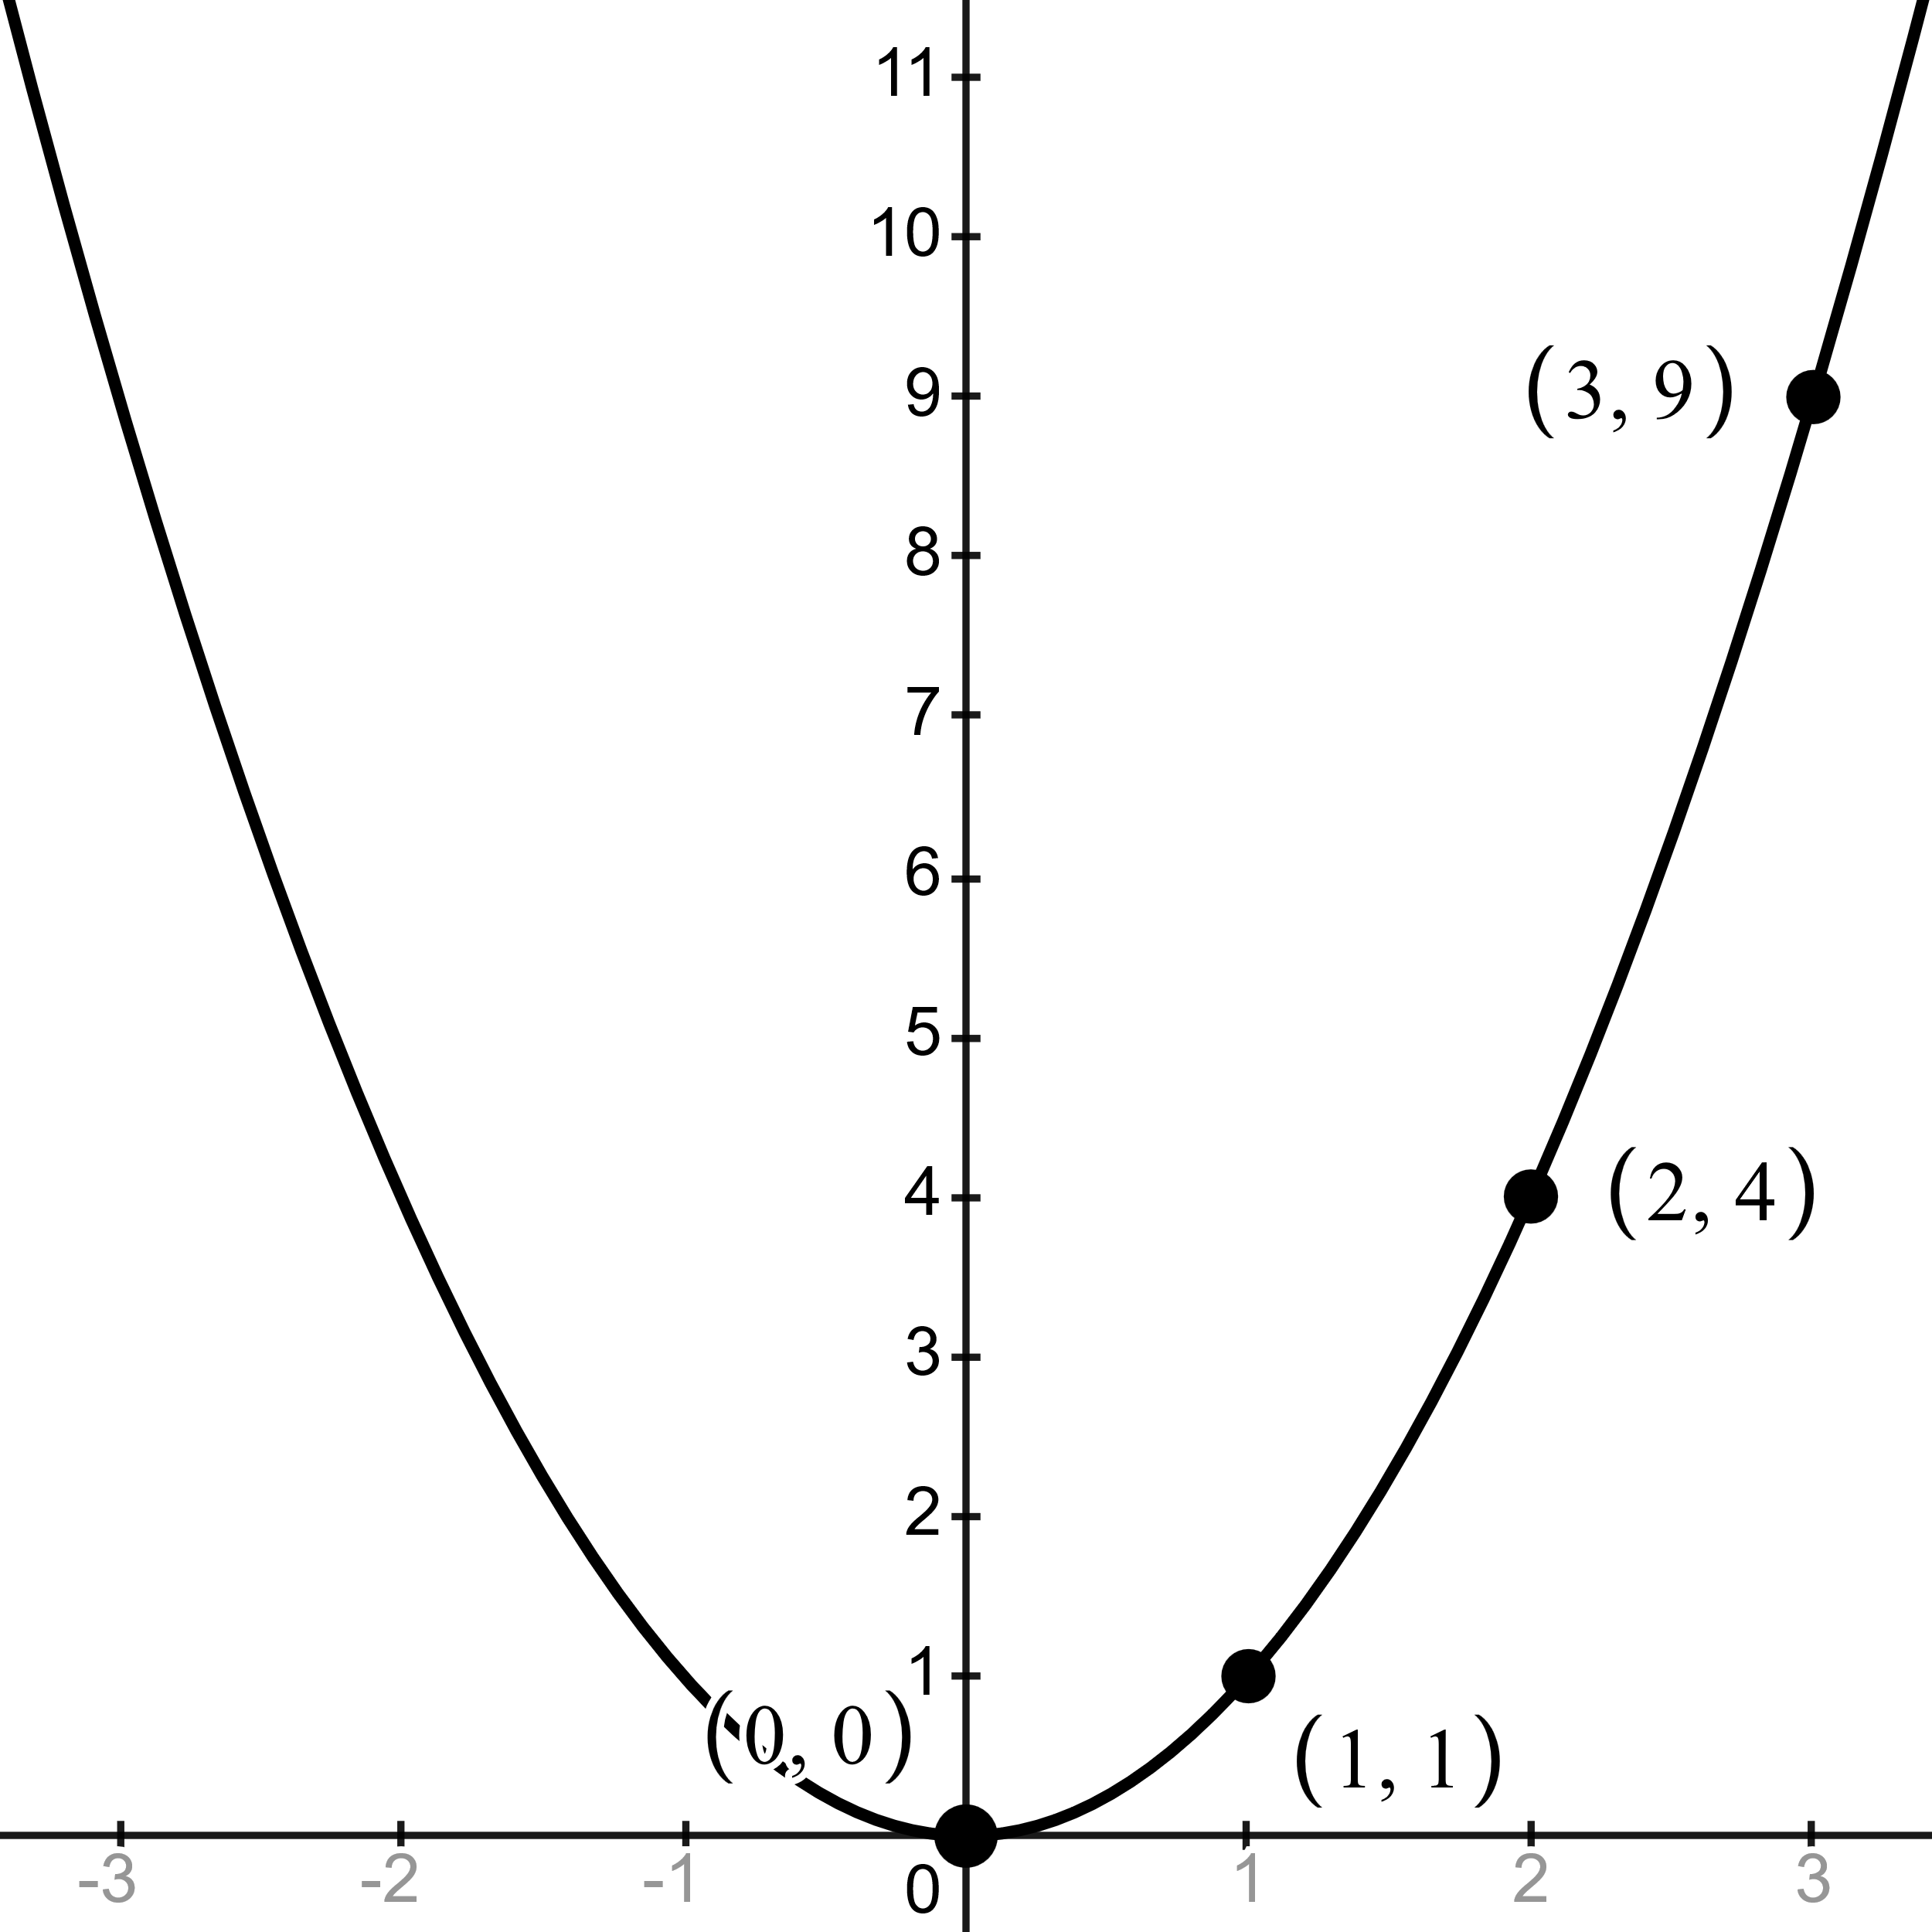
Notice the vertex is located at 0 for both x and y values.
Recall, that both the positive and negative of the same x-value share the same y-value.

Transformation Function
x | Y
0 | 2
1 | 3
2 | 6
3 | 11
-1 | 3
-2 | 6
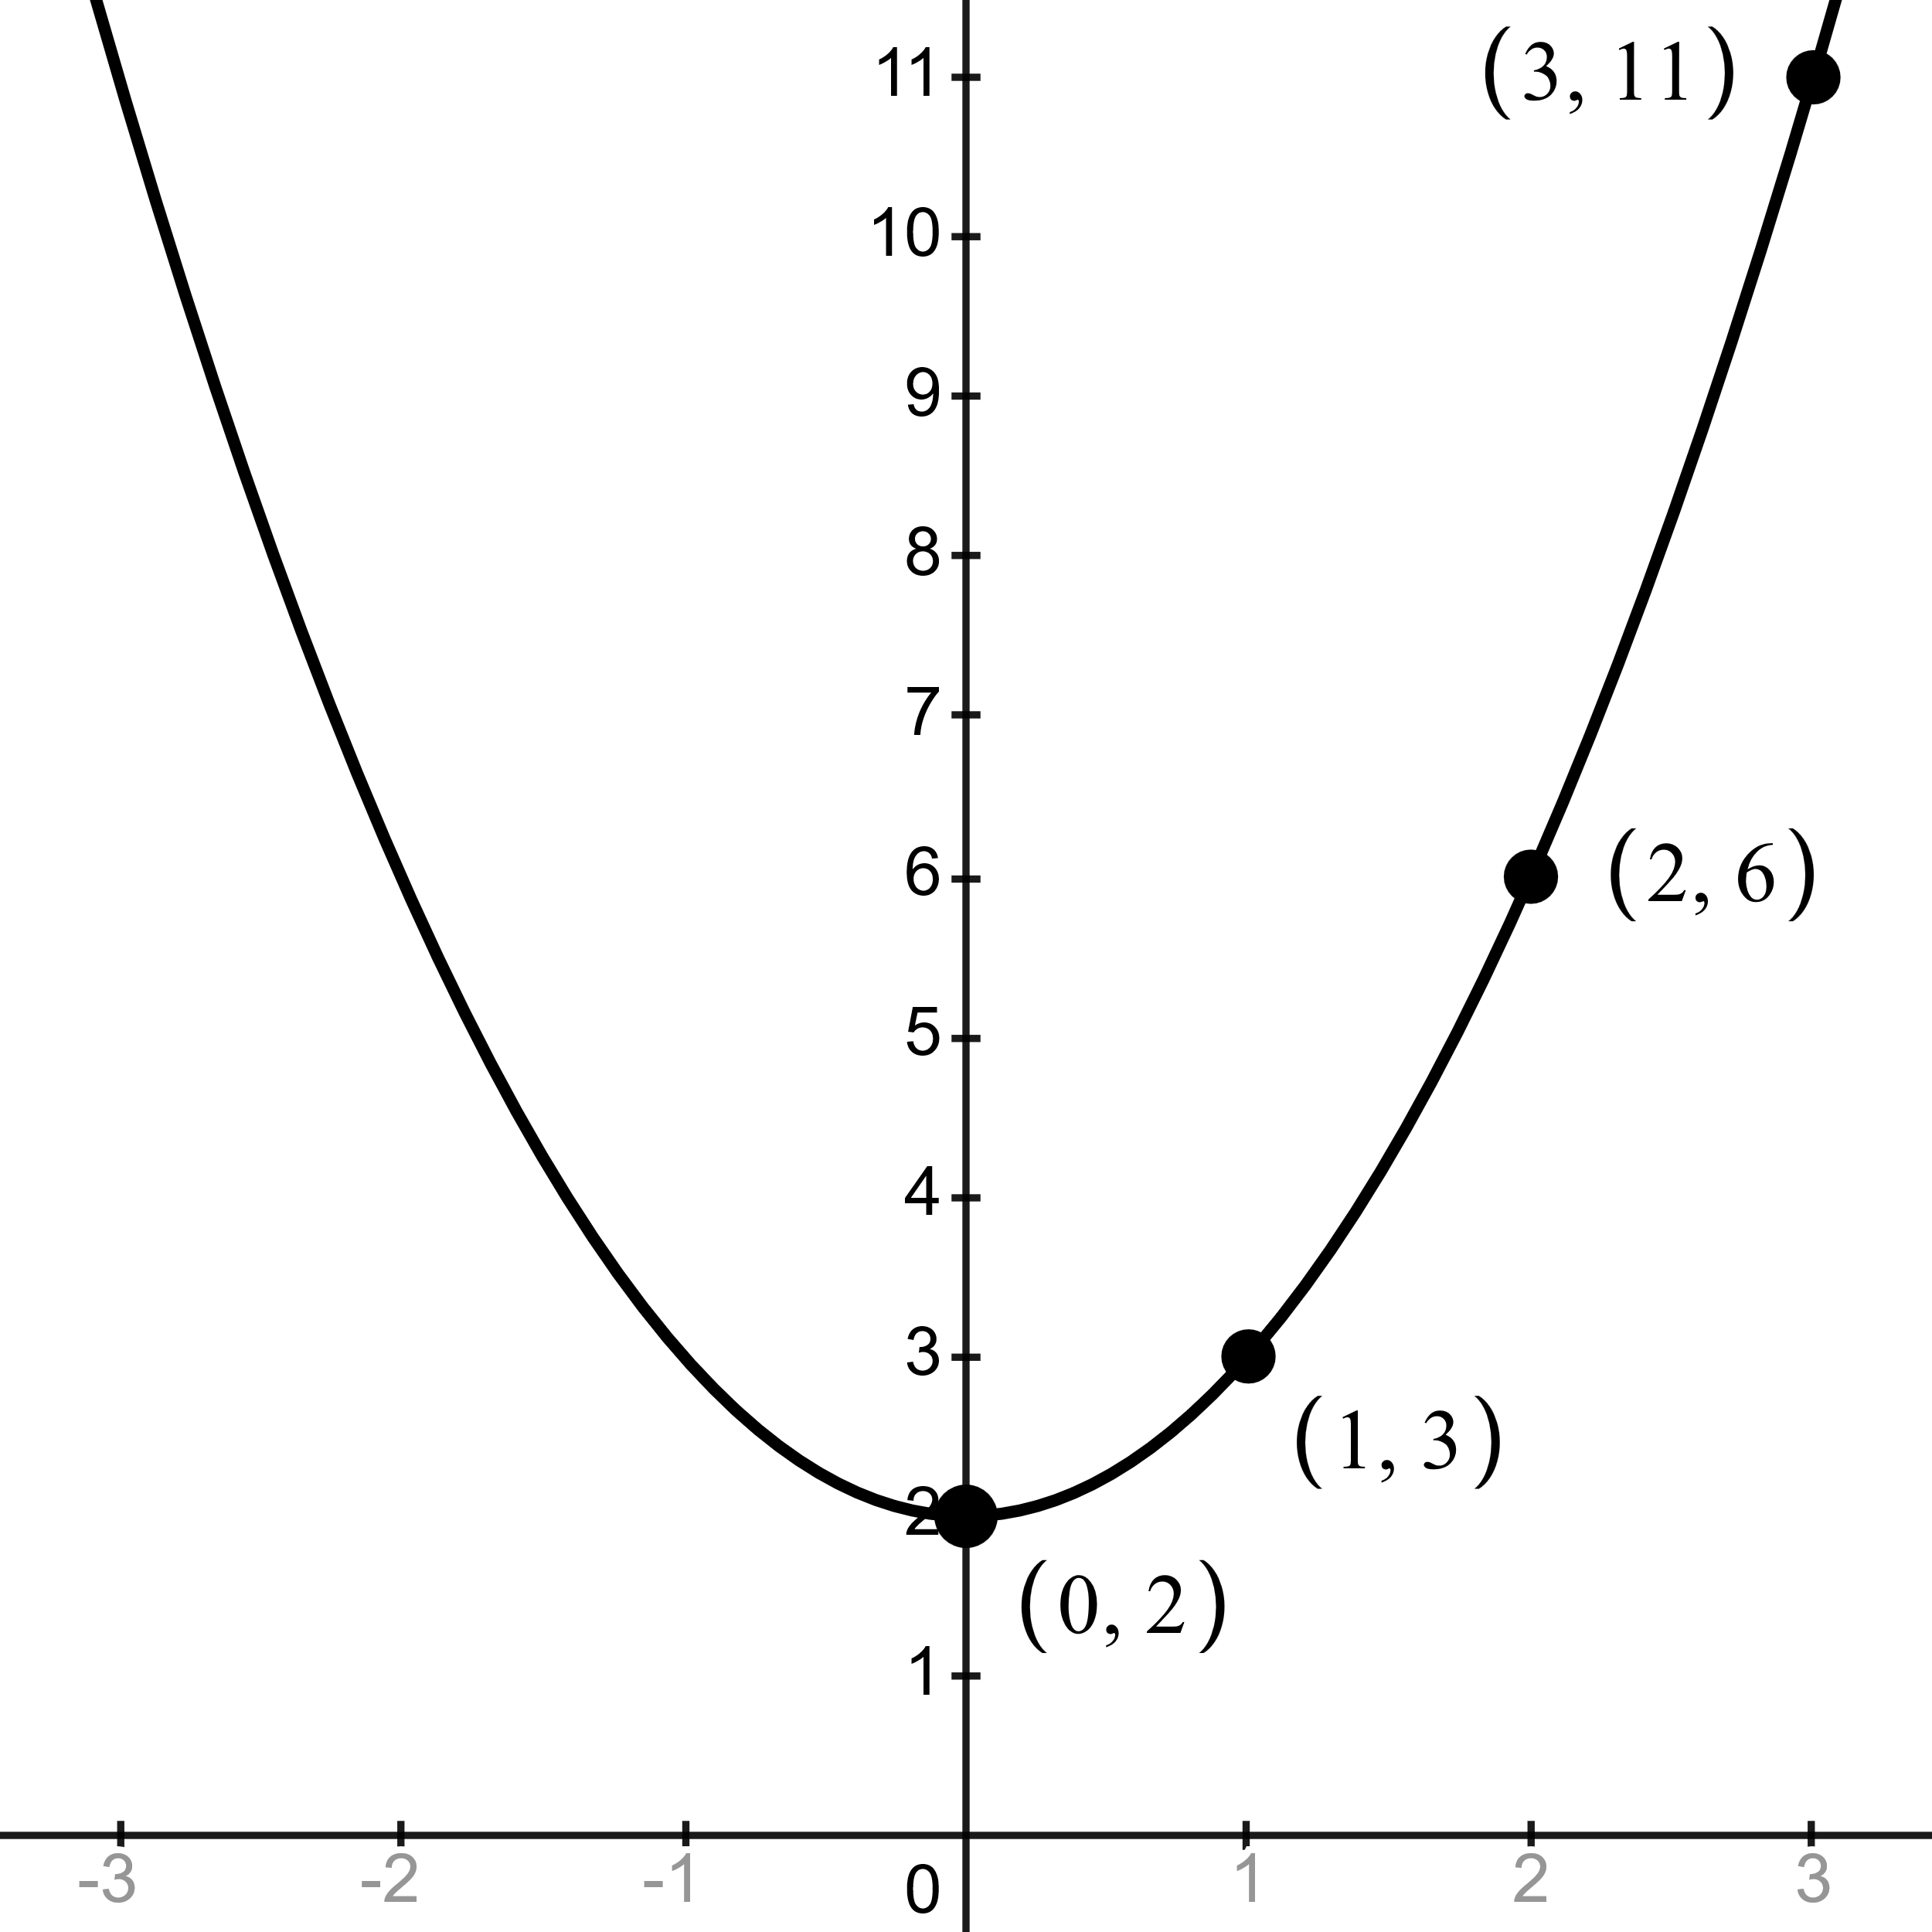
Example A: $f\left(x\right)=x^{2}+2$
Notice the vertex is now shifted up by 2, on the y axis, yet still holds the 0 position on the x axis.
Thus, this pattern follows for all other y values, their output being increased by a sum of 2.

Vertical Shift | Horizontal Shift | Vertical Stretch
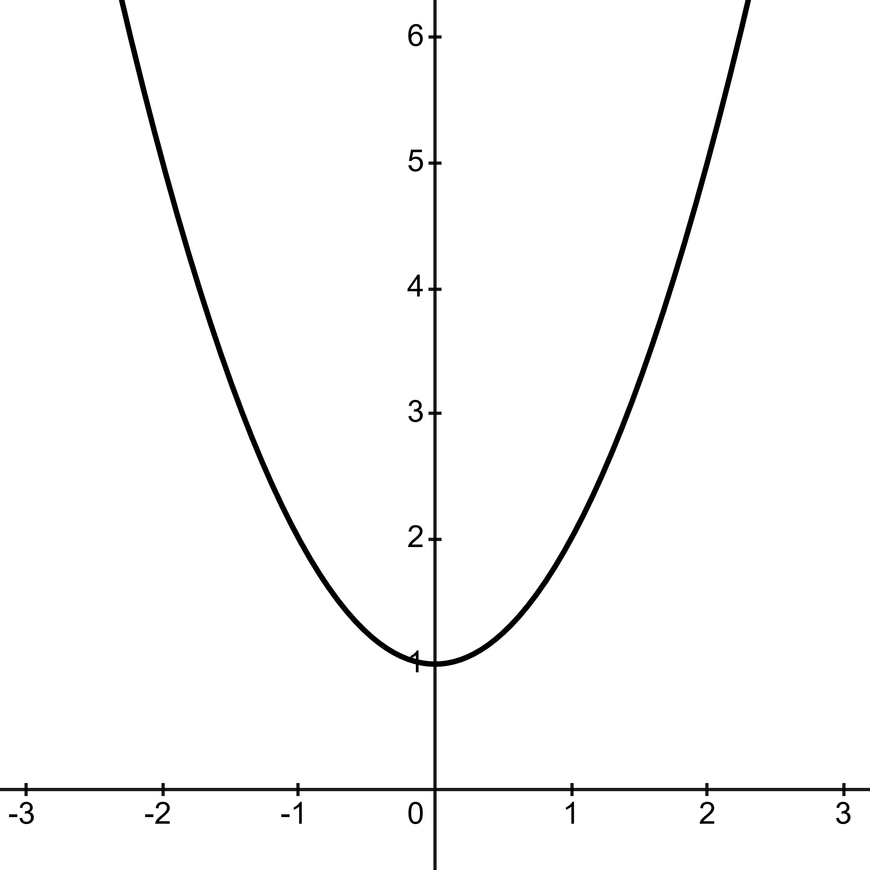 | 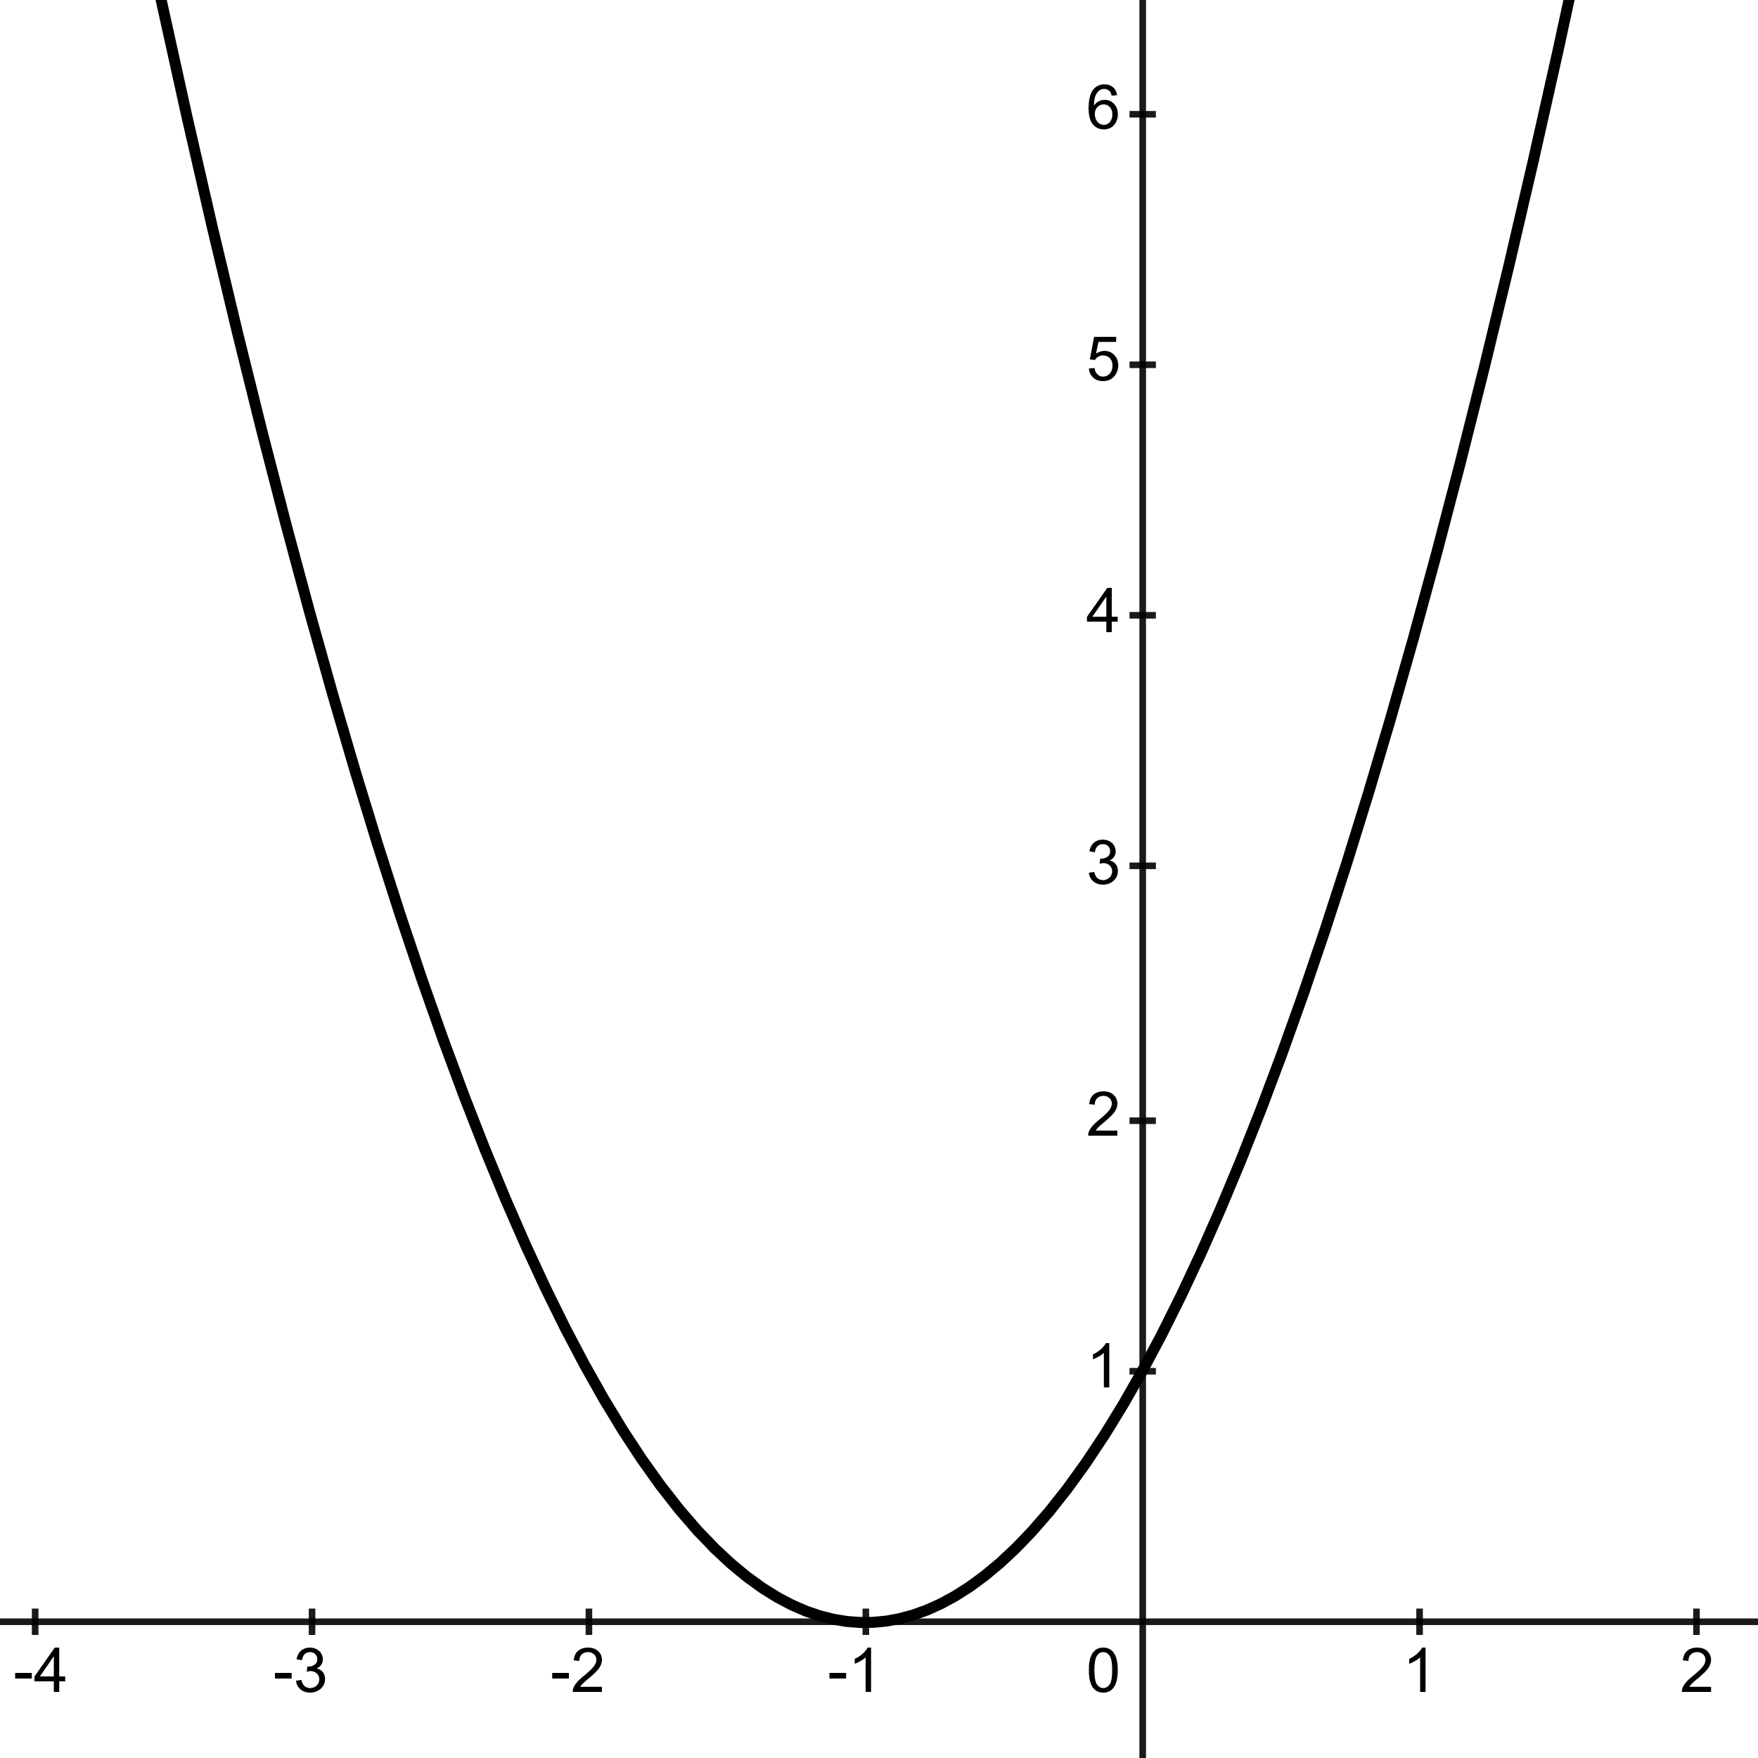 | 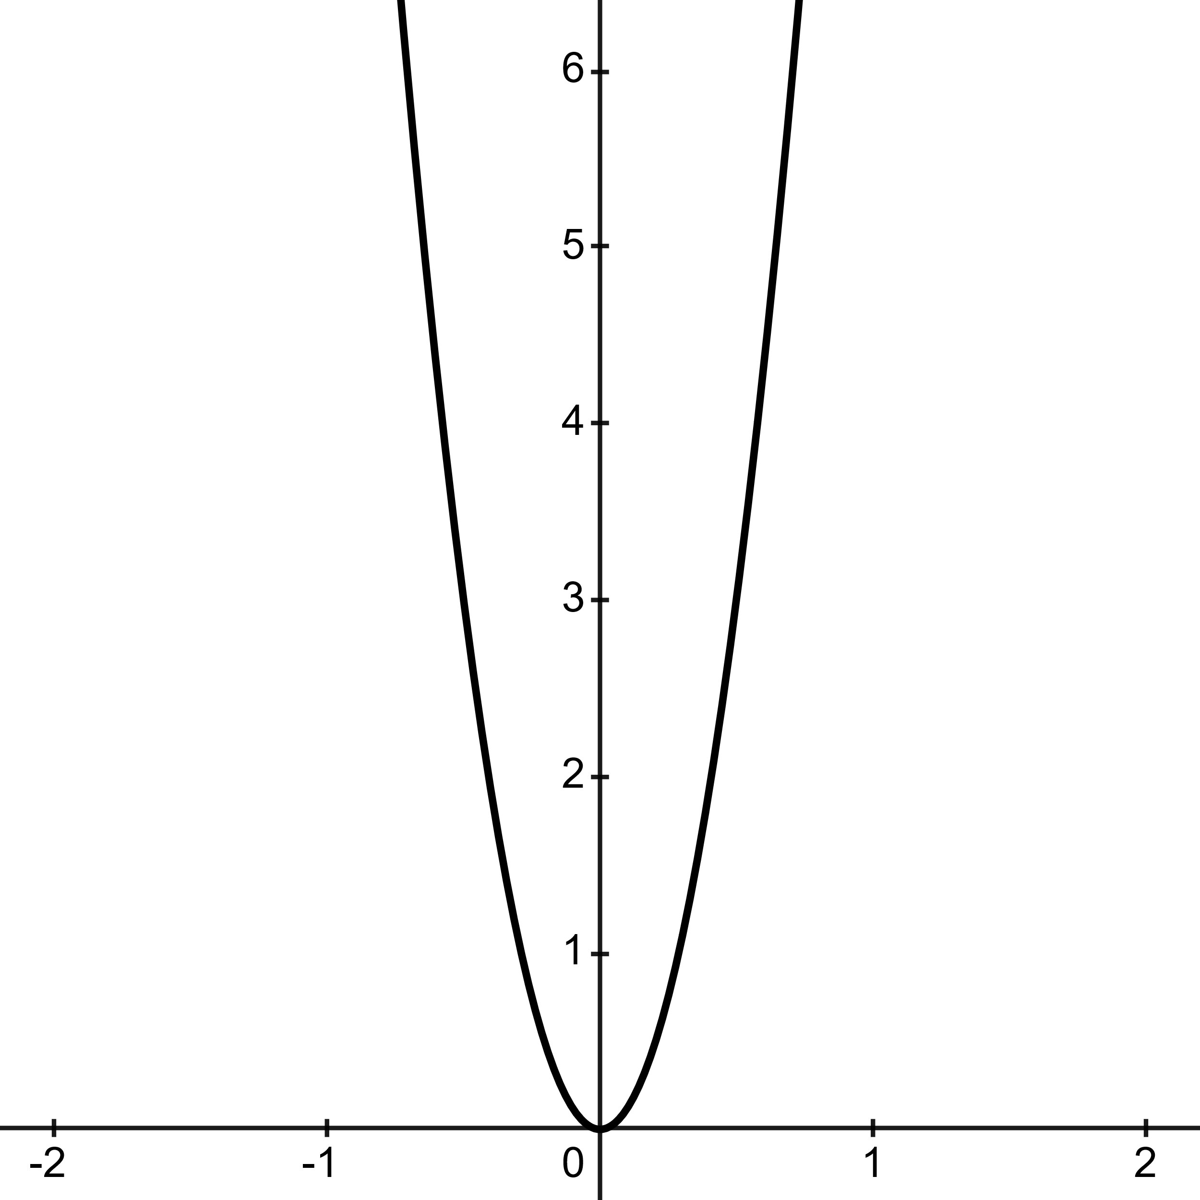
General Form: $x^{2}±k$  Example: $f\left(x\right)=x^{2}+1$ | General Form: ${\left(x±h\right)}^{2}+k$  Example: $f\left(x\right)={\left(x+1\right)}^{2}$ | General Form: $cf\left(x\right), c>1$  Example: $f\left(x\right)=12{(x}^{2})$
This example shows a standard Parent Graph parabola shifted up by a value of 1, for all y-values.  This transformation, under the general form, is applicable to any parent graph.  The function can shift upward by addition, and downward by subtraction. | When there is addition inside the parentheses, the curve shifts “h-units” the left.  When there is subtraction inside the function the curve shifts “h-units” to the right.  We can shift with respect to any numerical value given. If a $+2$ is in the “h” place, the graph shifts two x-values to the left. | Notice the coefficient is outside the parentheses of the function.  The coefficient is directly proportional to the function f(x).  In this example, every y-coordinate is multiplied by a factor of 12.
Vertical Compression | Horizontal Compression | Horizontal Stretch
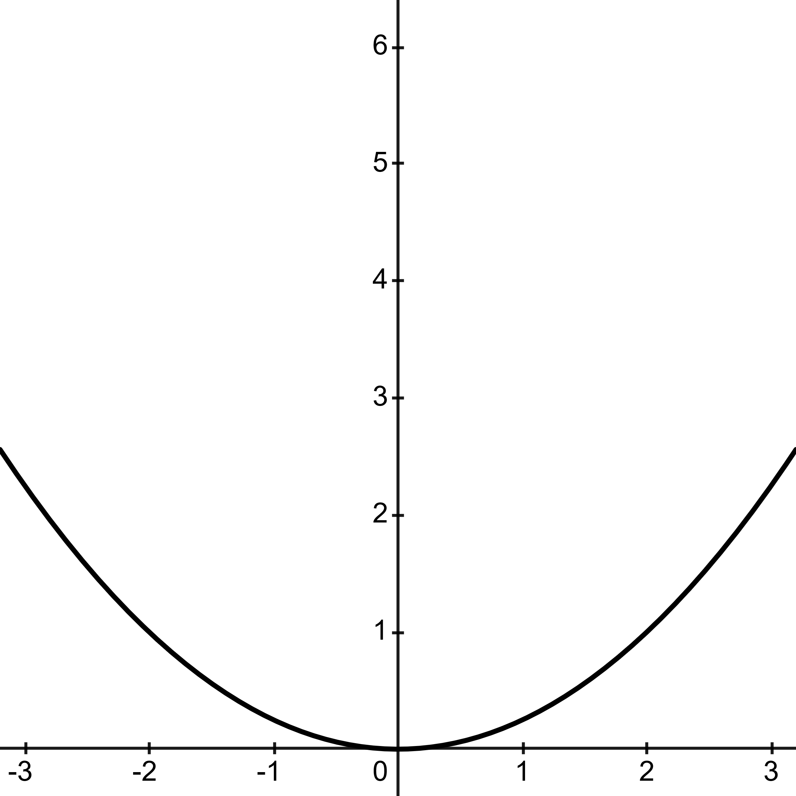 | 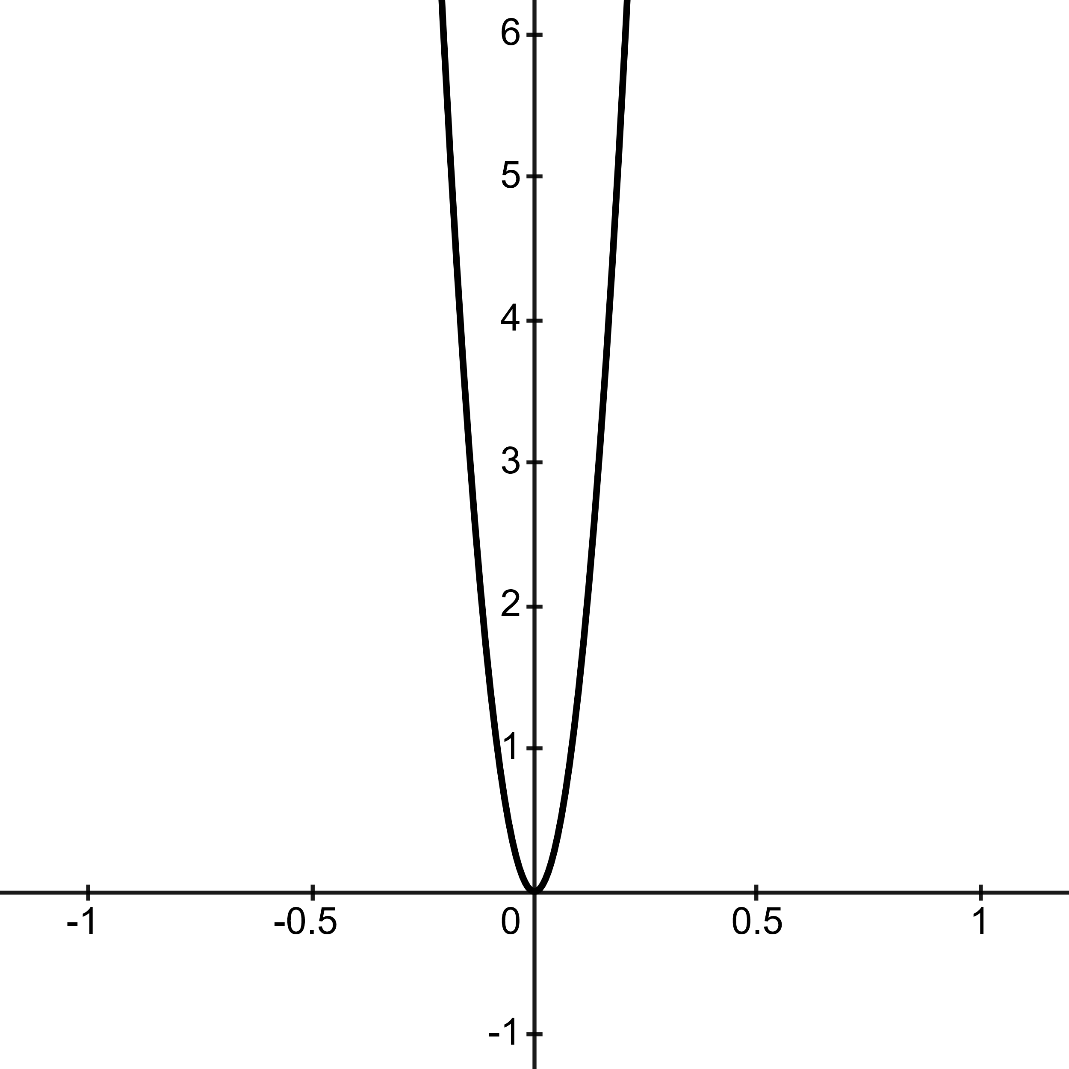 | 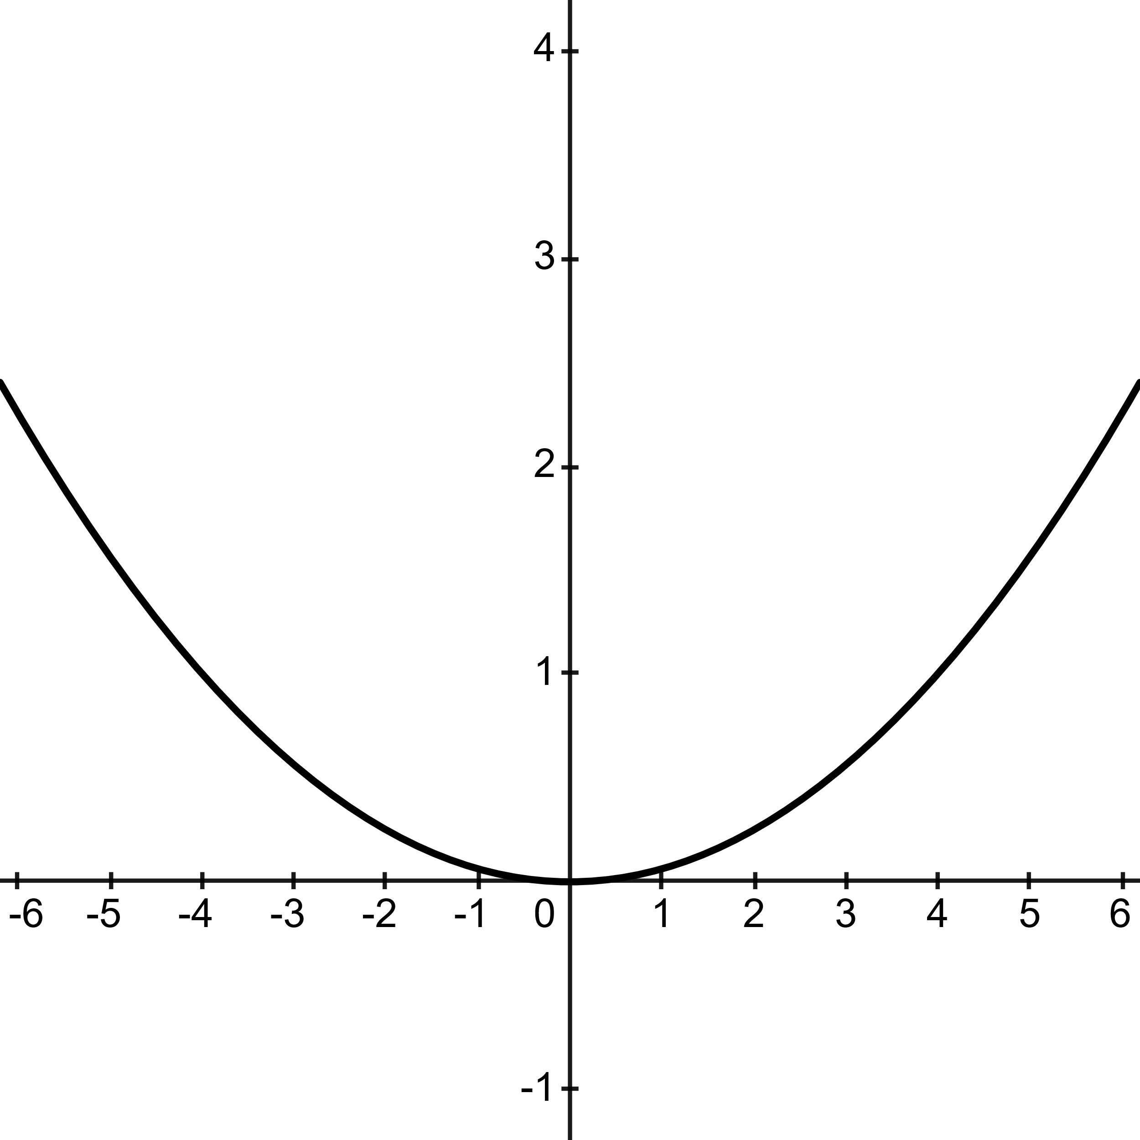
General Form: $cf\left(x\right), 0<c<1$  Example: $f\left(x\right)=\frac{1}{4}\left(x^{2}\right)$ | General Form: $f\left(cx\right),c>1$  Example: ${\left(12x\right)}^{2}$ | General Form: $f\left(cx\right), 0<c<1$  Example: $f\left(x\right)={\left(\frac{1}{4}x\right)}^{2}$
The coefficient is outside the parentheses of the function. This implies that all outputs of y, that is f(x) are multiplied by a factor of $\frac{1}{4}$. | Here the coefficient is inside the parentheses of the function.  Here, the value c compresses the curve horizontally, making a steeper slope by the reciprocal of the c-value, in this case by a factor of $\frac{1}{12}$. | Notice the coefficient is inside the parentheses of the function, as previously shown. In this case, the value c horizontally stretches the function by the reciprocal of the c-value, in this case by a factor of 4.

Y-Axis Reflection | X-Axis Reflection | X,Y Reflection
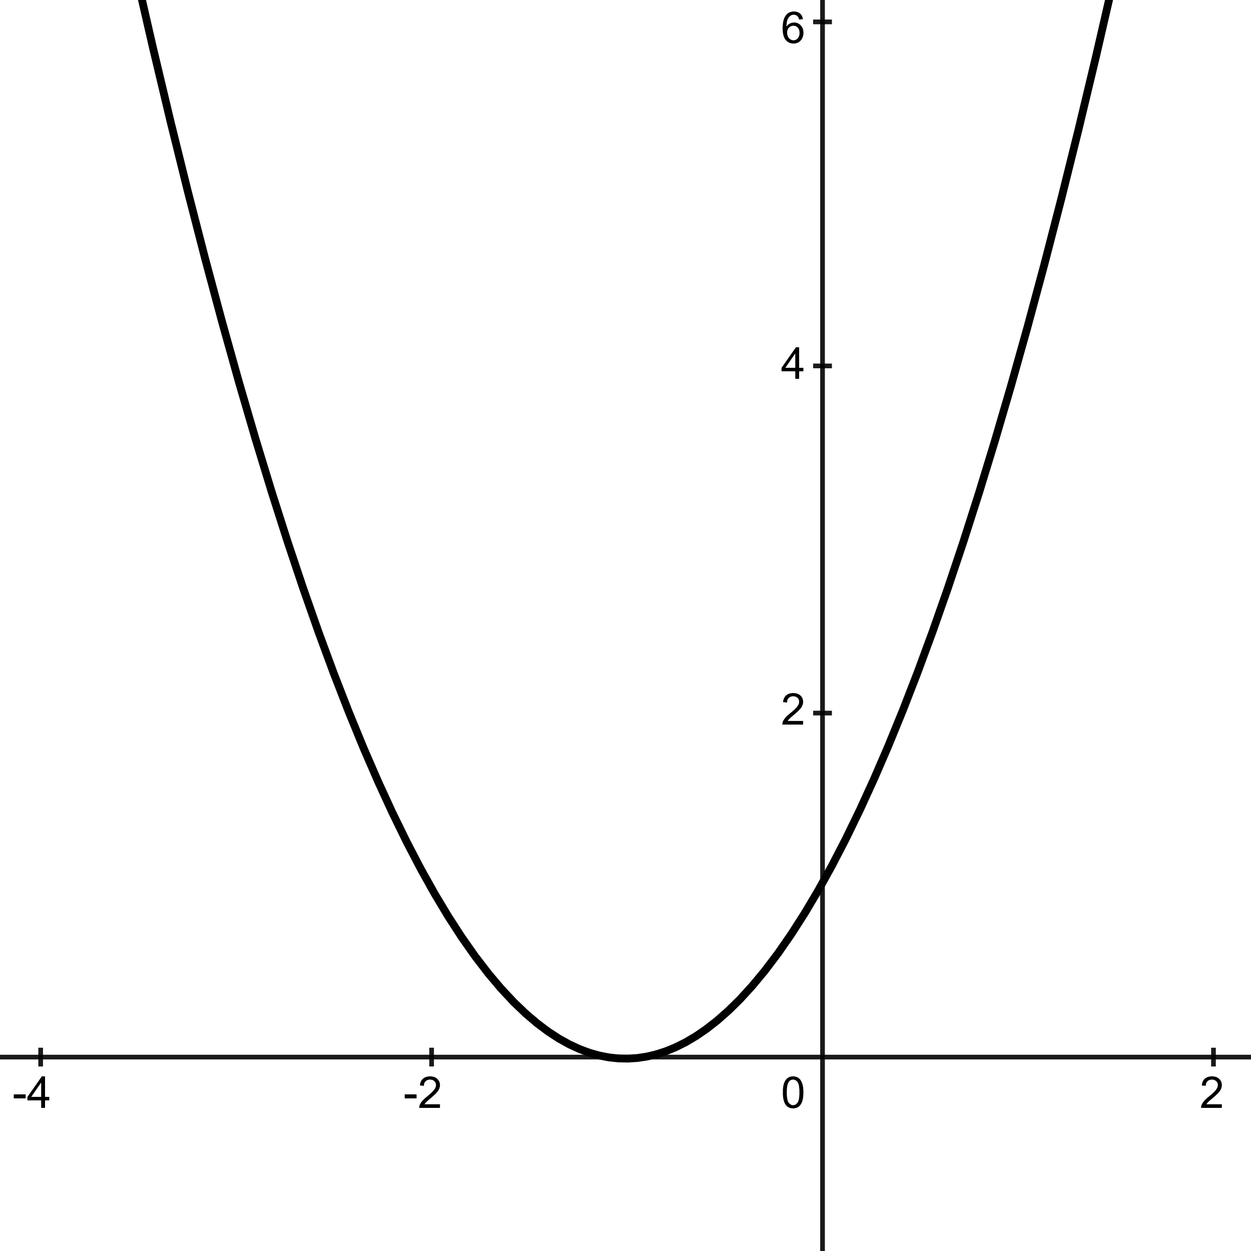 | 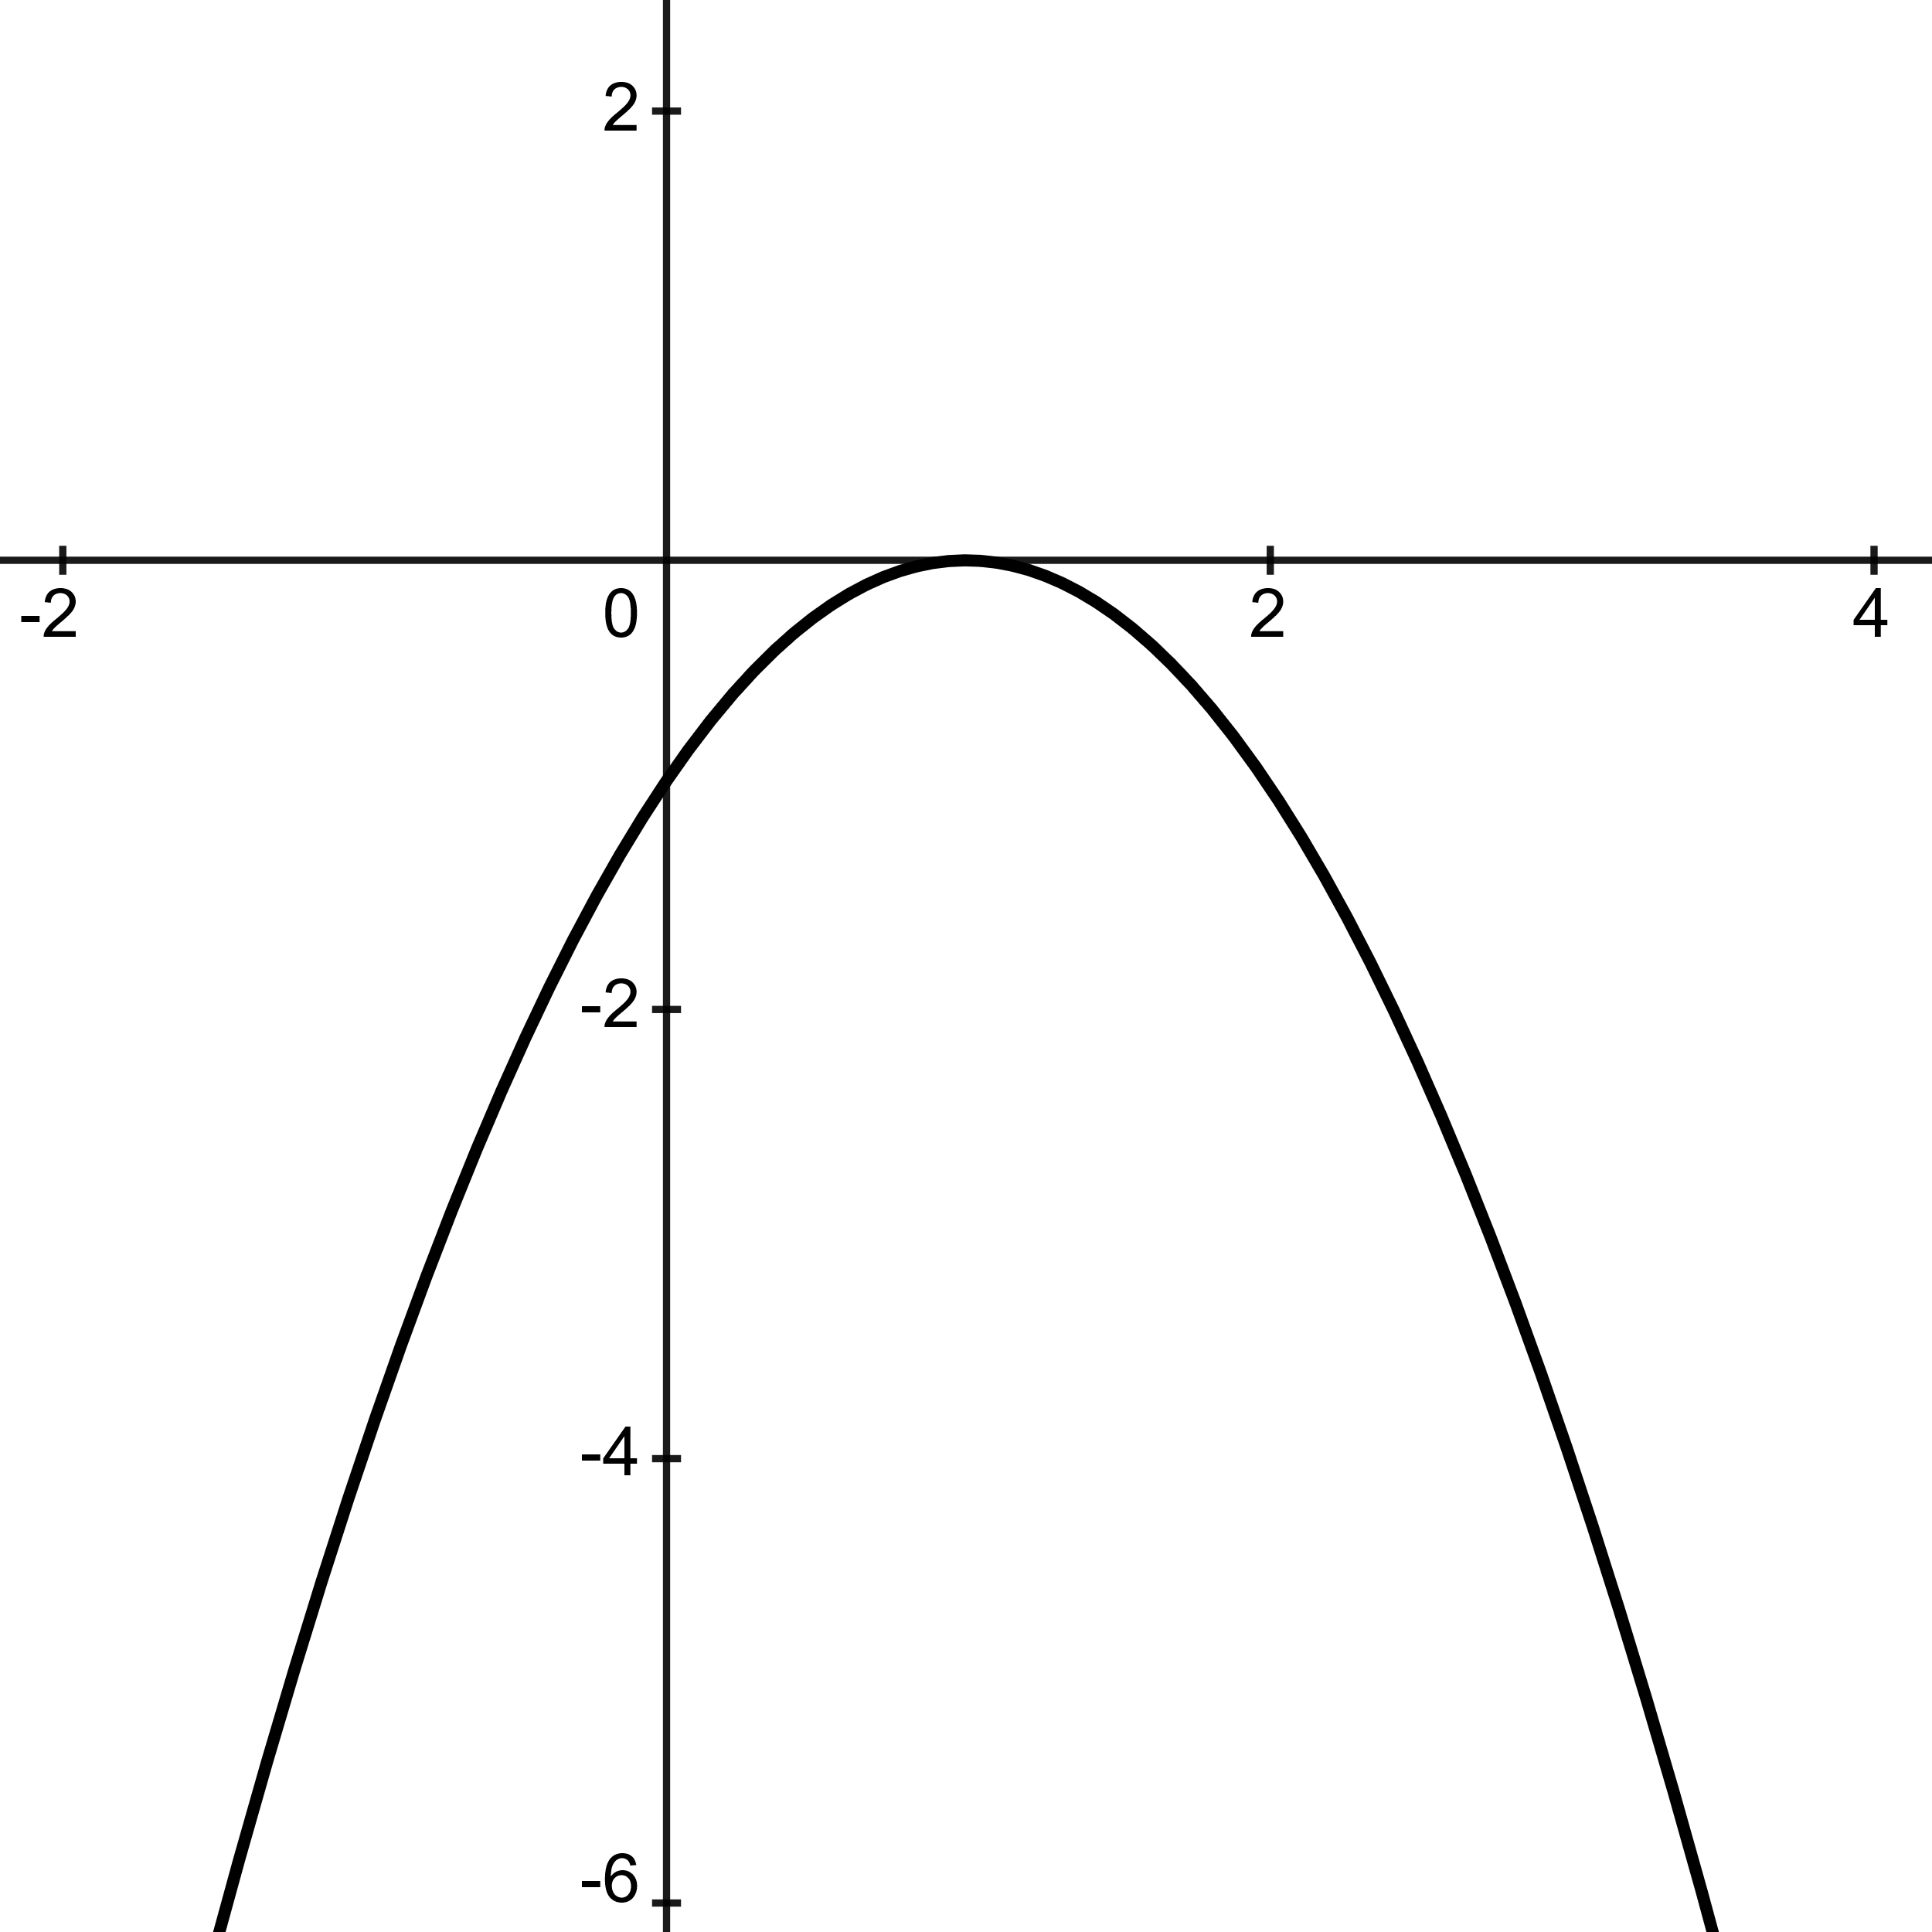 | 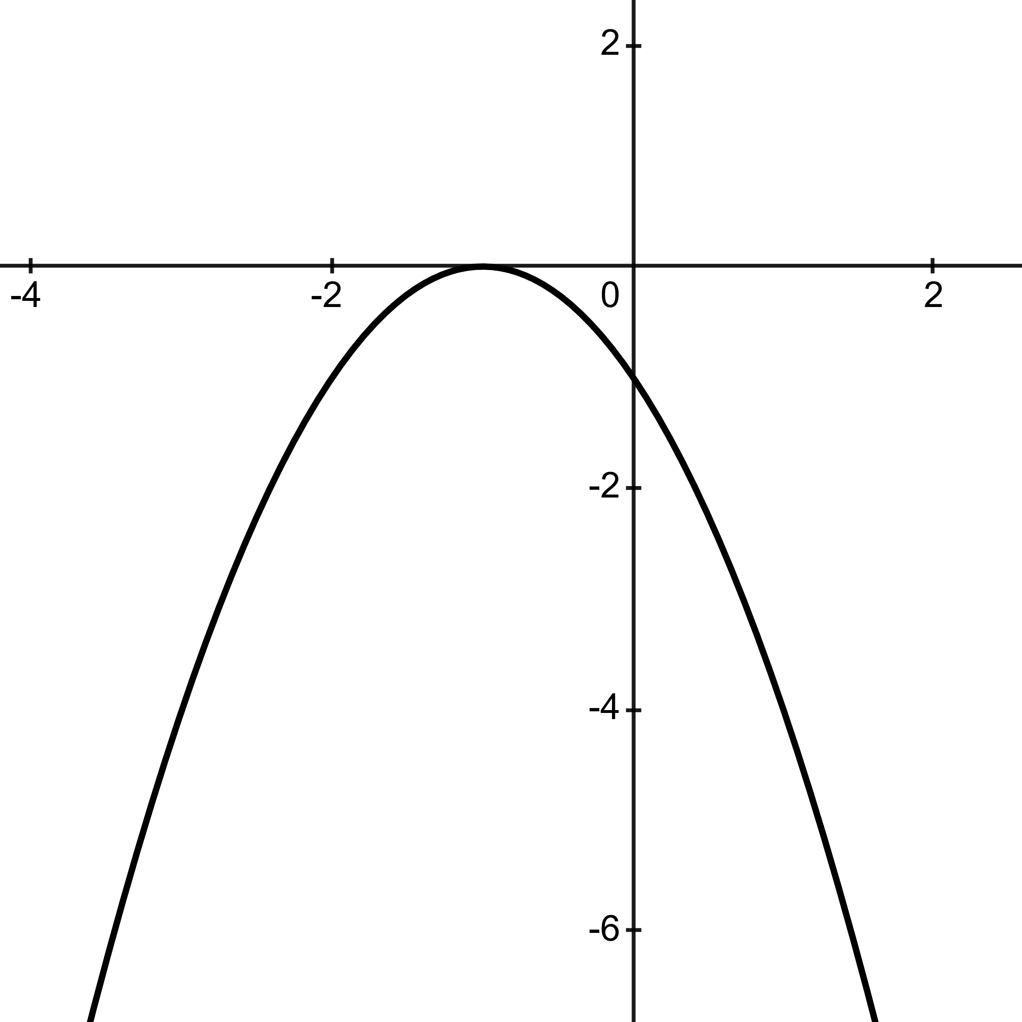
$$f\left(x\right)={\left(-x-1\right)}^{2}$$ | $$f\left(x\right)={-\left(x-1\right)}^{2}$$ | $$f\left(x\right)=-{\left(-x-1\right)}^{2}$$
Notice, this shift is reflected over the y-axis, as if reading:  $$f\left(x\right)={\left(x+1\right)}^{2}$$  When the negative is inside the function, the function reflects about the y-axis.  Due to the reflection, all the x-values change their sign from positive to negative. | Notice, this same function now reflects about the x-axis. This is due to the negative sign being on the outside of the function.  Again, consider the function:  $$f\left(x\right)={\left(x-1\right)}^{2}$$  Due to the reflection, all the y-values change their sign from positive to negative. | Consider the previous two transformations, applying both transformations to this function allows for two reflections.  This is a function that reflects both about the y-axis and about the x-axis.  Thus, all values of x and y have changed signs.

X | y
0 | 0
$$\frac{1}{2}$$ | 0
$$\frac{3}{4}$$ | -3
$$-\frac{1}{4}$$ | -3
$$\frac{1}{4}$$ | 1

Transformation Function
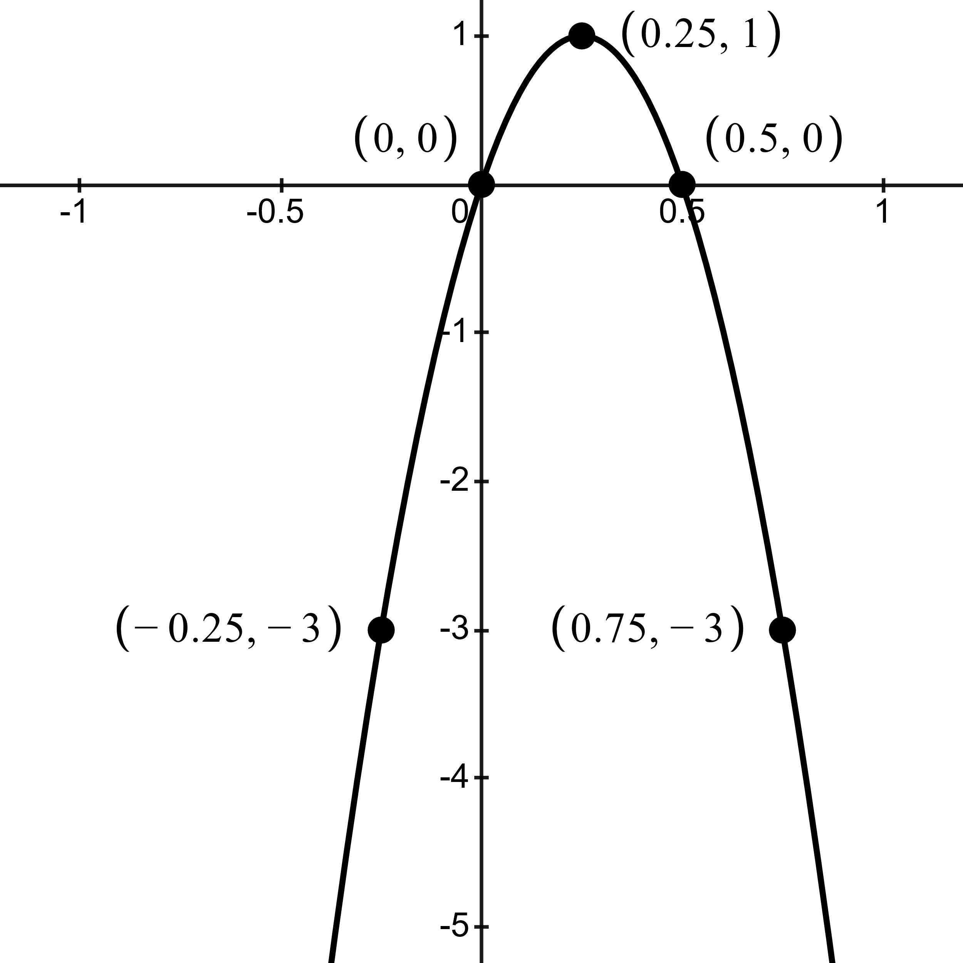
Example
$$f\left(x\right)=-{\left(-4x+1\right)}^{2}-1$$
In this unique Transformation, there is a vertical shift, horizontal shift, horizontal stretch, and reflection over both axes.
The function moves down by 1, left by 1, stretches horizontally by a factor of 4, then reflects over the x-axis and y-axis from the Parent Function’s original position.
As a result of the combined reflections and prior shifts, the vertex is relocated upward by 1 unit on the y-axis and rightward by $\frac{1}{4}$ unit on the x-axis.

All graphs are freely generated via ‘Desmos Graphing Calculator.’ At desmos.com/graphing

