Lewis Structures
Lewis structures are visual representations of the physical arrangement of atoms and their bonds in respect to each other. Only the valence shell of an atom is illustrated because it contains the only electrons involved in bonding. The information obtained by this process can be used to predict reactivity, intermolecular forces, molecular geometry, and other properties of a given substance. This worksheet includes some rules and guidelines to help you draw Lewis structures.
Rules
- Identify the central atom of the molecule. This is the least electronegative atom (See back of periodic table for values) or the only one able to form more than one bond.
- Assign the valence electrons to each atom as dictated by the periodic table placing one electron at each compass direction and then pairing them only after the first four until you have place all of the atom’s valence electrons. (See the Roman numeral above the group/column it is in.)
- Arrange the remaining atoms around the central atom and join them to the central atom by a single bond. The more electronegative atoms are typically farther away from the center and attaching hydrogen last is advised.
- Lone electrons (not lone pairs) indicate an ability to form more covalent bonds, resulting in either double or triple bonds. Their presence or the lack of a full octet on any atom indicates there is a better Lewis structure.
- To check yourself, add up the valence electrons of each atom in the molecule and your Lewis structure should have the same total between all its bonds and lone pairs.
- Rules are followed by the overwhelming majority, but there are always exceptions.

Guidelines
- Negative charges increases the valence electron total by the number while positive charges subtract from the valence electron total.
- Extra electrons typically reside on the more electronegative atom(s) while lost electrons are typically removed from the less electronegative atom(s).
- For any central atom aluminum or larger, negatively charged adjacent atoms will resonate their lone pairs into the central to become neutral.
- Molecules are often symmetrical, and are very unlikely to form rings (closed structures).
- If there are no combinations resulting in a full octet for all atoms, then transfer an electron from a less electronegative atom to a more electronegative atom.
- Example: Carbon Dioxide, CO₂
- Carbon is the least electronegative atom, hence the central.

- Carbon has 4 valence electrons, each oxygen atom has 6.
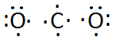

- Single Bonded.
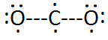
- Double bonded to remove lone electrons.
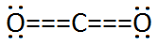
- Total valence electrons = 4+ 2(6) = 16 electrons
2 double bonds = 2 x 4 electrons = 8 electrons
4 lone pairs = 2 x 4 electrons = 8 electrons
8 + 8 = 16 electrons CHECK

Practice Problems
Draw the Lewis structures of the following:

- C 2.) CH₄

- H₂O 4.) C₂F₄

- N₂ 6.) Cl

- Cl⁻ 8.) Ca

- Ca²⁺ 10.) CaCl₂

Lewis Structures Answers
- 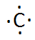 2.) 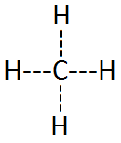
- 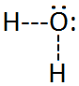 4.) 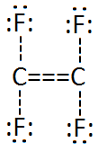
- 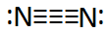 6.) 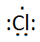
- 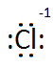 8.)
- 
 