Whole Numbers
Whole numbers are the building blocks of all mathematics. They are the familiar sequence that starts as 0,1,2.

Adding Whole Numbers
When we add two numbers together, the numbers being added are called “
addends
” and
what they add up to is called the “
sum
”.
2
+
3
=
5
+
addend
+
addend
+
sum
Here are some properties of addition:
+
The
addition property of 0
says that the sum of 0 and any number is that number.
For example
0 + 2 = 2
and
2 + 0 = 0
.
+
The
commutative property of addition
says that changing the order of two numbers
being added does not change their sum.
For example
3 + 4 = 7
and
4 + 3 = 7
.
+
The
associative property of addition
says that if we add three numbers, putting
parentheses around the first two or the second two doesn’t change the sum.
For example
(2 + 3) + 4 = 5 + 4 = 9
and
2 + (3 + 4) = 2 + 7 = 9
.

Subtracting Whole Numbers
When we subtract two numbers, the result is called the “difference”.
6 − 2 = 4
+ difference
Here are some properties of subtraction:
+ The difference of any number and itself is 0. For example 4 − 4 = 0. Also 0 − 0 = 0.
+ The difference of any number and 0 is itself. For example 4 − 0 = 4.
CAUTION: order matters in subtraction, so 4 − 2 is not the same as 2 − 4.

Multiplying Whole Numbers
Multiplication
is repeated addition.
3+3=2
·
3=6
3+3+3=3
·
3=9
3+3+3+3=4
·
3=12
In algebra,
×
is not used because it can be confused for the variable
x
. Another way to
write the product of two numbers is by putting one next to the other with the second one in
parentheses.
2
·
3=2(3)=6
The result of multiplying two numbers is called the “
product
”. The numbers being multiplied
are “
factors
” of the product.
2
·
3
=
6
+
factor
+
factor
+
product

Here are some properties of multiplication:
+ The multiplication property of 0 says that the product of 0 and any number is 0.
For example 3 · 0 = 0 and 0 · 3 = 0.
Also 0 · 0 = 0.
+ The multiplication property of 1 says that the product of 1 and any number is that same number. For example:
4 · 1 = 4 and 1 · 4 = 4
We still have
- · 1 = 0 and 1 · 0 = 0
Also
- · 1 = 1
+ The commutative property of multiplication says that changing the order of two numbers being multiplied doesn’t change their product. For example:
4 · 3 = 3 + 3 + 3 + 3 = 12 and 3 · 4 = 4 + 4 + 4 = 12
+ The associative property of multiplication says that changing the grouping of factors does not change their product. For example:
4 · (3 · 5) = 4 · 15 = 60
(4 · 3) · 5 = 12 · 5 = 60
+ The distributive property says that multiplication distributes over addition. For example:
- · (4 + 5) = 3 · 4 + 3 · 5
Also:
- + 5) · 3 = 4 · 3 + 5 · 3

Dividing Whole Numbers
Division
means separating a quantity into equal parts.
Be careful what part goes where. The number that is being divided is called the
dividend
and the number that it is being divided into is called the
divisor
. The number of times the
divisor goes into the dividend is called the
quotient
.
There are three different ways to write a division problem. It is important to understand each
way and what part goes where. Let’s say we want to divide
12
by
4
. Then
12
is the divisor
and
4
is the dividend. We could use the symbol
÷
for division:
12
÷
4
=
3
+
dividend
+
divisor
+
quotient
In words we would say “
12
divided by
4
is
3
.”
We could also use a bar to represent division. Note that
the dividend goes on top and the
divisor goes on the bottom
. We would write:
12
4
=
3
+
dividend
+
divisor
+
quotient
We would read this “
12
over
4
is
3
.”
We use the following for long division:
3
4

12
+
divisor
+
dividend
+
quotient
This is read “
4
into
12
is
3
.” Note: the dividend goes on the
outside
when using this notation
and the divisor goes on the
inside
.
Some properties:
+ The quotient of 0 and any number (except 0) is 0.
= 0 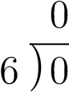 0 ÷ 7 = 0
+ The quotient of any number and 0 is not a number. For example:
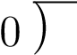6 4 ÷ 0
are undefined.

Exponents
We use
exponents
for repeated multiplication.
3
·
3
·
3
·
3
·
3
|
{
z
}
3
is a factor
5
times
=
3
5
+
base
+
exponent
Reading:
+
4 = 4
¹
is “four to the first power.”
Note
:
we don’t need to write the exponent when it is
1
.
+
4
·
4 = 4
²
is read “four to the second power” or “ four squared.”
+
4
·
4
·
4 = 4
³
is read as “four to the third power” or “four cubed.”
+
4
·
4
·
4
·
4 = 4
⁴
is read as “four to the fourth power.” There are no special ways to read
powers higher than
3
.

Order of Operations
When using more than one operation in the same expression, we need to be careful to do the operations in the correct order.
- Perform all operations within grouping symbols such as parentheses () or brackets [].
- Evaluate any expressions with exponents.
- Multiply or divide in order from left to right.
- Add or subtract in order from left to right.
Example: We are given
6 · 2 ÷ 4 + 3² − 4
First, we evaluate the exponent 3² = 9 which gives:
6 · 2 ÷ 4 + 9 − 4
Next, we evaluate the multiplications and divisions in order 6·2÷4 = 12÷4 = 3 which gives:
3 + 9 − 4
Finally, do all additions and subtractions from left to right. If we put ∗ under an operation, that’s the one we’re doing:
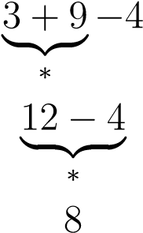
So:
6 · 2 ÷ 4 + 3² − 4 = 8
It’s extremely common to see this written as:
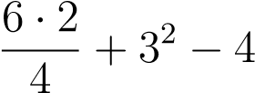
Sometimes there are things you should consider to “be in parentheses” even if there are no actual parentheses.
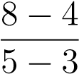
+ Anything above or below a division line is automatically considered “in parentheses.” Example:
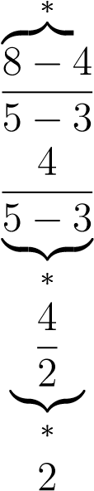{
When something is in parentheses, it’s important to follow order of operations for everything
that’s inside before moving outside.
Example:

2
·
3
−
6
3

·
2
−
5
We do what’s inside parentheses first. There is one multiplication
and one division.

2
·
3
|{z}
∗
−
6
3
!
·
2
−
5



6
−
6
3
|{z}
∗



·
2
−
5


6
−
2
|
z
{
}
∗


·
2
−
5
4
·
2
−
5
Now that we are done with parentheses, we finish the problem still using order of operations.
4
·
2
|{z}
∗
−
5
8
−
5
|
{
z
}
∗
3
+ Anything in the exponent is considered “in parentheses.”
Example: 2⁴⁻¹
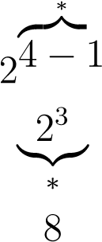{
Now Give It a Try!
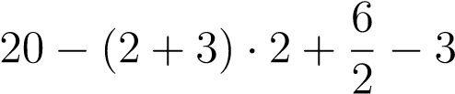
1. 2 · 3² − 5
AnswerKey:
1.
13
2.
8
3.
8
4.
0
5.
4
2. (3 − 2) · 3 + 5
3.
- [2 · (3 + 2) + 1] − 11
- 2^{2 · 4-6}

