Integers
The integers are the positive whole numbers, 0, and negative numbers.
{...,−4,−3,−2,−1,0,1,2,3,4,...}

The Number Line and Comparing Integers
Integers can be graphed on the number line:

−3 −2 −1 0 1 2 3
Negative numbers are to the left of zero and positive numbers are to the right.
Zero
Negative Numbers
Positive Numbers
−3 −2 −1 0 1 2 3
For any two integers on a number line, the number to the right is greater, and the number to the right is less than the other number.

−6 −5 −4 −3 −2 −1 0 1 2 3 4 5 6
Since −5 is to the left of −3, −5 is less than −3. This is written as:
−5 < −3 or − 3 > −5.
Careful: The negative sign is important! −3 is greater than −5 even though 3 is less than 5.

Absolute Value
The absolute value of a number is that number’s distance from 0 on the number line.
3 units 4 units

−6 −5 −4 −3 −2 −1 0 1 2 3 4 5 6
We use | | for the absolute value of a number.
Examples:
+ |4| = 4
+ | − 3| = 3
+ | − 58| = 58
+ |0| = 0
Helpful Hint: The absolute value of a number is never negative, but it can be 0.

Opposites
Two numbers that are the same distance from 0 on the number line but are on opposite sides of 0 are called opposites.
5 units 5 units

−6 −5 −4 −3 −2 −1 0 1 2 3 4 5 6
5 is the opposite of −5 and −5 is the opposite of 5
3 units 3 units

−6 −5 −4 −3 −2 −1 0 1 2 3 4 5 6
3 is the opposite of −3 and −3 is the opposite of 3
We use the negative sign − in front of a number to write the opposite of a number. Examples:
+ −(5) = −5
+ −(−5) = 5
+ −(3) = −3
+ −(−3) = 3
Hints:
+ The opposite of a number is not always negative (even though we put the − sign in front). For example
−(−1) = 1
+ The opposite of the opposite of a number is the original number! If n is a number
−(−n) = n
+ Since there is no distance from 0 to itself, 0 is its own opposite
−0 = 0

Adding Integers
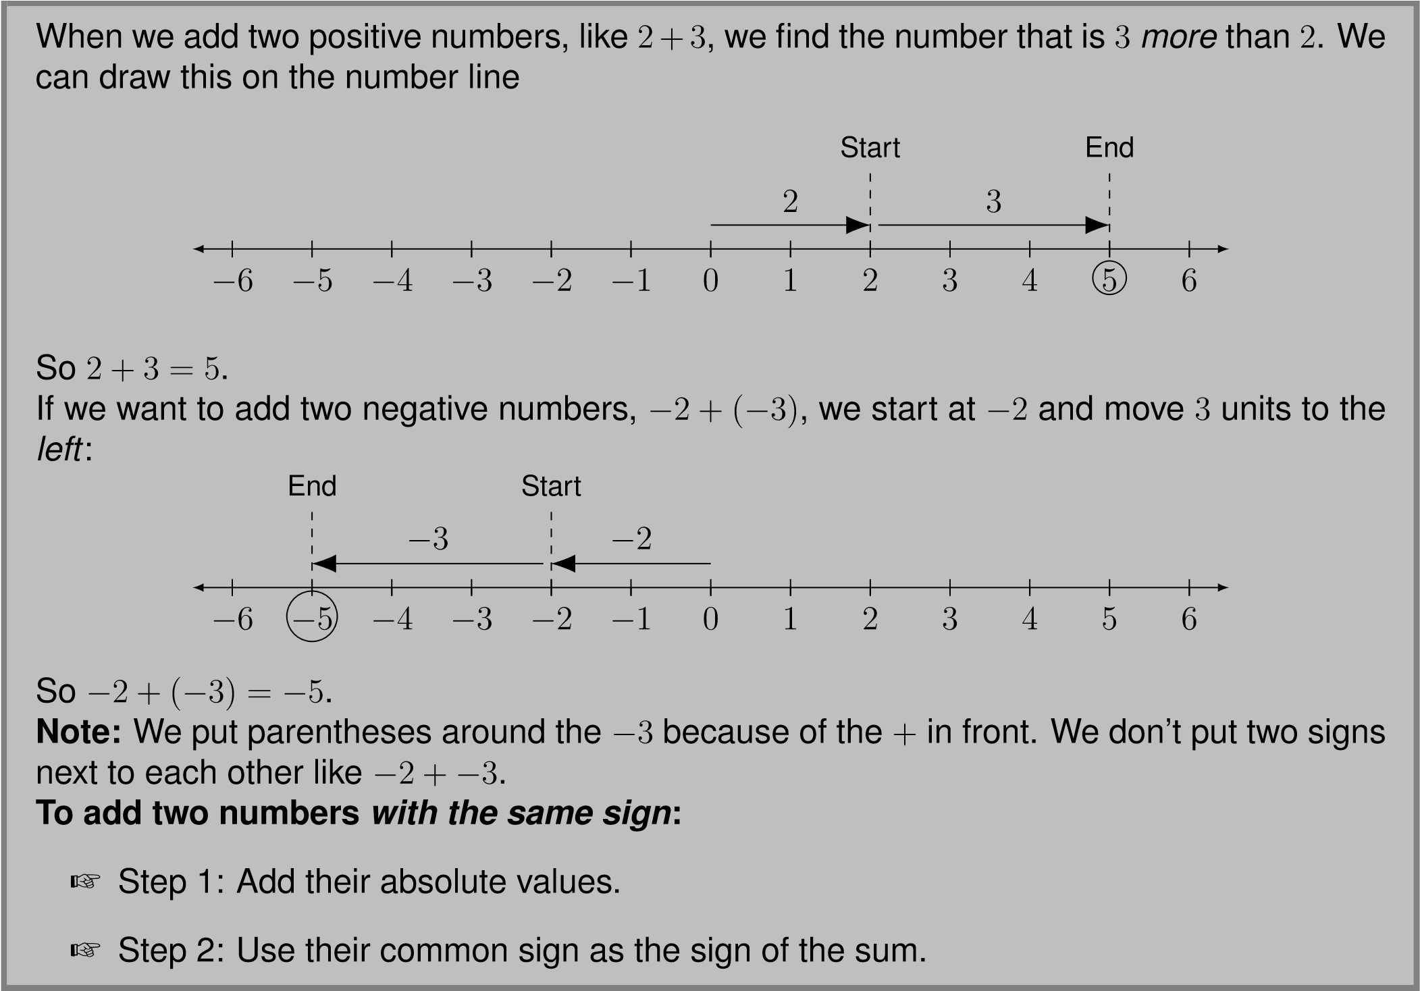

Hint: Adding two positive numbers is just normal addition.
Example: 5 + 7 = 12
Example: −3 + (−4). Both −3 and −4 are negative. Since the signs are the same, we add the absolute values.
+ | − 3| = 3 and | − 4| = 4
+ 3 + 4 = 7
+ The common sign is −
So −3 + (−4) = −7
If we want to add two numbers with different signs, like
5+(
−
2)
, we start at
5
and move two
to the
left
.
−
1
0
1
2
3
4
5
6
5
−
2
Start
End
So
5 + (
−
2) = 3
. This is the same as
5
−
2 = 3
.
Rule:
When adding a positive number, move
right
, when adding a negative number, move
left
.
Even when we start with a negative number and add a positive number we still subtract the
absolute values. For example
−
4 + 6
−
6
−
5
−
4
−
3
−
2
−
1
0
1
2
3
−
4
6
Start
End
So
−
4 + 6 = 2
. This is the same as
6
−
4 = 2
. Notice that we subtract the number with
smaller absolute value from the number with bigger absolute value.

When adding two numbers with different signs, we can get a negative answer. For example if we want −5 + 2
Start End
−
6
−
5
−
4
−
3
−
2
−
1
0
1
−
5
2
So −5 + 2 = −3. Notice that the number with bigger absolute value is −5 and the sum is negative. The absolute value of the answer is 5−2 = 3. This is the difference of the absolute values of −5 and 2.
To add two numbers with different signs:
+ Step 1: Subtract the number with smaller absolute value from the one with bigger absolute value.
+ Step 2: Use the sign of the number with larger absolute value as the sign of the sum.
Hint: When adding two integers, always check to see if the signs are the same or if they are different. Then use the appropriate rule for that case.
Hint: You might want to draw an arrow sketch like the ones shown above to know what the sign of the answer will be.
Example: 15 + (−23)
The signs are different, so we use the rules for adding numbers with different signs.
+ |15| = 15 and | − 23| = 23
+ 23 is bigger than 15 so we subtract: 23 − 15 = 8
+ −23 has a bigger absolute value than 15 so the answer should be negative.
So 15 + (−23) = −8
Example: −13 + (−16)
Now the signs are the same (remember to always check this first).
+ | − 13| = 13 and | − 16| = 16
+ 13 + 16 = 29
+ The common sign is −
So −13 + (−16) = −29
Let’s see what happens when we add two numbers that are opposites.
−
6
−
5
−
4
−
3
−
2
−
1
0
1
−
5
5
Start
End
−
1
0
1
2
3
4
3
−
3
Start
End
In any case, the answer is
0
. When we add two numbers that are opposites the answer is
always
0
. If
n
is a number
n
+ (
−
n
) = 0
−
n
+
n
= 0
We say that opposite numbers are
additive inverses
of each others because they add up to
0
. We also say they cancel each other out.
Remember:
The commutative and associative properties are true for addition:
+
a
+
b
=
b
+
a
+
a
+ (
b
+
c
) = (
a
+
b
) +
c

Subtracting Integers
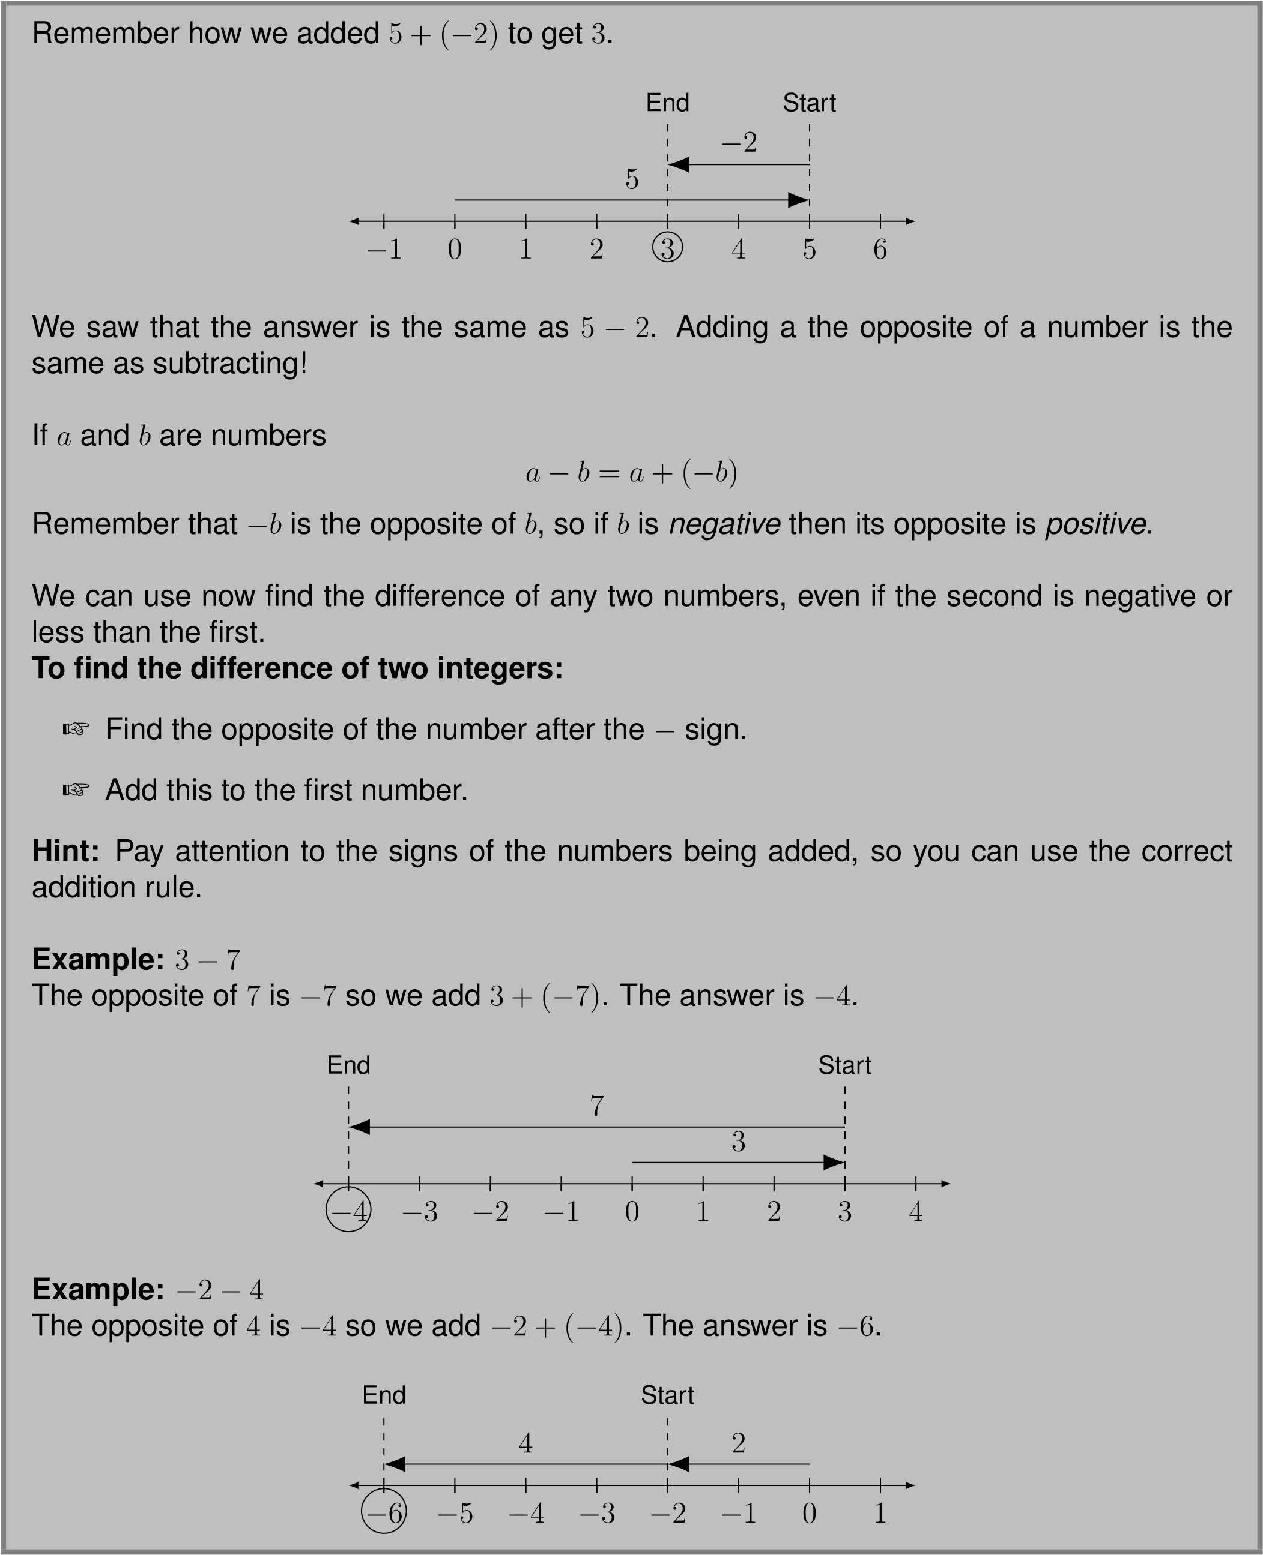
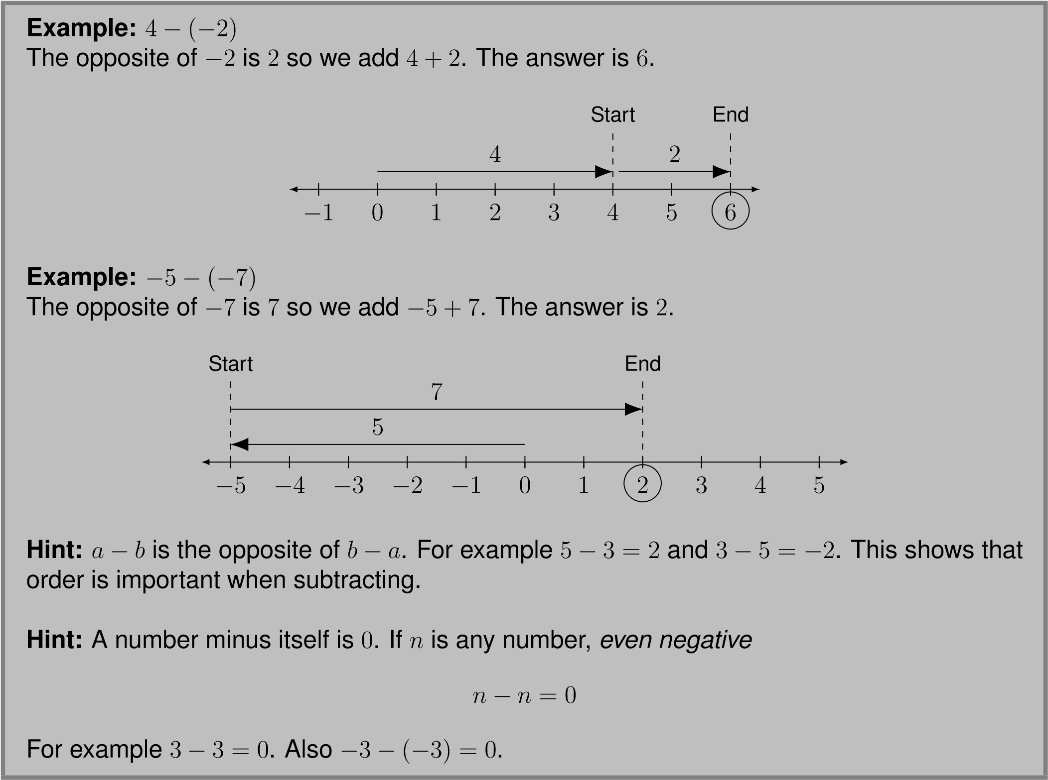

Multiplying Integers
Multiplication of integers can be written using · or by putting the second number in parentheses:
−2 · 3 = −2(3).
Now that we know how to add negative numbers, we can guess how to multiply positive numbers.
Example: −3 · 4
Multiplication of whole numbers is just repeated addition, so we add −3 to itself 4 times:
−3 + (−3) + (−3) + (−3)
Notice that all the signs of the numbers being added are negative. To add numbers with the same sign, add up the absolute values and use their common sign as the sign of the answer.
−3 · 4 = −12
We know that order doesn’t matter when multiplying, so we can also say that
4 · (−3) = −12
To multiply numbers with different signs:
+ Step 1: Multiply the absolute values of the numbers
+ Step 2: The sign of the answer is negative.
Remember: “Minus times plus is minus.”
Example: 6 · (−5) = −30
Example: −9 · 8 = −72

We can also multiply two negative numbers. Pay attention, because this is different from the process of multiplying numbers with different signs. Let’s see what happens when we multiply a negative number by decreasing positive numbers:
−2 · 3 −2 · 2 −2 · 1 −2 · 0
+2
+2
+2
−6 −5 −4 −3 −2 −1 0 1 2 3 4 5 6
Notice that each time the second number goes down by one, the answer goes up by 2 because we are adding one less −2.
Question: What are the next numbers if the pattern continues?
Answer: The next terms are 2,4, and 6. So −2 · (−1) = 2,−2 · (−2) = 4, and −2 · (−3) = 6:
−2 · 3 −2 · 2 −2 · 1 −2 · 0 −2 · (−1) −2 · (−2) −2 · (−3)
+2
+2
+2
+2
+2
+2
−6 −5 −4 −3 −2 −1 0 1 2 3 4 5 6
Although it may seem weird the answer when multiplying two negatives is positive.
To multiply two numbers with the same sign:
+ Step 1: Multiply the absolute values.
+ Step 2: The sign of the answer is positive.
Remember:
“Minus times minus is plus.”
To multiply two numbers, remember the following rules: If the numbers have the same sign the answer is positive:
(+)(+) = + (−)(−) = +
If the numbers have different signs the answer is negative:
(+)(−) = − (−)(+) = −
Remember: The rules for multiplication are different from addition and subtraction.

Dividing Integers
Division is the inverse operation of multiplication. If we want to know how to divide integers, we can use the rules for multiplication.
Examples:
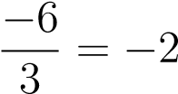 because 3(−2) = −6
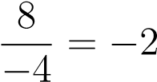 because −4(−2) = 8
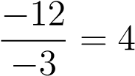 because 4(−3) = −12
To divide integers:
“Plus over minus is minus.”
“Minus over plus is minus.”
“Minus over minus is plus.”
If the signs are the same the answer is positive:
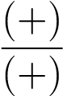 = (+) 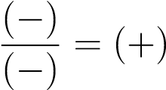
If the signs are different the answer is negative:
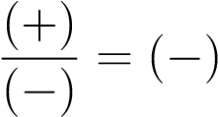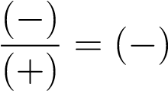

Order of Operations
The order of operations for integers is the same as for whole numbers:
- Do all operations in grouping symbols such as parentheses, brackets, starting with the innermost set.
- Evaluate any expressions with exponents.
- Multiply or divide in order from left to right.
- Add or subtract in order from left to right.
Careful: Parentheses make a big difference when evaluating exponents.
(−2)² = −2(−2) = 4
but
−2² = −2(2) = −4
Example: −5 − 4(7 − 9)⁴ Answer: We do what’s in parentheses first, keeping parentheses around the answer:
−5 − 4(−2)⁴
Now we do the exponent:
−5 − 4(16)
Next comes multiplication:
−5 − 32
Finally, we do the subtraction:
−5 + (−32) = −37
So:
−5 − 4(7 − 9)⁴ = −37
Now Give It a Try!
- 23 + 34
- −23 + (−34)
- −256 + 512
- 103 + (−269)
- −12 · 8
6. −7(−11)
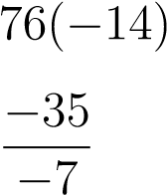
7.
8.
- (−5 + 8 − 6 + 2)(−4 + 3 + 15 − 3)
- 83 − 64[4 − 2(19 − 25)]

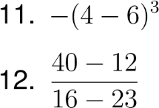

AnswerKey:
1.
57
2.
−
57
3.
256
4.
−
166
5.
−
96
6.
77
7.
−
1064
8.
5
9.
17
10.
−
941
11.
8
12.
−
4

