Bucks County Community College

Academic Success Center

Online Tutoring   
Guide for Students

j0292982

Overview

All asynchronous online tutoring is done through email and Microsoft Word. All real-time online tutoring is done through a web-based, interactive whiteboard called Scribblar™. Scribblar™ is user-friendly; however, it is recommended that students review this guide for some general information before using the tool.

For **drop-in hours**, tutors can be found in the appropriate **Online Academic Success Center Canvas** space for the subject. For **appointments**, tutors and students will log into Scribblar™ using emailed invitations from ASC’s email account at designated times before the appointment.

Table of Contents:

**Online Tutoring Guidelines and Strategies3  
Scribblar Tools and Features4  
The Assets Tab6  
Drop-in Tutoring: Logging in to Canvas7  
Online Appointments: Logging in to Scribblar9  
Uploading a File to the Assets Tab 10  
Setting up the Audio and Video Tools11  
Setting up and Using the Bamboo Tablet12  
Saving and Deleting the Session Materials13  
Documenting the Session14  
Checking the Center’s Email14  
Checking the Center’s Voicemail15  
Checking TutorTrac Schedules15  
Scheduling TutorTrac Appointments16  
Canceling Appointments and Deleting Availability17  
Asynchronous Online Writing Tutoring18  
Asynchronous Ask a Tutor Form25  
Troubleshooting Common Challenges26  
Important Contact Information28**

**Online Tutoring Guidelines and Strategies**

**Guidelines:**

* Tutors cannot share their last names, phone numbers, or email addresses. Always use the Center’s contact information – 215-968-8044 and [asc@bucks.edu](mailto:asc@bucks.edu).
* Pay attention to the links provided in the emailed invitations for real-time sessions to ensure you enter the correct rooms for your appointments. The most recent emailed invitations will always contain the correct link.
* If unable to upload a file within Scribblar, students may also email file attachments to [asc@bucks.edu](mailto:asc@bucks.edu) for the tutor’s review.
* The rooms will be cleared at the close of each session. Let your supervisor know if you would like to stay in the room to continue working. The Center will know to clear the room at a later time.

**Strategies:**

* For sessions using audio features, the tutor may call you from a blocked phone number. If your phone cannot accept calls from blocked numbers, be sure to let your tutor know.
* While the text of the chat window can be saved, it is not included in the PDF save of the whiteboard screen(s). For this reason, it may be best to have most conversation and suggestions posted in the margins of the white board using the text box feature. That way you can save all of the text in the one PDF document.
* Utilizing the shared pointer can be helpful, but be sure to test its visibility with the student before relying on it. Different screen sizes can impact what is seen along the bottom and right borders of the white board. Only the area in the blue box (the space within the two tool bars) is guaranteed visibility.

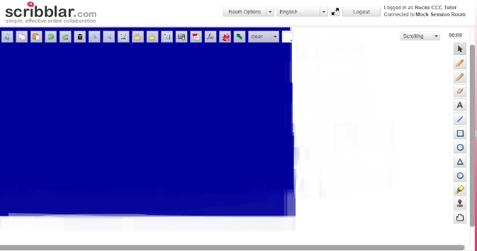

* **Background is available if a session needs lined or graph paper.**

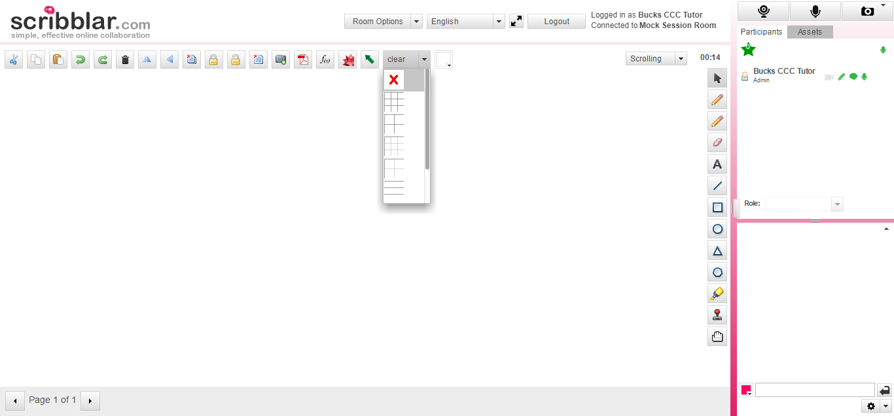

**\*\*Additional strategies and best practices are shared throughout this document with each of the specific features.\*\***

**Scribblar™ Tools and Features:**

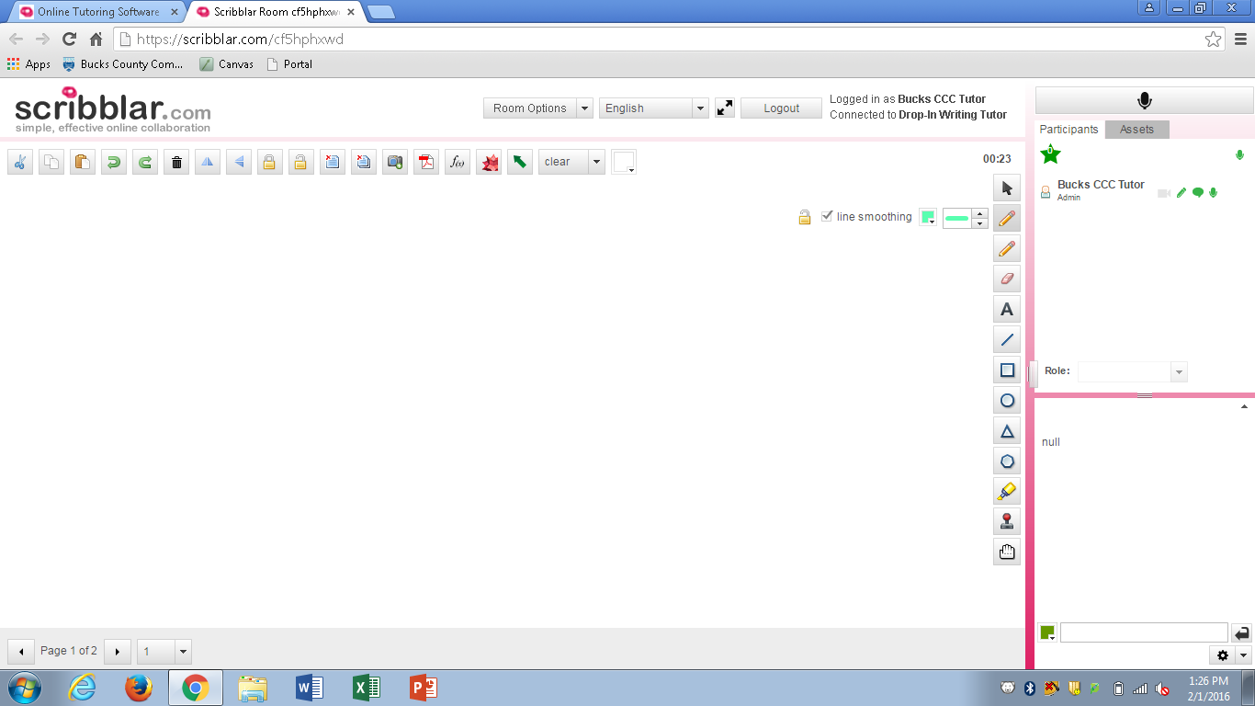

5. Chat Window

9. Clear Whiteboard

7. Scroll Options

6. Chat Options

11. Assets Tab

2. Arrow Icon/Tool Selection

4. Whiteboard Tools

10. Screenshot

8. The Moderator Tools

3. Microphone/Audio

1. Room Options Options

1. **Room Options** – The drop down arrow brings you to a menu where you can invite a student into the room; however, this does not work properly with Bucks emails. You will not need these tools.
2. **The Arrow Icon/Tool Selection** – This icon within the whiteboard tools brings the user back to the primary state of the whiteboard with no special tools selected, allowing the opportunity to click items on the board without remaining in the last tool selected.
3. **The Microphone Icon** – This icon allows the user to set up audio preferences and equipment. **\*Some rooms are also equipped with a video tool that will be next to the microphone tool.**
4. **The Whiteboard Tools** – This collection of tools is available to both participants and moderators and includes the highlighter, text box, shared pointer, and pencil tools.
5. **The Chat Window** – This is the area where participants and moderators can have written discussion.
6. **Chat Options** – By selecting this drop down arrow, moderators and participants are able to save the contents of the chat window. **After copying the contents of this window**, the chat should be cleared at the end of the session by selecting “Clear Chat Transcript” from the drop-down menu at the bottom right of the chat window.
7. **Scroll Options** – By using the arrows, moderators and participants are able to scroll between additional pages of the whiteboard when available.
8. **The Moderator Tool bar** – Moderator status is granted to students by the tutor so that students and tutors can make full use of these tools.
9. **Clear Whiteboard Icons** – These two icons allow users to clear one page or all pages of the whiteboard. **The full whiteboard should be cleared at the end of the session**.
10. **Screenshot** – This icon allows all participants to save the full content of the whiteboard after a session. **Tutors will send this file to the supervisors**, along with any chat transcripts, at the end of the session.
11. **Assets Tab** - This area is where students or tutors can upload documents, presentations, or images to the whiteboard. More details provided on page 6.
12. 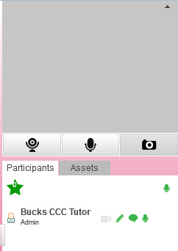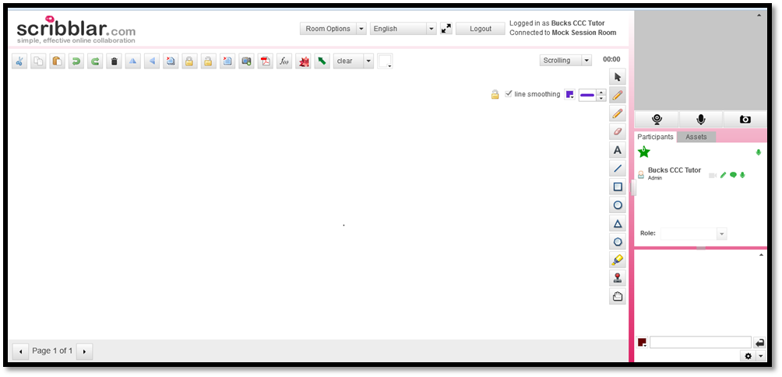**Video Set up** - For select subjects, rooms will have video capabilities in addition to audio. Note the difference in appearance from the prior screen shot:

This is the window in which a video or a still image will be visible.

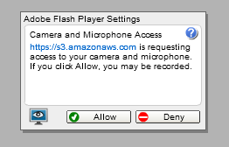

This arrow will minimize this window so that the video is no longer visible to you. Note that it still may be viewed by the participants even if your view is minimized.

These icons activate the Video and Camera Snapshot functions. As with the microphone function, a permission window opens. After selecting “allow,” the webcam will be activated.

The Assets Tab

****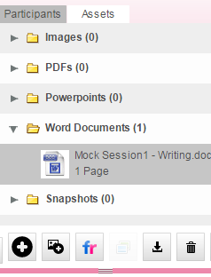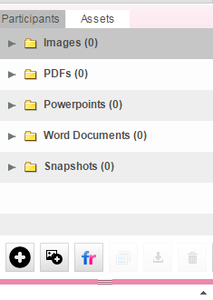The following are three views of the assets tab. In the first image, there are no documents uploaded, as indicated by the (0) following each file type. The third image indicates that there has been one Word document uploaded. By clicking the small arrow to the left of the file icon (image 3), the file will be “expanded” allowing you to view some details about the file.

1

3

2

3. Add a Flickr image

2. Add a Website screenshot

1. Upload and Download
2. **The Upload and Download Icons** – These buttons allow users the opportunity to upload files (i.e. documents and photos), which can then be automatically placed on the whiteboard for discussion. The other participant may use the download icon to download the full document. The files should be removed from the “Assets” tab at the end of the session by selecting the file and hitting the trashcan icon to delete all files after the session.
3. **Add a Website Screen Shot** – This option will allow users to include a screen shot from another web page and add it to the “assets.”
4. **Add a Flickr image** – This option will allow users to search the collection of images in Flickr to add an image to the whiteboard.

Uploading a File to the Assets Tab

1. 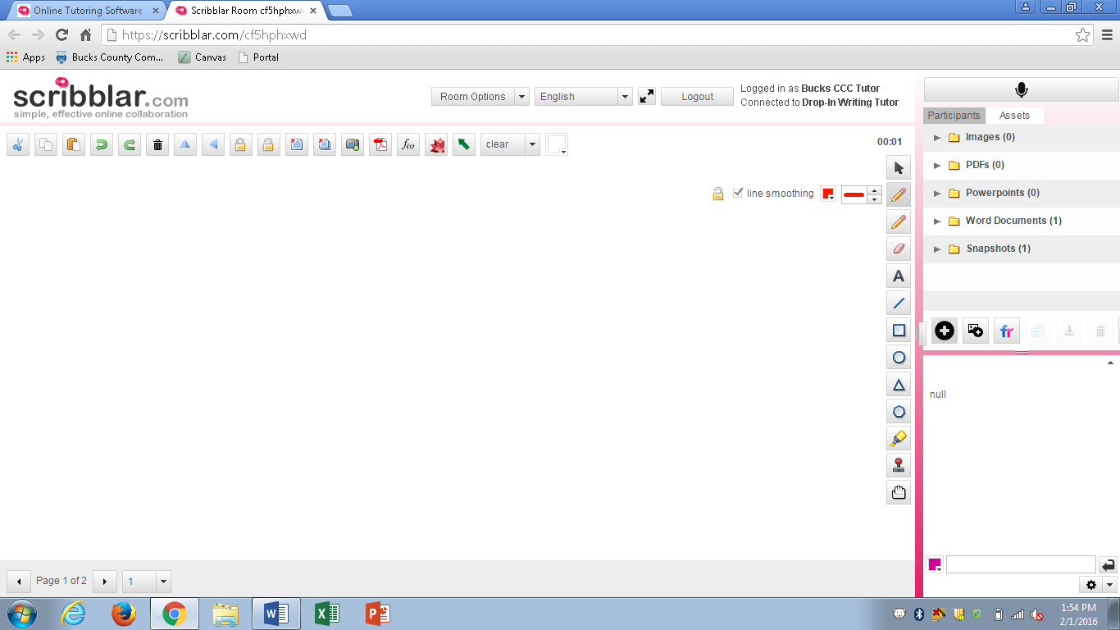Select the “**Assets**” tab to the right of “**Participants**.” Then select the icon with the black circle with the white “plus” on it to select a file for upload.

1. A dialog box will appear for participants to select a file to place onto the whiteboard or to be available for download. **Whenever possible, save the file as a .doc instead of .docx, as .docx frequently causes an upload error.** **Troubleshooting note**: If struggling to change the file type, go to “File” and select “Save As.” From there, you can change the file type.
2. Once uploaded, the file will automatically appear on the whiteboard. The tutor and student may then review the document, screenshot, or problem using the whiteboard tools, chat window, and/or audio. Use the arrows on the bottom left of the screen to scroll between pages.

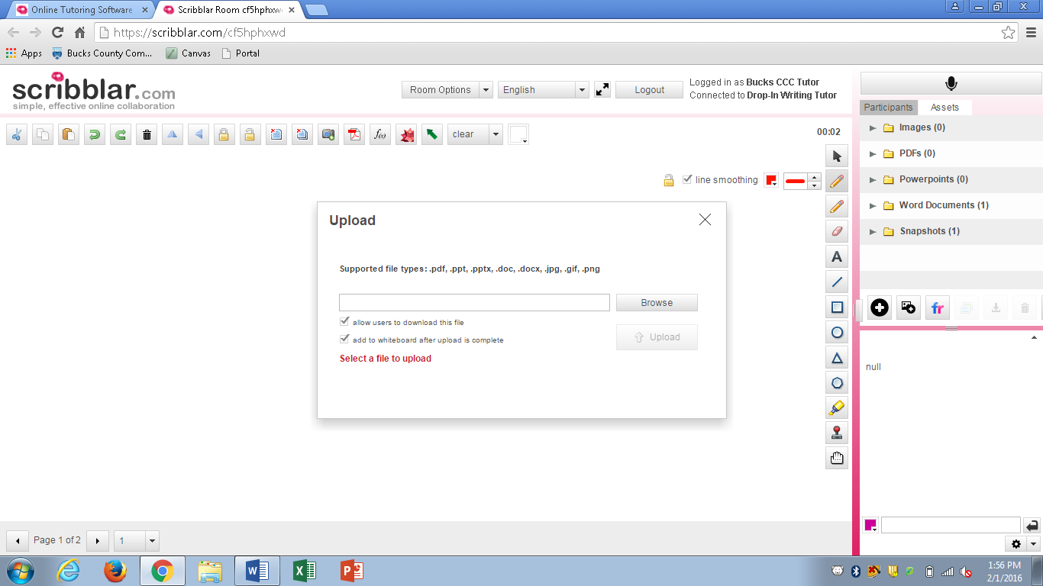

As files are added, they will appear in the “Assets” tab.

If needed, tutors or students may download the files by selecting them and clicking the download icon here.

“Browse” will allow students to search for their file.

Setting up the Audio and Video Tools

1. Right click on the microphone icon on the top right of the window and select “settings.”

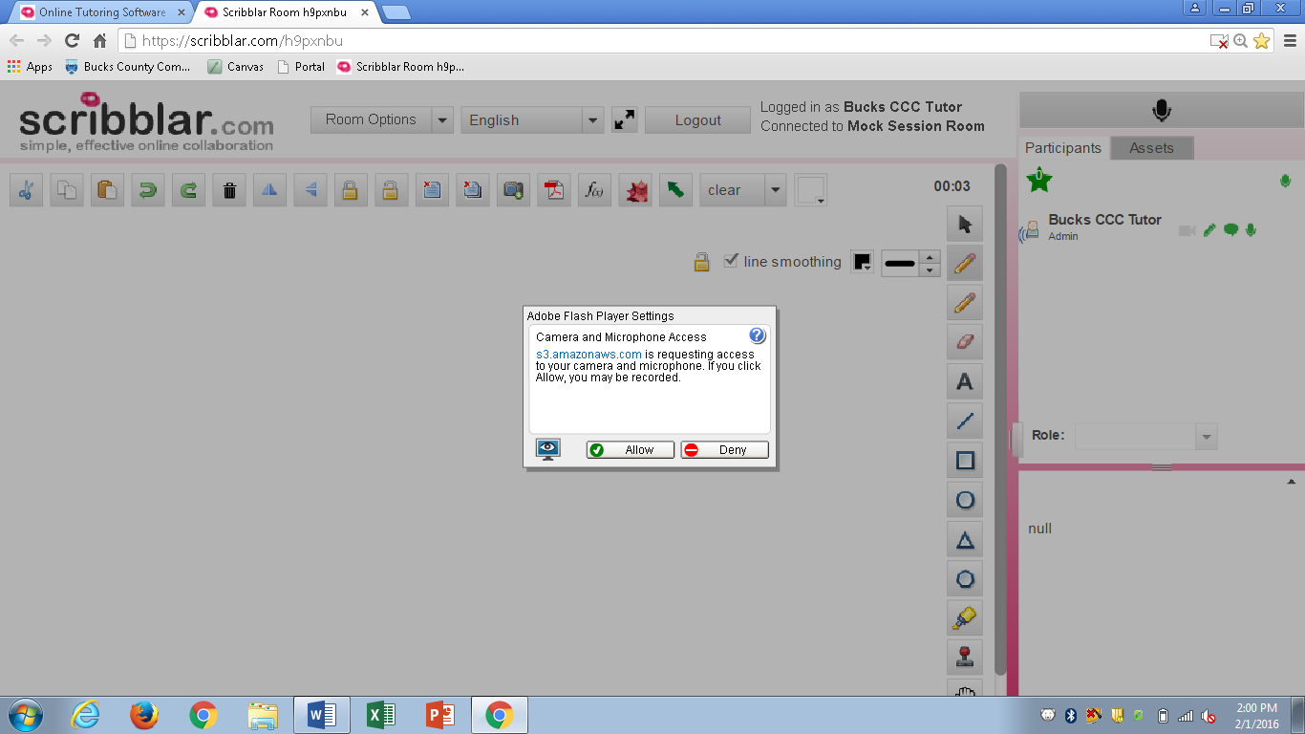

1. Follow the prompts to select your microphone and speakers. (The details of this step may vary.)
2. If the audio setting does not work or develops technical difficulties, tutors may call the student and communicate over the phone while still using the whiteboard and chat as needed. Tutors will use *67 to block their phone numbers, unless calling from a campus phone.
3. Repeat steps with the video icon to set up video as needed.



Saving/Deleting the Session Materials

1. **Students and Tutors can select the Adobe PDF symbol located next to the camera icon.** This option will export the entire document and convert it to a PDF. When this option is selected, a small window will open allowing the student to select whether to convert and save the whole document or select pages.

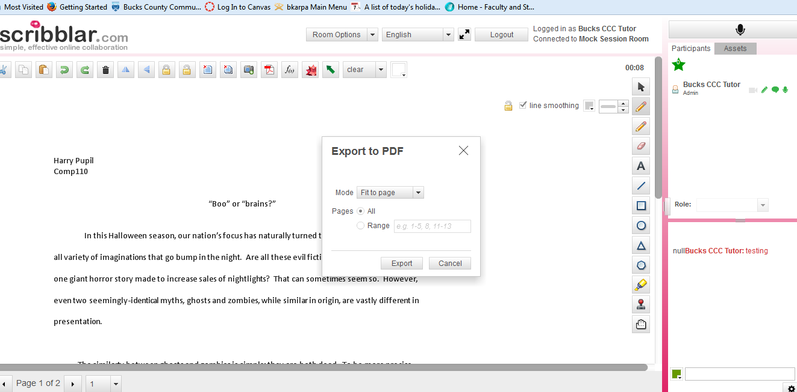

1. **To save the chat window, it is best to copy and paste the entire text of the chat window into a Word document**.
2. **To delete the whiteboard pages, select the icon that looks like papers with a red x in the corner.** Notice that there are two icons. One will allow the user to clear a single page, while the other icon will delete all pages of the whiteboard.

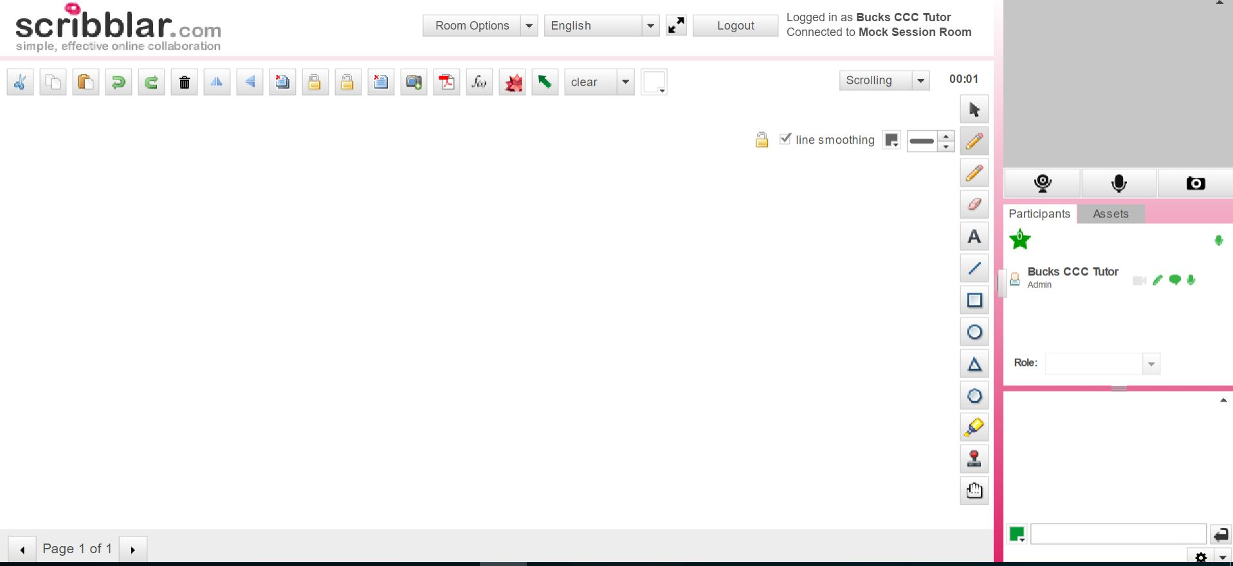

1. **Next, click on the assets tab, and select each file uploaded then the trashcan icon to delete the file**.

